Press release

Liebherr Miami facilities to support FBR Hadrian X® maintenance and service

⸺

Liebherr Miami facilities serves as the maintenance base for Hadrian X® operations

Liebherr team members gain access to hands-on knowledge through on-site service and maintenance

Liebherr USA, Co. and robotic technology company, FBR Limited, have agreed to utilize the Liebherr Miami facilities as a US service and maintenance base for the next generation Hadrian X® robots.

Miami, FL (USA), Liebherr USA, Co., March 19, 2024 – Liebherr USA and robotic technology company, FBR Limited (FBR), have reached an agreement to utilize the Liebherr Miami facilities as a service and maintenance base for the [next-generation Hadrian X® robots](https://www.fbr.com.au/view/next-gen-hadrian-x) in the United States. Both Liebherr and FBR Limited will exchange information regarding the Hadrian X® mechanical and electrical systems, as well as maintenance and service requirements with the goal of large-scale manufacturing upon the execution of a long-term Manufacturing and Commercialization Agreement.

FBR’s Hadrian X® is a mobile robotic block laying machine. The robots build concrete block structures, such as walls, based on a 3D CAD model. Hadrian X® uses unique optimization software and an intelligent control system allowing this technology to be accurate and efficient for real world use.

“We continue to be impressed by FBR’s rapid development of their technology and product, particularly around the next-generation Hadrian X®. Liebherr and FBR share a vision for a safer, more efficient jobsite and strongly believe that automation and digitalization are key enablers to achieving this,” noted Stephen Albrecht, Managing Director of Liebherr-International AG.

A trusted partnership

The deployment of Hadrian X® robots in the United States will complete the recently announced Demonstration Program between FBR Limited and CRH Ventures with the subsequent goal of forming a joint venture for delivering Wall as a Service® solution in the US. This strategic timing allowed FBR and Liebherr to mutually decide to extend Phase One of their Memorandum of Understanding by 12 months to allow sufficient time to commence operations, validate achievement of key performance targets, and for the agreement of commercial terms for the manufacturing and commercialization of the Hadrian X®.

FBR Managing Director and Chief Executive Officer, Mike Pivac noted, “Extending the term of Phase One of our Memorandum of Understanding will allow us the necessary time to get our robots on the ground in the United States, and give the Liebherr team who may be directly involved in the large-scale manufacture of the Hadrian X® robots the opportunity to work directly with them and build their hands-on knowledge of the technology by working with us to service and maintain them at their facilities.”

“We are glad to continue our relationship with FBR and supporting them to demonstrate and validate their technology in the US. We are confident that the Hadrian X® will be successful in meeting its performance targets ahead of a possible long-term Manufacturing and Commercialization Agreement,” said Albrecht.

The Demonstration Program aims to create a pathway to 300 Hadrian X® units in the USA, thus accelerating commercial rollout.

“Use of the Miami facility is a significant benefit to FBR and will allow us to demonstrate the capabilities of our technology to US builders in pursuit of a pipeline of work for the future Wall as a Service® operating entity,” said Pivac.

About Liebherr USA, Co.

[Liebherr USA, Co](https://www.liebherr.com/en/usa/start/start-page.html). based in Newport News, VA provides sales and service on behalf of ten different Liebherr product segments: earthmoving, material handling, mining, mobile and crawler cranes, tower cranes, concrete technology, deep foundation machines, maritime cranes; components, and refrigeration and freezing.

About the Liebherr Group

The [Liebherr Group](https://www.liebherr.com/en/usa/about-liebherr/about-liebherr.html) is a family-run technology company with a highly diversified product portfolio. The company is one of the world's largest manufacturers of construction machinery. It also offers high-quality, user-oriented products and services in multiple other areas. Today, the group consists of more than 140 companies across all continents. In 2022, it employed more than 50,000 people and achieved combined revenues of over 12.5 billion euros. Liebherr was founded in 1949, in Kirchdorf an der Iller in southern Germany. Ever since then, the company’s employees have been committed to satisfying customers with advanced solutions and to helping drive technological progress.

Images

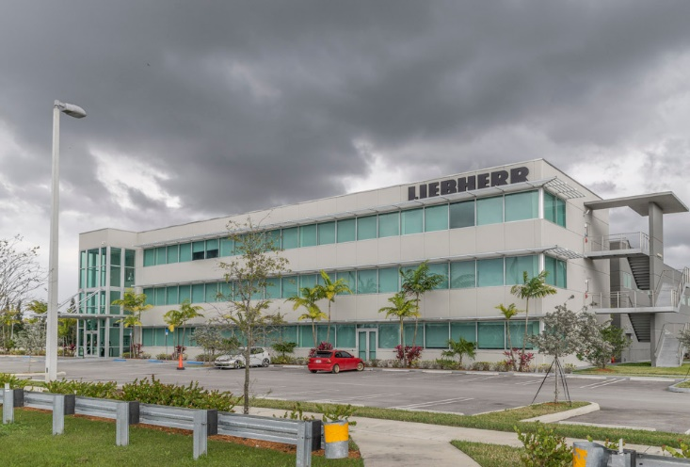

liebherr-usa-Miami-campus-1.jpg  
The Liebherr Miami facilities will serve as a maintenance and service base for FBR Limited’s Hadrian X® robots.

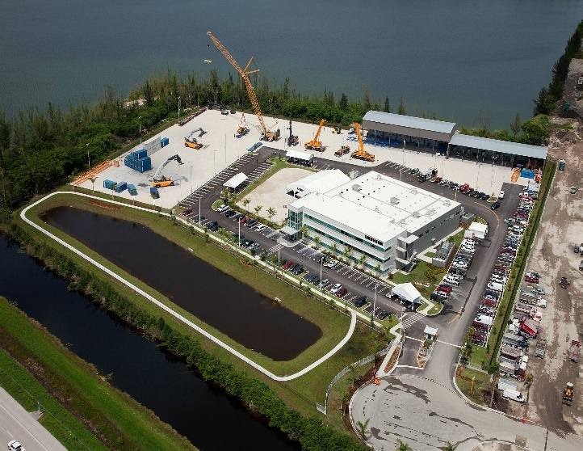

liebherr-usa-Miami-campus-2.jpg  
Liebherr will exchange information with FBR limited regarding the Hadrian X® mechanical and electrical systems, as well as maintenance and service requirements.

Contact

Ana Cabiedes   
Head of Marketing

Liebherr USA, Co  
E-Mail: ana.cabiedes@liebherr.com

Published by

Liebherr USA, Co.   
Newport News / USA  
www.liebherr.com