Press release

Biggest order in the history of Saudi Liebherr Co.

⸺
Arabian Machinery & Heavy Equipment Co. (AMHEC) invests in 55 new Liebherr all-terrain cranes
The order includes new cranes from five up to nine axles
This order is making history: the Saudi Arabian company AMHEC has ordered 55 new cranes from Liebherr. It is the largest order that Saudi Liebherr Co. has ever received. Mr. Abdullah Al-Suwaiket, Chief Executive Officer at AMHEC said: “Our company's purchase decision is based on many years of positive experience with mobile cranes from Liebherr. We trust in the quality of Liebherr's products and their excellent service.”
Ehingen (Donau) (Germany), 19 March 2024 – The crane and heavy haulage company Arabian Machinery & Heavy Equipment Co. (AMHEC) decided to place an extraordinary order in December 2023: AMHEC ordered a total of 55 new mobile cranes from Liebherr with lifting capacities from 100 to 800 tonnes. Mr. Ajanthas Kumarathas, Branch Manager and Head of Division at Saudi Liebherr Co. emphasised: “We are proud to be able to supply AMHEC with this number of cranes. Since 1983, Liebherr has consistently demonstrated to its customers in Saudi Arabia its reliability as a partner. This track record is the foundation upon which customers, including AMHEC, rely, and extend the partnership further.” Within the scope of this record order the company will acquire LTM 1100-5.3, LTM 1110-5.2, LTM 1160-5.2, LTM 1230-5.1, LTM 1250-5.1, LTM 1300-6.3, LTM 1450-8.1, LTM 1650-8.1 and LTM 1750-9.1 cranes. “We already have numerous cranes with a lifting capacity between 50 and 500 tonnes. We are now proud to also complete our fleet with a nine axle crane so that we can fulfil all orders for our customers. The cranes are a great addition to our fleet and a beneficial factor to our sustainable growth in this promising market.” emphasizes Mr. Abdullah Al-Suwaiket.
AMHEC uses its cranes throughout the Kingdom of Saudi Arabia for industrial lifting jobs and many other areas of application. Mr. Abdullah Al-Suwaiket said: “We serve a wide variety of tasks in Saudi Arabia. We depend on and trust in the reliable, high-quality medium-sized and large cranes from Liebherr.” To take account of these different areas of application and the requirements of its major customers, AMHEC ordered its cranes with the maximum possible number of driven axles and the “Emergency Package” for the highest level of safety.
Al-Suwaiket confirmed Liebherr's excellent reputation in the Arab country: “Liebherr is a very well-known brand here in the Kingdom and is preferred throughout the local markets. Its cranes are characterised by high quality and reliability. The local branch here also ensures excellent service.”
The first cranes from this order will arrive in the Kingdom in a few months, bringing the company's crane fleet to a total of more than 400 cranes. Al-Suwaiket added: “We are looking forward to receiving our new cranes. Each crane is characterised by its own advantages. Some models also include great improvements.”

About Liebherr-Werk Ehingen GmbH
Liebherr-Werk Ehingen GmbH is a leading manufacturer of mobile and crawler cranes. Its range of mobile cranes extends from 2-axle 35 tonne cranes to heavy duty cranes with a lifting capacity of 1200 tonnes and a 9-axle chassis. Its lattice boom cranes on mobile or crawler travel gear deliver lifting capacities of up to 3000 tonnes. With universal boom systems and extensive additional equipment, they can be seen in action on construction sites throughout the world. The Ehingen site has a workforce of 4,300. An extensive, global service network guarantees the high availability of Liebherr mobile and crawler cranes. In 2022, the Liebherr plant in Ehingen recorded a turnover of 2.37 billion euros.
About the Liebherr Group
The Liebherr Group is a family-run technology company with a widely diversified product range. The company is one of the largest manufacturers of construction machines in the world. However, it also supplies high quality, user-focused products and services in many other sectors. The group currently comprises more than 140 companies based in every continent of the world. In 2022, it had a workforce of over 50,000 and recorded a consolidated total turnover of more than 12.5 billion euros. The company was founded in 1949 in Kirchdorf an der Iller in southern Germany. Since then, its aim has been to win customers by supplying high quality solutions and to contribute to technological progress.

Image
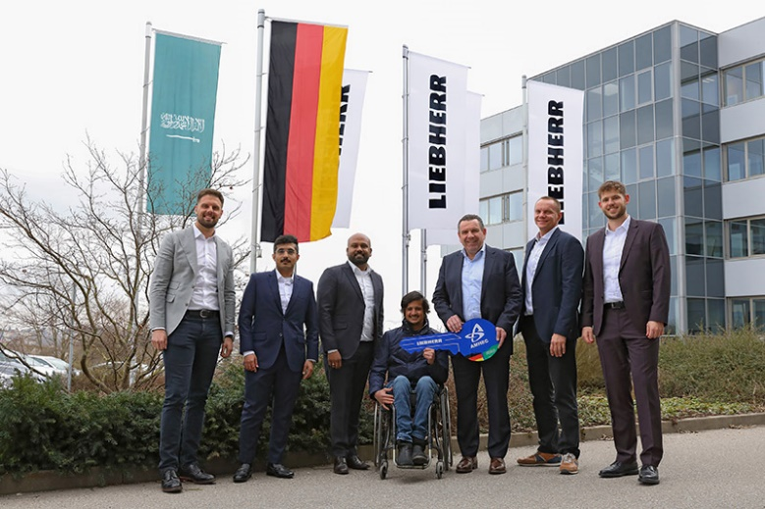
lwe-amhec-major-order.jpg
Symbolic handover of the key in Ehingen: (from left to right) Daniel Türkis, Thamer Al Harbi, Ajanthas Kumarathas (alle Saudi Liebherr Co.), Abdullah Al-Suwaiket (Arabian Machinery Heavy Equipment Co.), Christoph Kleiner, Georg Reinbold, Marius Kleck (alle Liebherr-Werk Ehingen GmbH).

Contact
Wolfgang Beringer
Marketing and Communication
Phone: +49 7391/502 - 3663
Email: wolfgang.beringer@liebherr.com
Published by
Liebherr-Werk Ehingen GmbH
Ehingen (Donau) / Germany
www.liebherr.com

