Press release

Looking ahead: Kran-Maurer modernises and grows

⸺
Kran-Maurer modernises its crane fleet with Liebherr mobile cranes
First foray into the 6-axle class with an LTM 1300-6.3
Generational change in management and rejuvenation of the team underway

Kran-Maurer GmbH is modernising its crane fleet. In recent months, the South German company from Göppingen has taken delivery of the Liebherr LTM 1050-3.1, LTM 1090-4.2 and LTM 1110-5.1 mobile cranes. This was followed in March by an LTM 1230-5.1. The delivery of an LTC 1050-3.1 is scheduled for April. An LTM 1300-6.3 has already been ordered from Liebherr, which will further strengthen Kran-Maurer's fleet.
Ehingen (Donau) (Germany), 27 March 2024 – "We have replaced our machinery over the last 24 months. Hardly any of our cranes are more than two years old," explains managing partner Johannes Maurer, who runs the family business together with his mother Petra Maurer. "A modern vehicle fleet is important to us. At the same time, we are forging ahead with our growth strategy. We see the potential for this. To meet customer requirements, you have to be a full-service provider."
Entry into the 6-axis class
As part of its growth strategy, Kran-Maurer has ordered an LTM 1300-6.3 from Liebherr. Petra Maurer says: "It will be the first 6-axle crane in the history of our company. This 300-tonne-crane will significantly strengthen our fleet. We see potential in the energy sector and in infrastructure projects."
In recent years, Kran-Maurer has switched from a two-manufacturer strategy to a one-brand philosophy. "We now only have Liebherr mobile cranes. The intrinsic value, the service and the support – it's just a perfect fit. We feel that our collaboration with Liebherr is based on an extremely close and friendly partnership," says Johannes Maurer.
Generational change runs smoothly
The beginnings of today's company go back to the 1920s, when Gottlieb Maurer transported goods with horse-drawn carriages and, from the 1930s, with the first lorries. His son Gerhard Maurer added several Unimogs to the fleet from 1948. With the purchase of his first mobile crane in 1962, he laid the foundations for today's Kran-Maurer GmbH. Today, the company is a full-service partner in the field of heavy goods logistics. Machine and company relocations, assembly and disassembly, sophisticated transport solutions, various storage services and an extensive rental programme complete its range of services.
The transition from the second to the third generation is currently underway within the company's management. Petra Maurer reports: "Two generations are working very well hand in hand. And our authorised signatory Andreas Gülch has followed in the footsteps of his predecessor as Commercial Director." His son Johannes adds: "The rejuvenation process in our company has been a success. The values of a family business are being preserved and paired with a fresh spirit. Our customers can rely on us and we are confident about the future."
About Liebherr-Werk Ehingen GmbH
Liebherr-Werk Ehingen GmbH is a leading manufacturer of mobile and crawler cranes. Its range of mobile cranes extends from 2-axle 35 tonne cranes to heavy duty cranes with a lifting capacity of 1200 tonnes and a 9-axle chassis. Its lattice boom cranes on mobile or crawler travel gear deliver lifting capacities of up to 3000 tonnes. With universal boom systems and extensive additional equipment, they can be seen in action on construction sites throughout the world. The Ehingen site has a workforce of 4,300. An extensive, global service network guarantees the high availability of Liebherr mobile and crawler cranes. In 2022, the Liebherr plant in Ehingen recorded a turnover of 2.37 billion euros.
About the Liebherr Group
The Liebherr Group is a family-run technology company with a widely diversified product range. The company is one of the largest manufacturers of construction machines in the world. However, it also supplies high quality, user-focused products and services in many other sectors. The group currently comprises more than 140 companies based in every continent of the world. In 2022, it had a workforce of over 50,000 and recorded a consolidated total turnover of more than 12.5 billion euros. The company was founded in 1949 in Kirchdorf an der Iller in southern Germany. Since then, its aim has been to win customers by supplying high quality solutions and to contribute to technological progress.
Image
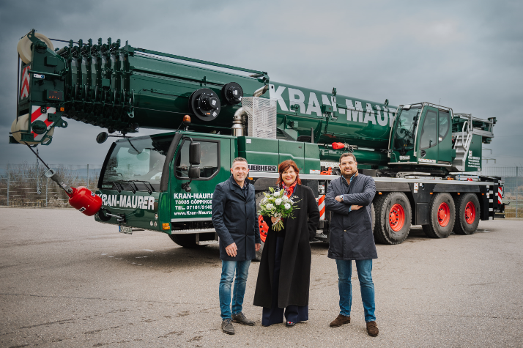
liebherr-ltm1230-5.1-maurer.jpg
Kran-Maurer takes delivery of an LTM 1230-5.1 at the Liebherr plant in Ehingen (from left to right): Joachim Sommer (Liebherr-Werk Ehingen GmbH), Petra Maurer, Johannes Maurer (Kran-Maurer GmbH).

Contact
Wolfgang Beringer
Marketing and Communication
Phone: +49 7391/502 - 3663
Email: wolfgang.beringer@liebherr.com
Published by
Liebherr-Werk Ehingen GmbH
Ehingen (Donau) / Germany
www.liebherr.com

