Press release

Liebherr mixing tower supplies quality concrete for crane ballast weights

⸺

Högerle Betonwerk GmbH has put a new Betomat mixing tower into operation

Existing mixing tower from 1987 was replaced

Quality concrete just in time for precast production

Sophisticated concretes for high-quality crane ballast weights

Betonwerk Högerle GmbH in Dietenheim has modernised its production of precast concrete parts with a new Betomat 3-235 concrete mixing tower. Högerle is known for the planning and production of high-quality solid components, prefabricated staircases, basement systems, filigree elements and ballast weights for Liebherr tower cranes.

Bad Schussenried (Germany), 6 March 2024 - The new mixing plant for Högerle is a Betomat 3-235. This plant replaces a 36-year-old Liebherr mixing tower. In 1987, Högerle modernised and installed a Betomat mixing tower from Liebherr. This mixing tower served very well for 36 years. That is a proud achievement, says Managing Director Michaela Högerle. It was clear to buy the new mixing plant from Liebherr again. The requirement was a modern and reliable mixing plant for year-round operation and for supplying the neighbouring precast plant. The old mixing plant was dismantled and the existing concrete substructure could be reused. The new mixing plant can deliver the concrete either into the bucket conveyor or into a truck mixer. Sophisticated concrete types and qualities are one of the most important features in the precast industry. This is why the Liebherr RIM 1.5-D ring-pan mixer is used. This mixer works with a double agitator system, homogenising all materials and additives quickly and efficiently. In addition, the mixer is controlled by a frequency converter, which means that the speed of the mixer can be infinitely varied during the mixing process and thus optimally adapted to concrete recipes.

Particularly sophisticated ballast weights are manufactured

In addition to precast concrete parts for construction, Högerle also manufactures ballast weights for cranes. The manufacture of crane counterweights is a special discipline with a number of challenges. The weight per unit must fit perfectly, the tolerances are tight. Durability for decades must be guaranteed. The appearance of the visible surfaces should be smooth, without inclusions or other defects. As ballast weights are repeatedly put on and taken off the crane or loaded, high fatigue strength is particularly important. The casting moulds are complex, with weights or logos cast in relief. Högerle has specialised in this field and has been a reliable partner of Liebherr crane production for many years.

The facts about the mixing tower

The focus in concrete production is primarily on quality rather than quantity. The practical throughput capacity in hardened concrete is more than sufficient at around 75 m³ per hour. The tower with a diameter of 6.75 metres has a storage volume of 235 m³ for aggregates in seven chambers arranged in a star shape. The system is fed with a galvanised bucket elevator. Four types of cement with a total capacity of 160 tonnes can be stored in the cement section. The cement screw conveyors are controlled by frequency inverters and ensure greater dosing accuracy, resulting in considerable cost savings.

Durability and equipment

High-quality components and an almost completely galvanised steel construction make the system particularly durable. To ensure smooth operation during the cold winter months, the entire system is insulated, clad with plastic-coated façade sheeting and equipped with a heating system.

The mixing plant was equipped with many additional options at the customer's request: For example, high-pressure mixer cleaning, Litronic-MPS III plant control system, camera monitoring system, Liebherr Litronic-WMS sand moisture measurement system, silo filling signalling systems, swivel hopper for lorry loading, dry material outlet (mixer bypass), demand signalling point in the production hall. The intensive mixer is equipped with the "Cleaning mode with creep speed" function, which makes cleaning the mixer more convenient.

About Liebherr-Mischtechnik GmbH

Liebherr-Mischtechnik GmbH is a global manufacturer and supplier of high-quality mixing plants, concrete pumps and ready-mix truck mixers. The company belongs to the Liebherr Group and is based in Bad Schussenried, Germany.

About the Liebherr Group

The Liebherr Group is a family-run technology company with a broadly diversified product programme. The company is one of the largest construction machinery manufacturers in the world. However, it also offers high-quality, benefit-orientated products and services in many other areas. Today, the group comprises over 140 companies on all continents. In 2022, it employed more than 50,000 people and generated total consolidated sales of over 12.5 billion euros. Liebherr was founded in 1949 in Kirchdorf an der Iller in southern Germany. Since then, the employees have pursued the goal of convincing their customers with sophisticated solutions and contributing to technological progress.

About the company Högerle Betonwerk GmbH

**Josef Högerle Betonwerk GmbH, based in Dietenheim on the** **Iller between Ulm and Memmingen, is one of the leading concrete plants in Germany. The traditional company has been family-run since 1905. The company is now in its third generation of manufacturing high-quality concrete products. The production programme includes** Solid components, prefabricated staircases, basement systems, filigree elements and ballast weights. The company is successfully managed by the three daughters Hilde Brugger, Uschi Högerle-Herz and Michaela Högerle.

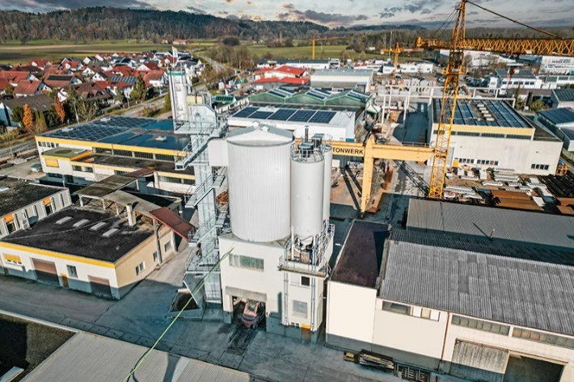Pictures

liebherr-betomat-hoegerle.jpg  
Liebherr Betomat 3 mixing plant with ring-pan mixer supplies sophisticated concrete types.

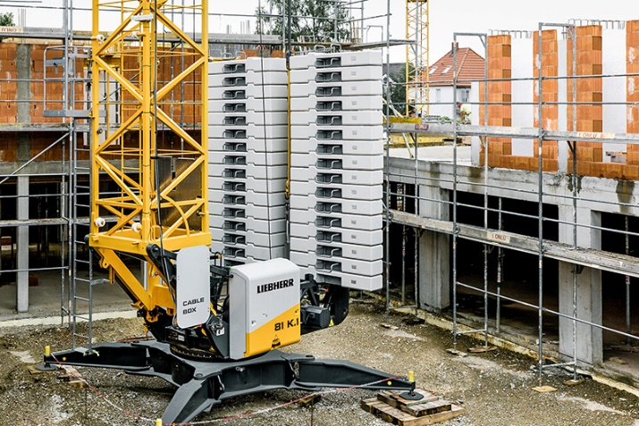

liebherr-crane-ballast.jpg  
Ballast weights in use on Liebherr tower cranes.

Contact us

Klaus Eckert  
Phone: +49 7583 949 328  
E-mail: klaus.eckert@liebherr.com

Published by

Liebherr-Mischtechnik GmbH  
Bad Schussenried, Germany  
[www.liebherr.com](http://www.liebherr.com)