Press release

New carrier machine for slurry wall construction LBX 600

⸺

Liebherr launches a new carrier machine for slurry wall construction on the market. The compact size of the LBX 600 fulfils the requirements of jobsites in urban areas in particular. The electrically driven unplugged version also impresses with the advantages of zero emission. The LBX 600 can be fitted with mechanical or hydraulic grabs. The modular boom system allows for three different versions of the machine and a high degree of flexibility.

Nenzing (Austria), 14 March 2024 − With the LBX 600, the new carrier machine for slurry wall construction, Liebherr-Werk Nenzing GmbH is responding to the special challenges faced on urban jobsites. The compact size combined with the unplugged version enables work in even the most confined spaces and noise-sensitive areas. The LBX 600 can be flexibly equipped and customised to meet site requirements thanks to a modular system with three different booms. The standard version of the machine has a total height of 17.8 m. For applications with restricted height, e.g. working under bridges, the Low Head with 11 m or Ultra Low Head with 5.8 m can be used. The LBX 600 has a particularly impressive slim design. The compact basic machine can be transported in one piece as, thanks to the telescopic undercarriage, the track width can be reduced to 3 m.

Powerful grip

The carrier machine is not only designed for work using a hydraulic grab but also with a mechanical grab or chisel, thanks to the two free-fall winches with a line pull of 300 kN each. In combination with the HSG 5-18 hydraulic slurry wall grab, the LBX 600 offers very intuitive operation, which also enables hydraulic corrections to the grab alignment and thus a higher verticality of the trench.

The hydraulic slurry wall grab is modularly designed and has an extremely robust base body. As the names of the grabs imply, HSG 5-18 C and HSG 5-18 L, slurry walls with thicknesses between 500 and 1800 mm can be installed, depending on the composition. The term “C” (compact) stands for the compact standard design for the Low Head Version of the LBX 600, while the base body of the “L” (large) version is 2.5 m longer. The resulting total height of the grab at 9.5 m and the high weight with low centre of gravity provide for even better vertical positioning and are especially advantageous when installing larger dimensioned slurry walls.

When working in difficult ground conditions, the execution of the work can be improved through increasing the dead weight of the grab with an additional weight of 4.4 t or 6.5 t. Bites with lengths of 2500-3400 mm and maximum depths of 80 m can be excavated with the grab.

The slurry wall grab is fitted with a hydraulic rotating device, which allows the grab to be aligned in all directions and provides for quick and operator-friendly 180°-rotation after each grab cycle. The high cylinder force of 1527 kN attains an unbeatable performance even under extreme conditions. The fill level indicator on the grab ensures high productivity throughout the entire application. The maximum permissible grab weight - i.e. grab including filling capacity - is 30 tonnes.

Unplug: that’s all you have to do

The LBX 600 is available in both conventional and battery-powered versions, the LBX 600 unplugged. Both versions have identical performance data. One exceptional feature of the unplugged version is zero emission. They do not produce any exhaust fumes and are extremely quiet. This strikes the right note especially in noise-sensitive regions and finds favour with jobsite personnel and residents.

The battery is charged using a conventional jobsite electric supply. Operation can continue as normal while charging. In order to change to battery operation, you just need to pull out the plug, therefore: unplugged. Whether attached to the electric supply or not, the performance and range of application remains unchanged. Liebherr offers the LBX 600 and the LBX 600 unplugged as a complete package with hydraulic slurry wall grab HSG 5-18.

Digital solutions

All working processes for slurry wall construction can be electronically recorded and visualized using the process data recording system PDE. The system is operated and displayed on the PDE touchscreen in the cabin. PDE records operating data from the Litronic control system, as well as data from external sensors.

Using the MyJobsite software solution all relevant process, machine and jobsite data can be recorded, displayed, analysed, managed, and evaluated in one central location. The collected data can be accessed via a web browser when an internet connection is active. With the recorded PDE data, a working protocol is automatically generated as proof of quality directly after completion of a work process. The parameters of the driving protocol can be defined and assigned in advance, which is an enormous time-saver.

The LiDAT data transmission and positioning system enables the fleet management of Liebherr machines. The system supplies information about localisation as well as about the operation of the machines. This includes the machine position, operating and utilisation times, fuel consumption and service interval information.

Animation LBX 600: [LBX 600 − carrier machine for slurry wall construction | Liebherr - YouTube](https://www.youtube.com/watch?v=WHHil_vw9qU)   
Animation LRH 600: [Liebherr − Slurry wall grab HSG 5-18 C/L (youtube.com)](https://www.youtube.com/watch?v=aL-PlTM28GE)  
Film MyJobsite [MyJobsite − your jobsite at a glance](https://www.youtube.com/watch?v=DKi0tkZoX0s)

About the Liebherr Group of Companies

The Liebherr Group is a family-run technology company with a highly diversified product portfolio. The company is one of the largest construction equipment manufacturers in the world. It also provides high-quality and user-oriented products and services in a wide range of other areas. The Liebherr Group includes over 140 companies across all continents. In 2022, it employed more than 50,000 staff and achieved combined revenues of over 12.5 billion euros. Liebherr was founded in Kirchdorf an der Iller in Southern Germany in 1949. Since then, the employees have been pursuing the goal of achieving continuous technological innovation and bringing industry-leading solutions to its customers.

Images

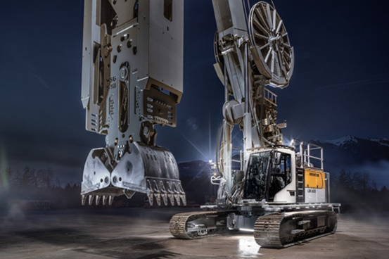

liebherr-1.jpg   
A perfect team for slurry wall construction: the carrier machine LBX 600 and the hydraulic slurry wall grab HSG 5-18.

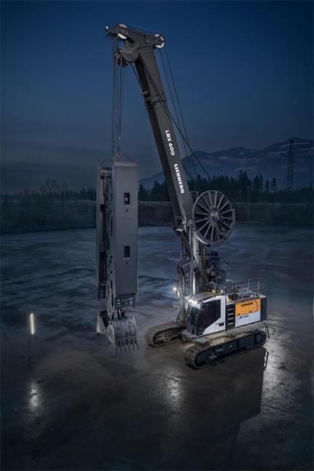

liebherr-2.jpg  
The slim design of the LBX 600 fulfils the requirements of urban jobsites in particular.

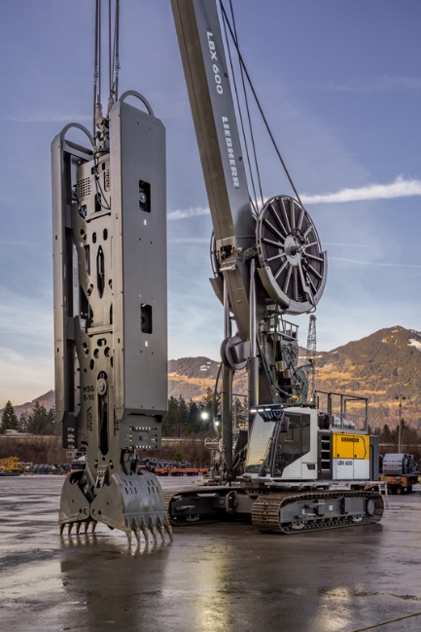

liebherr-3.jpg  
With the LBX 600 Liebherr launches a new carrier machine for slurry wall construction.

Contact

Gregor Griesser  
Strategic Marketing and Communications  
E-Mail: [gregor.griesser@liebherr.com](mailto:gregor.griesser@liebherr.com)

Wolfgang Pfister  
Head of Strategic Marketing and Communications  
Tel.: +43 50809 41-444  
Email: [wolfgang.pfister@liebherr.com](mailto:wolfgang.pfister@liebherr.com)

Published by:

Liebherr-Werk Nenzing GmbH  
Nenzing/Austria  
[www.liebherr.com](http://www.liebherr.com)