Press release

Liebherr exhibits at WasteExpo 2024

⸺

Liebherr exhibits at WasteExpo 2024 showcasing specialized machines for waste handling.

Liebherr USA’s earthmoving and material handling technology team exhibits at WasteExpo 2024 showcasing the LH 22 C Industry material handler and the L 550 XPower wheel loader at booth #2214.

Newport News, VA (USA), Liebherr USA, Co., March 14, 2024 – The WasteExpo 2024 takes place in Las Vegas, NV from May 7-9, 2024. Liebherr displays multiple machines at their booth including the [LH 22 C Industry material handler](https://www.liebherr.com/en/usa/products/material-handling-equipment/crawler-material-handling-machine/details/67831.html) and the [L 550 XPower wheel loader](https://www.liebherr.com/en/usa/products/construction-machines/earthmoving/wheel-loaders/details/69217.html). Liebherr experts are also on-site at booth #2214 to answer any questions and provide assistance with equipment.

The recycling industry is growing rapidly, and many waste disposal companies require specialized recycling operations. This has brought a new set of challenges to the machines used in recycling. In response, Liebherr continues to develop machines and equipment for every need and application, including waste handling.

Liebherr manufactures different components itself and the company offers capable and efficient machines including mobile material handling machines, crawler material handlers, wheel loaders, dozers, and crawler loaders for sorting, separating, and loading recyclables and solid waste quickly and reliably.

LH 22 C Industry material handler

The LH 22 C Industry material handler offers a sturdy and compact design, making it particularly suitable for waste handling. With the latest engine and hydraulics technology, developed in-house by Liebherr, the main focus is on fuel efficiency and enhancing material handling performance. The attachment of the machine is available in a variety of versions and is always optimally matched to the respective application.

The recycling industry is highly varied. This generation of Liebherr material handlers is adept at a wide range of tasks including feeding a conditioner or crusher, loading and unloading trucks and containers, sorting materials and waste products, and piling up and moving materials of all kinds. The interaction between the hydraulics and electronics guarantees fast and powerful movements when handling materials and provides efficient and precise work for challenging sorting tasks.

Performance data

|  |  |
| --- | --- |
| Model: | LH 22 C-EW |
| System performance: | 141 hp |
| Operating weight: | 50,000 lbs. |
| Reach: | 32’ |
| Grapple: | 0.8 yd3 |
| Magnet: | 48 |
| Eye level: | 16’ 11” |

L 550 XPower wheel loader

The high-performance Liebherr XPower wheel loaders are highly productive and can handle a wide range of materials including waste. With strong lift arm variants and application-specific attachments, they are versatile and universally deployable.

In addition to the different types of machines, you can choose between industrial and z-bar kinematics within the L 550 – L 566 XPower wheel loaders and the L 580 XPower. This means the right machine is always available for specific operations such as transporting and loading waste materials. This increases the utilization of the machine and increases productivity by keeping job sites on time and within budget.

Performance data

|  |  |
| --- | --- |
| Model: | L 550 XPower |
| Engine power: | 219 hp / 163 kW |
| Bucket capacity: | 4.5 yd3 |
| Operating weight: | 40,895 lbs. |
| Breakout force: | 37,095 lbs. |
| Tipping Load: | 27,560lbs. |

About Liebherr USA, Co.

[Liebherr USA, Co](https://www.liebherr.com/en/usa/start/start-page.html). based in Newport News, VA provides sales and service on behalf of ten different Liebherr product segments: earthmoving, material handling, mining, mobile and crawler cranes, tower cranes, concrete technology, deep foundation machines, maritime cranes; components, and refrigeration and freezing.

About the Liebherr Group

The [Liebherr Group](https://www.liebherr.com/en/usa/about-liebherr/about-liebherr.html) is a family-run technology company with a highly diversified product portfolio. The company is one of the world's largest manufacturers of construction machinery. It also offers high-quality, user-oriented products and services in multiple other areas. Today, the group consists of more than 140 companies across all continents. In 2022, it employed more than 50,000 people and achieved combined revenues of over 12.5 billion euros. Liebherr was founded in 1949, in Kirchdorf an der Iller in southern Germany. Ever since then, the company’s employees have been committed to satisfying customers with advanced solutions and to helping drive technological progress.

Images

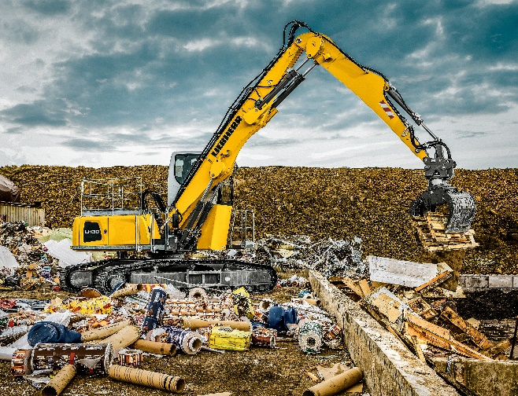

liebherr-usa-LH30C-material-handler.jpg  
Liebherr material handlers offer a sturdy and compact design, making it particularly suitable for waste handling.

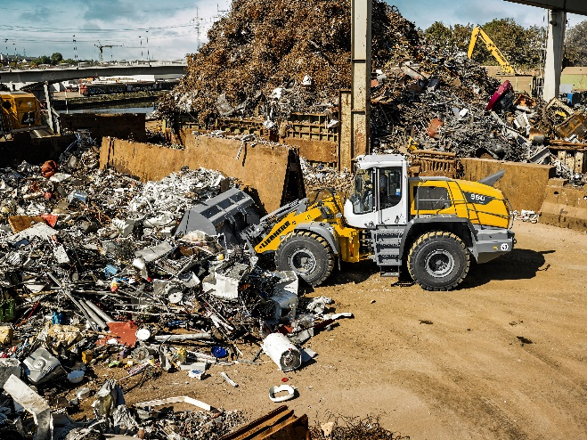

liebherr-usa-550-XPowe-wheel-loader.jpg  
With strong lift arm variants and application-specific attachments, Liebherr wheel loaders are versatile and universally deployable.

Contact

Ana Cabiedes   
Head of Marketing

Liebherr USA, Co  
E-Mail: ana.cabiedes@liebherr.com

Published by

Liebherr USA, Co.   
Newport News / USA  
www.liebherr.com