Press release

Jandt adds second LTM 1250-5.1 to its crane fleet - first use for demanding tandem lift

⸺
- Jandt uses two LTM 1250-5.1s to unload barges
- Heavy wind power components are handled in tandem lift
- Jandt Kranvermietung GmbH looks back on over 70 years of company history

Two Liebherr LTM 1250-5.1 mobile cranes from Jandt Kranvermietung GmbH in Bielefeld played a key role in unloading wind power components at the port of Berenbusch in Bückeburg, Lower Saxony. The heaviest parts, the generator and the hub, had to be lifted by the two 250-tonne cranes in tandem lifts. Precise coordination between the crane operators was crucial here. One of the two LTM 1250-5.1 cranes mastered the challenging lifts as first use.
Ehingen (Donau) (Germany), 28 March 2024 - Two LTM 1250-5.1 cranes from Jandt Kranvermietung GmbH were used for a challenging project to unload wind turbine components from a 70-metre-long barge in the port of Berenbusch. The two 250-tonne cranes were equipped with the complete ballast of 88 tonnes. An additional transport vehicle delivered the special lifting gear.
It was the first major assignment for one of the two LTM 1250-5.1 cranes. Authorized signatory Jens Lübeck, Sales Manager at Jandt, explains: "With the new crane, we have added a second LTM 1250-5.1 to our fleet. We are very satisfied with the first one and we can now swap equipment parts between the two machines. Another important criterion for the Liebherr 250-tonner was its outstanding lifting capacity with its strong 60-meter telescopic boom."
Maximum load capacity on five axles
The LTM 1250-5.1 is characterized by enormous lifting capacities. Liebherr pursued a clear concept when developing the crane: to get the maximum lifting capacity out of the available weight of a 5-axle mobile crane. Another highlight of the LTM 1250-5.1 is the VarioBallast®: The adjustable radius of the counterweight offers maximum lifting capacities with a large ballast radius and optimized application possibilities on tight construction sites with a small ballast radius. And this can be quickly adjusted in just a few simple steps. The 250-tonner can be equipped with a folding jib, a long angled fixed jib or a rigidly attached strong jib. Proven Liebherr technologies such as VarioBase®, ECOmode and ECOdrive make the LTM 1250-5.1 particularly safe and efficient.

Challenging tandem lifts in the port of Berenbusch
Unloading the generator, the heaviest part weighing 98 tonnes, and the hub proved to be particularly challenging. These components had to be moved by both LTM 1250-5.1s together. During these tandem lifts, the sensitive coordination of the two drivers was crucial in order to lift the load safely and set it down again on the heavy-duty vehicle. A single crane was sufficient for the lighter nacelle. After just two hours, all three components were unloaded and placed on the low-loaders.
The freight, which had come a long way from Rotterdam, was transported the last few kilometers from the port in Berenbusch to the wind turbine construction site in Porta Westfalica with the help of three heavy-duty trucks. Two cranes were already waiting there to unload and then assemble the three components.
Successful company history
Jandt Kranvermietung was founded in 1950 by Friedrich Jandt in Bielefeld. In the beginning, only excavator and haulage work was carried out before the first crane vehicle was purchased in 1964. Jandt can therefore look back on a long and successful company history. With over 70 years of experience, more than 35 employees and a fleet of over 25 cranes with a lifting capacity of up to 250 tons, Jandt is a reliable partner for demanding crane work throughout Germany.

About Liebherr-Werk Ehingen GmbH
Liebherr-Werk Ehingen GmbH is a leading manufacturer of mobile and crawler cranes. Its range of mobile cranes extends from 2-axle 35 tonne cranes to heavy duty cranes with a lifting capacity of 1200 tonnes and a 9-axle chassis. Its lattice boom cranes on mobile or crawler travel gear deliver lifting capacities of up to 3000 tonnes. With universal boom systems and extensive additional equipment, they can be seen in action on construction sites throughout the world. The Ehingen site has a workforce of 4,300. An extensive, global service network guarantees the high availability of Liebherr mobile and crawler cranes. In 2022, the Liebherr plant in Ehingen recorded a turnover of 2.37 billion euros.
About the Liebherr Group
The Liebherr Group is a family-run technology company with a widely diversified product range. The company is one of the largest manufacturers of construction machines in the world. However, it also supplies high quality, user-focused products and services in many other sectors. The group currently comprises more than 140 companies based in every continent of the world. In 2022, it had a workforce of over 50,000 and recorded a consolidated total turnover of more than 12.5 billion euros. The company was founded in 1949 in Kirchdorf an der Iller in southern Germany. Since then, its aim has been to win customers by supplying high quality solutions and to contribute to technological progress.

Images
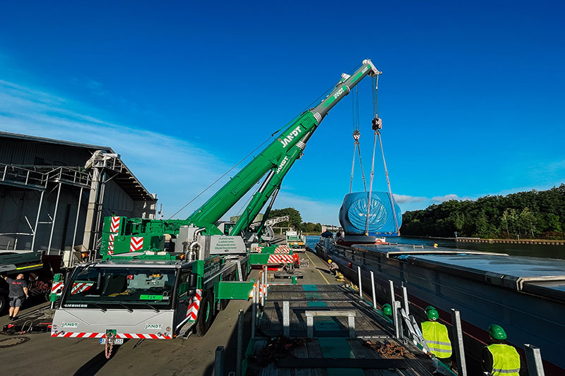
liebherr-ltm1250-5.1-jandt-01.jpg
The two Liebherr LTM 1250-5.1s lift the hub of the wind turbine out of the barge in a tandem lift.

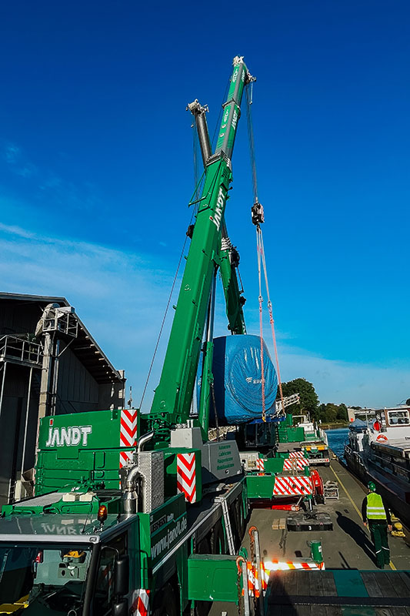
liebherr-ltm1250-5.1-jandt-02.jpg
Passing the load between the two cranes required precise coordination between the two crane operators.
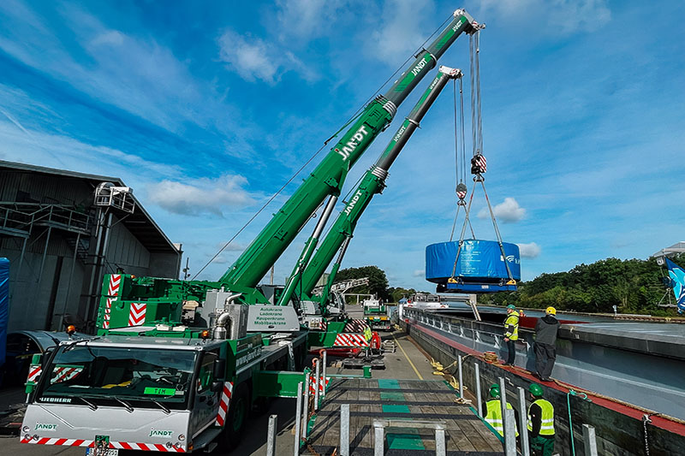
liebherr-ltm1250-5.1-jandt-03.jpg
At 98 tonnes, the generator was the heaviest component.
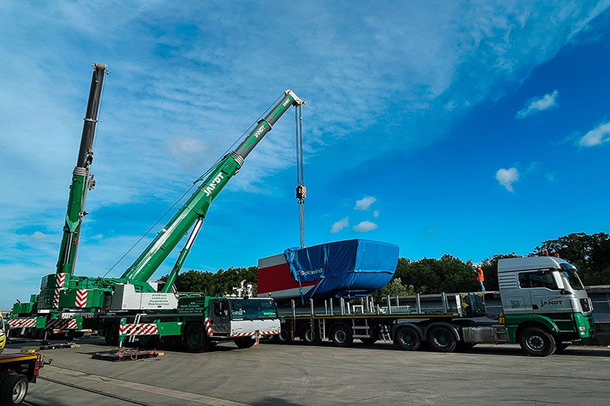
liebherr-ltm1250-5.1-jandt-04.jpg
An LTM 1250-5.1 is sufficient for loading the lighter nacelle.
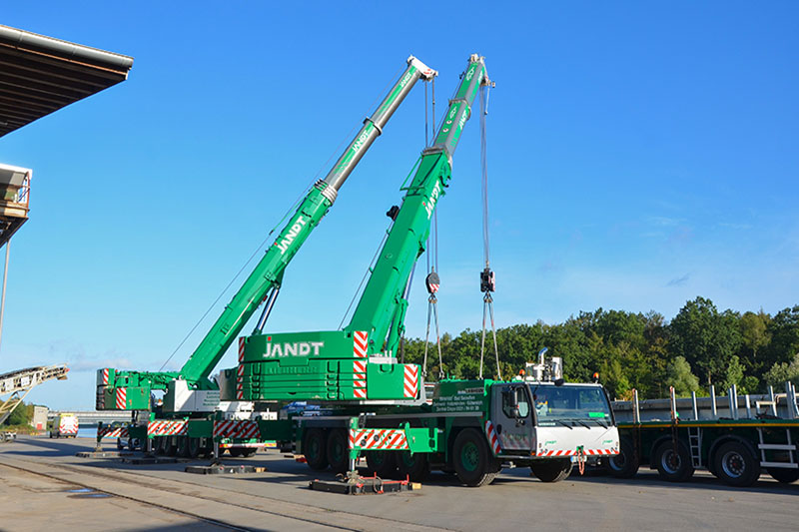
liebherr-ltm1250-5.1-jandt-05.jpg
The two 250-tonne cranes were ballasted with their full counterweight of 88 tonnes.

Contact
Wolfgang Beringer
Marketing and Communication
Phone: +49 7391/502 - 3663
Email: wolfgang.beringer@liebherr.com
Published by
Liebherr-Werk Ehingen GmbH
Ehingen (Donau) / Germany
www.liebherr.com

