Press release

Liebherr: 2023 marks yet another record revenue business year

⸺

The Liebherr Group finished the 2023 business year with a record revenue of €14,042 million. Compared with the previous year, this represents a revenue growth of €1,453 million or 11.5 % for the company.

Bulle (Switzerland), 3 April 2024 – Liebherr’s revenue once again increased significantly compared with the previous year. The Group achieved increased revenues in 11 of its 13 product segments, some of them significant. It surpassed its previous revenue record from 2022 by €1,453 million. At €9,557 million, revenue in the earthmoving, material handling technology, deep foundation machines, mobile and crawler cranes, tower cranes, concrete technology and mining product segments was 11.6 % higher than in the previous year. In the product segments of maritime cranes, aerospace and transportation systems, gear technology and automation systems, refrigerators and freezers, components and hotels, Liebherr achieved total revenues of €4,485 million, an increase of 11.3 % compared with the previous year.

Business saw positive growth in virtually all sales regions. A satisfying revenue increase was registered in the European Union, which has traditionally been the Group’s strongest sales region. Revenues in Germany, France and Spain recorded particularly positive growth. The Group recorded a slight decline in the non-EU countries. The business year was also extremely encouraging in North America – driven by the USA and Mexico – as well as in Asia and Oceania. Revenue in the Africa, Near and Middle East region was also well above the previous year’s level. In Central and South America, revenue remained at the previous year's level.

The Group achieved a net income of €367 million in 2023. Both the earnings before interest and taxes (EBIT) and the finance result have improved significantly. Furthermore, the number of employees grew once again in the 2023 business year. At the end of the year, Liebherr had a total of 53,659 employees worldwide, 2,338 more than in the previous year.

Research and development: focusing on alternative drives and digitalisation

Liebherr is pursuing an objective to be a major player in the advancement of technological innovation. Consequently, the Group invested €634 million in research and development in the previous year. The bulk of this was used in the development of new products. The fields of alternative drives, digitalisation and autonomy were once again the main focus of the research and development. Liebherr continued to develop existing technologies in the 2023 business year and added numerous machines, components and solutions to its product programme.

In drive technology, Liebherr is pursuing an approach that embraces new technology. This includes electric drives, alternative fuels for conventional combustion engines and hydrogen-based drives, such as hydrogen combustion engines and hydrogen fuel cells. 2023 saw not only the sale of the very first battery-electric Liebherr wheel loader, the L 507 E, but also the first delivery of the new LH 80 M High Rise Industry electric material handling machine. In the maritime cranes product segment, the CBG 500 E transshipment crane commenced operation and the LS 800 E became the first fully electric heavy-lift crane currently in production. In aerospace, there is also a focus on alternative technologies in order to generate electrical energy to propel future aircraft and supply them with electricity. For instance, a test bench for hydrogen technology was installed in the test centre in Toulouse (France) for testing fuel cell power generation for non-propulsive onboard systems.

In the field of digitalisation, Liebherr also pushed ahead in developing, among other things, various digital platforms in the business year, making machines more reliable, more convenient and more efficient. The central online platform that combines the Group’s digital services and offerings is MyLiebherr. The Tower Crane Portal was fully integrated into the MyLiebherr customer portal in 2023. Furthermore, programmes such as the Crane Finder for mobile and crawler cranes, the MyNotifier app and the ‘Tower Crane Operating System 2’ for many bottom-slewing cranes were developed further. In the product segments of earthmoving machinery and material handling technology, Liebherr introduced a new app with MyGuide for earthmoving.

Projects within the fields of autonomy and automation were also a key focus for development. The latest series of Liebherr mobile harbour cranes features the Master V crane control system. This provides the basis for integrating future assistance systems and partial automation systems. As part of the ZIRKEL research project, Liebherr is developing automated disassembly processes for the battery packs of electric vehicles. These processes are needed to achieve high recycling rates and to establish carbon-neutral battery production throughout the process chain for the long term. The LiReCon teleoperation unit was also further developed and tested, and autonomous T 264 mining trucks entered into operation for validation testing with a customer.

Record investment in production, sales and service

The Group invested a record sum of €1,030 million in its production sites and its global distribution and service networks. Investments thus increased by €167 million compared with the previous year. This was offset by depreciation amounting to €623 million.

The site of the Liebherr plant in Ehingen (Germany) is currently being expanded to increase physical capacity for mobile and crawler crane production due to rising demand. Liebherr-Logistics GmbH in Oberopfingen (Germany) has invested in improved storage facilities. The highly automated logistics centre has been expanded to include a new cold hall and a hazardous materials storage facility for lubricants. At the site in Newport News (USA), the Group has invested in the production of mining trucks. In addition to the construction of a new painting facility, the focus is on expanding the existing production hall – both projects are due to be completed by 2025. Building work also began at the Campsas site (France) in the business year in order to enlarge the site there. In Schüttorf (Germany), Liebherr is building a subsidiary for sales, maintenance, repair and leasing of earthmoving machines on a site spanning more than 18,000 m2. Work is due to be completed in 2024. A new administration building is also being built at the Biberach site (Germany), which Liebherr-Purchasing Services GmbH and Liebherr-International Deutschland GmbH will use for group-wide activities.

Outlook for 2024

Economic conditions will remain challenging in 2024, however Liebherr has started the current business year with a very solid volume of orders. Although there are differing trends in the individual product segments, Liebherr will be able to compensate for this thanks to its decentralised, diversified structure and international positioning. The demand for large cranes and raw materials is growing as numerous economies around the world undergo transformation processes. This provides market opportunities for Liebherr. The Group anticipates growth in the USA and Australia, for instance.

On Wednesday, 3 April 2024, the Liebherr Group publishes its current annual report. In addition to detailed figures, it contains a magazine section reviewing the past business year. In an interview, Jan Liebherr, President of the administrative board of Liebherr-International AG, and Stéfanie Wohlfarth, Vice President of the administrative board of Liebherr-International AG, sum up 2023.

The annual report of the Liebherr Group can be found online at [www.liebherr.com/geschaeftsbericht](http://www.liebherr.com/geschaeftsbericht).

About the Liebherr Group – 75 years of moving forward

The Liebherr Group is a family-run technology company with a highly diversified product programme. The company is one of the largest construction equipment manufacturers in the world. It also provides high-quality, user-oriented products and services in a wide range of other areas. The Liebherr Group includes over 150 companies across all continents. In 2023, it employed more than 50,000 staff and achieved combined revenues of over 14 billion euros. Liebherr was founded by Hans Liebherr in 1949 in the southern German town of Kirchdorf an der Iller. Since then, the employees have been pursuing the goal of achieving continuous technological innovation, and bringing industry-leading solutions to its customers. Under the slogan ‘75 years of moving forward’, the Group celebrates its 75th anniversary in 2024.

Images

liebherr-tower-cranes-2023.jpg  
Two Liebherr luffing jib cranes are at work on the construction of New Zealand’s tallest residential building (187 metres).

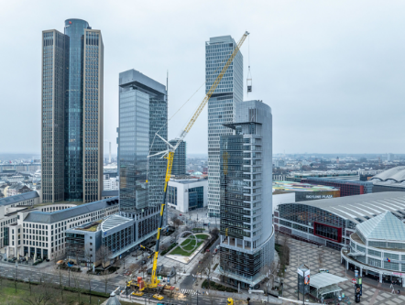

liebherr-mobile-cranes-2023.jpg  
An LTM 1650-8.1 mobile crane from Liebherr, with a maximum load capacity of 700 t, is used to replace the cooling units on a skyscraper in central Frankfurt am Main (Germany).

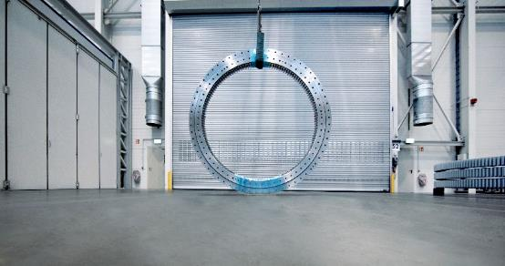liebherr-bearing-for-mtex-antennas-2023.jpg  
Unlocking the secrets of the universe: Liebherr slewing bearings provide the azimuth adjustment of the next-generation Very Large Array antennas.

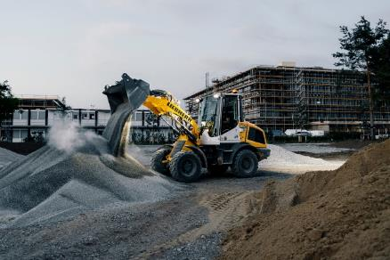

liebherr-earth-moving-2023.jpg  
The L 507 E is the first electric wheel loader in the Group. Due to its battery-electric drive, the L 507 E produces zero local CO2 emissions and the noise emissions are kept low.

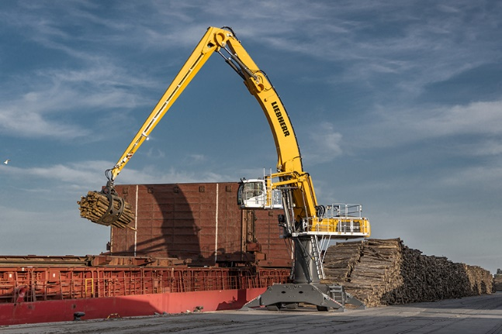

liebherr-material-handling-2023.jpg  
The Liebherr LH 110 M HR Port Litronic material handling machine was designed especially for handling bulk goods and general cargo in port operations. Two of these Liebherr machines are at work in Rostock’s cargo and fishing port in Germany, ensuring maximum handling capacity.

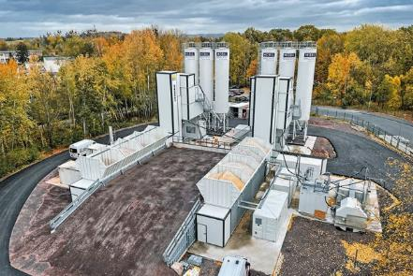liebherr-concrete-technology-2023.jpg  
The Liebherr double concrete mixing plant is versatile and can be moved easily from one construction site to the next.

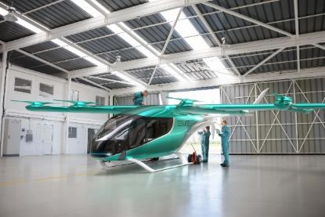

liebherr-aerospace-2023.jpg  
© Eve Air Mobility  
The new actuators developed and manufactured by Liebherr-Aerospace will be integrated into the eVTOL aircraft for actuation of its aileron, elevator and rudder surfaces. The robust, lightweight actuators come with a fully integrated control and power electronics module, which makes them more compact and easier to install than competing actuators.

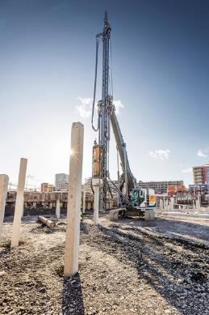

liebherr-piling-rig-2023.jpg

The LRH 100.1 unplugged is installing piles with the H 6 hammer in Karlstad.

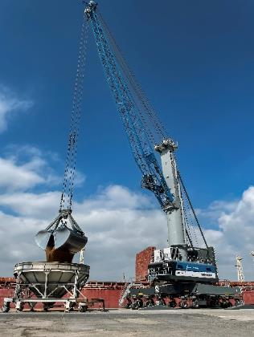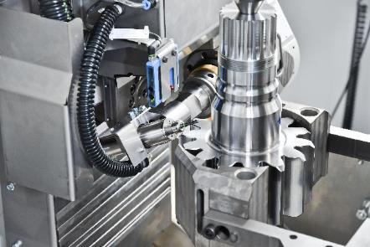liebherr-chamfercut-2023.jpg  
One of a kind: chamfering during the machining process with ChamferCut or FlexChamfer

liebherr-mobile-harbour-crane-2023.jpg  
The latest version of the Liebherr mobile harbour crane has successfully arrived on the market – here the LHM 550 in the port of Tarragona, Spain.

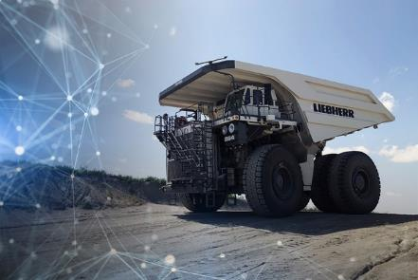

liebherr-mining-2023.jpg

The ‘Autonomous Haulage Solution’ project has reached an impressive milestone: in October, four T 264 dump trucks entered into operation for validation testing with a customer.

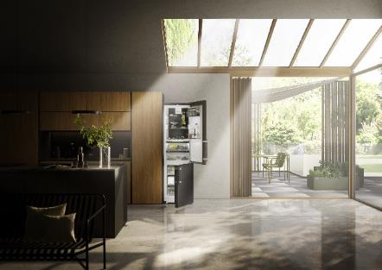liebherr-domestic-appliances-2023.jpg  
The Liebherr CBNbsa10 575i fridge-freezer with a height of 201 cm is ten percent more efficient than A-rated appliances, the highest energy efficiency class.

Contact

Larissa Lunitz  
Head of Public Relations  
Telephone: +41 56 296 4091   
Email: larissa.lunitz@liebherr.com

Published by

Liebherr-International AG  
Bulle / Switzerland  
[www.liebherr.com](http://www.liebherr.com)