Press release

Liebherr tower cranes renovate bridge in Spain

⸺

Seville's southernmost bridge is getting new stay cables and an extra traffic lane

Two Liebherr 420 EC-H 16 Litronic cranes are secured to the bridge's pylons

Good cooperation between Liebherr Tower Crane Solutions and Sancho Toro Sur

Lifts at a height of 110 metres

**A major bridge in Seville is being renovated with the help of two high-top cranes. Securing them to the bridge’s pylons proved a tricky task in terms of planning and assembly, as the struts had to be guided through the stay cables connecting the carriageway to the pylons.**

Seville (Spain), 4 April 2024 – Two Liebherr 420 EC-H 16 Litronic tower cranes are currently in Seville, Spain's fourth largest city, where they are helping to renovate the Puente Quinto Centenario road bridge. The bridge, a high traffic crossing point in Seville, currently spans the Gualdalquivir River with three lanes. An extra lane will be added as part of the renovation work so that traffic can spread across two lanes in both directions at peak times. Until now, the third lane has either been opened to traffic travelling towards Seville or in the opposite direction out of the city, depending on traffic volume.

A challenging task: ties between the bridge's cables

Opened in 1991, the bridge's carriageway is suspended by a total of 80 stay cables from two pylons erected on opposite banks. The two high-top cranes stand next to the bridge pylons and are attached to them at two points with struts. The welded box section struts (0.5 x 0.5 metres) secure the cranes and reach through the carriageway's stay cables to the bridge pylons. This scenario posed a number of challenges during planning and assembly. The struts for securing the cranes needed to stay clear of the cables at all times; something that had to be factored into the design process. Box section struts were chosen and these are attached to two tower sections with an external frame. During assembly, the lower ties of the two 420 EC-H 16 Litronic cranes had to be guided through the tensioned stay cables of the bridge structure. Liebherr’s Tower Crane Solutions (TCS) project department, which is responsible for planning and assisting with special projects, was on hand from the start to support Liebherr’s rental partner Sancho Toro Sur with site and assembly planning. A mobile crane was used to assemble the 420 EC-H 16 Litronics straight to their final height. The ties were installed first, and the slewing parts were then mounted on the cranes. As the assembly took place while the bridge remained open to traffic, the safety requirements were accordingly high.

Overhaul of the 33-year-old bridge

An inspection of the bridge revealed that the ageing cables securing the carriageway to the pylons needed to be replaced. The cranes are being used to lift metal pylon reinforcements weighing up to 7.5 tonnes at a height of 110 metres. Ten of these reinforcements will make the bridge, which dates back to 1991, ready for the carriageway's expansion. The Puente Quinto Centenario is being remodelled during the course of extensive renovation work.

Israel Requena, Managing Director at Sancho Toro Sur, S.L., is proud of the work on this iconic project, “The work is a challenge for us and we're happy to be involved in this important project. The two Liebherr 420 EC-H 16 Litronic cranes are ideal for this job with their maximum hook height of 87.10 metres, 16-tonne lifting capacity and radius of up to 75 metres. Their efficiency, agility and reliability make them the perfect choice for renovating the Puente Quinto Centenario.”

About Sancho Toro Sur

Seville-based Sancho Toro, which also has a branch in Tenerife, has 280 Liebherr tower cranes in its fleet. The company specialises in the rental and sale of used cranes and is a capable partner for crane assembly, dismantling, maintenance and repairs.

About the Liebherr Tower Cranes Division

More than seven decades of experience have made Liebherr a recognised specialist for lifting technology on all types of construction sites. The range of Liebherr Tower Cranes encompasses an extensive selection of high-quality tower cranes that are used worldwide. This includes fast-erecting, top-slewing, luffing jib and special-purpose cranes as well as mobile construction cranes. In addition to these products, Liebherr also offers a wide range of services that complete the company’s portfolio: Tower Crane Solutions, the Tower Crane Center and Tower Crane Customer Service.

About the Liebherr Group

The Liebherr Group is a family-run technology company with a highly diversified product portfolio. The company is one of the world's largest manufacturers of construction machinery. It also offers high-quality, user-oriented products and services in multiple other areas. Today, the group consists of more than 140 companies across all continents. In 2022, it employed more than 50,000 people and achieved combined revenues of over 12.5 billion euros. Liebherr was founded in 1949, in Kirchdorf an der Iller in southern Germany. Ever since then, the company’s employees have been committed to satisfying customers with advanced solutions and to helping drive technological progress.

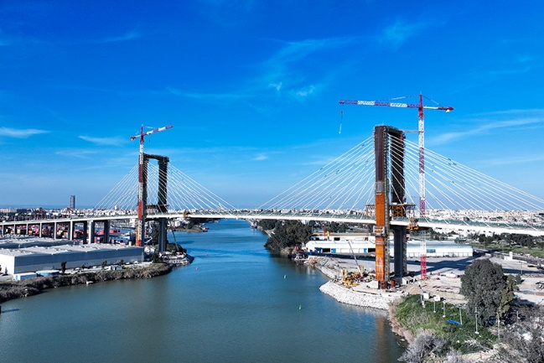Images

liebherr-420-ec-h-seville-01.jpg  
A total of 80 stay cables support the bridge's three lanes. The cables are being replaced as part of the construction work and the bridge will be extended by an extra lane.

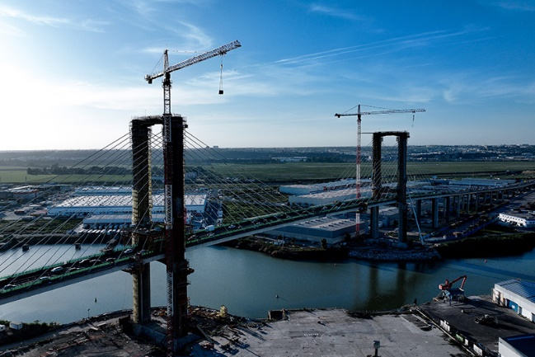

liebherr-420-ec-h-seville-02.jpg  
The two 420 EC-H Litronic cranes show what they are capable of, lifting 7.5 tonne metal reinforcements at a height of 110 metres.

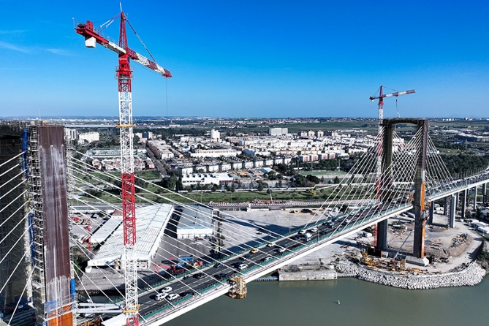

liebherr-420-ec-h-seville-03.jpg  
The cranes are each attached to a bridge pylon with two ties, with a yellow external frame spanning each tower section used. The lower ties had to be guided through the stay cables of the bridge structure so they would reach the pylons.

Contact

Astrid Kuzia  
Communication Specialist  
Phone: +49 7351 / 41– 4044  
Email: astrid.kuzia@liebherr.com

Published by

Liebherr-Werk Biberach GmbH  
Biberach / Germany  
www.liebherr.com