Press release

Working on water:

LTM 1300-6.2 from Sönke Jordt erects pier

⸺
An LTM 1300-6.2 erects a pier in Scharbeutz Haffkrug
Challenging operating conditions due to Baltic Sea storm surge
An LTM 1110-5.1 with VarioBase® assists with the set-up of the 300-tonne crane
Sönke Jordt Maschinen- und Schwertransport GmbH & CO. KG has been relying on Liebherr cranes for twelve years, which it uses for assembly and dismantling work, among other things. Its most recent crane job took place in Scharbeutz Haffkrug in northern Germany, where an LTM 1300-6.2 erected a pier on which visitors will be able to walk 230 metres across the Baltic Sea this summer.
Ehingen (Donau), (Germany), 8 April 2024 – Until recently, the Schleswig-Holstein municipality of Scharbeutz had two piers on which walkers and tourists could stroll across the water. They jutted out 165 and 260 meters from the shore onto the Baltic Sea and were a popular excursion destination. However, due to rising sea levels, the maritime structures now need to be demolished and replaced by new, higher sea bridges. For the new installation of the pier in Scharbeutz Haffkrug, an LTM 1300-6.2 from Sönke Jordt Maschinen- und Schwertransport GmbH & CO. KG was put to work.
Well-equipped for use on the water
Carrying 96 tonnes of ballast, the Liebherr mobile crane was placed in the water for around nine weeks on a specially constructed cofferdam, of which three weeks were spent working with a 70-metre-long luffing jib. The LTM 1300- 6.3 lifted pre-assembled steel construction elements and beams, each weighing four tonnes. “That wasn’t easy,” recalls project manager Patrick Kellotat from Jordt. “Due to the cramped conditions on the nine-metre-wide embankment, an LTM 1110-5.1 with VarioBase® helped to set up the 300-tonne machine.”
Storm surge presents a challenge for crane operations
“I was fascinated by this project, as there were many factors to consider in advance,” says Kellotat. Harsh weather conditions and a small storm surge during the operation were additional challenges alongside the cramped conditions on site. As the water from the Baltic Sea continued to rise towards the dam, it was even necessary to employ pumps to safeguard the construction site. “Our team reacted quickly and flexibly to every situation, enabling us to successfully overcome all challenges.”
The new pier in Haffkrug will be 230 metres long – and therefore 65 metres longer than the old one. The deployment of the LTM 1300-6.3 was completed at the end of the February. If the construction project proceeds as planned, visitors will be able to stroll across the new sea bridges from summer 2024, which will not only be modern and barrier-free, but will also be equipped with play areas for children, seating and recreation areas, sports facilities, event spaces and information terminals, and more besides.
Twelve years of trust
For twelve years, Sönke Jordt Maschinen- und Schwertransport GmbH & CO. KG has relied on cranes from Liebherr. Most recently, Jordt was the first company in Germany to add the LTM 1100-3.5 mobile crane with the LICCON3 control to its fleet. In addition to traditional crane hire and assembly and dismantling work in the industrial sector, Jordt also offers towing and transport services as well as its own workshop service.
About Liebherr-Werk Ehingen GmbH
Liebherr-Werk Ehingen GmbH is a leading manufacturer of mobile and crawler cranes. Its range of mobile cranes extends from 2-axle 35 tonne cranes to heavy duty cranes with a lifting capacity of 1200 tonnes and a 9-axle chassis. Its lattice boom cranes on mobile or crawler travel gear deliver lifting capacities of up to 3000 tonnes. With universal boom systems and extensive additional equipment, they can be seen in action on construction sites throughout the world. The Ehingen site has a workforce of 5,000. An extensive, global service network guarantees the high availability of Liebherr mobile and crawler cranes. In 2023, the Liebherr plant in Ehingen recorded a turnover of 2.81 billion euros.
About the Liebherr Group – 75 years of moving forward
The Liebherr Group is a family-run technology company with a highly diversified product programme. The company is one of the largest construction equipment manufacturers in the world. It also provides high-quality, user-oriented products and services in a wide range of other areas. The Liebherr Group includes over 150 companies across all continents. In 2023, it employed more than 50,000 staff and achieved combined revenues of over 14 billion euros. Liebherr was founded by Hans Liebherr in 1949 in the southern German town of Kirchdorf an der Iller. Since then, the employees have been pursuing the goal of achieving continuous technological innovation, and bringing industry-leading solutions to its customers. Under the slogan ‘75 years of moving forward’, the Group celebrates its 75th anniversary in 2024.
Images
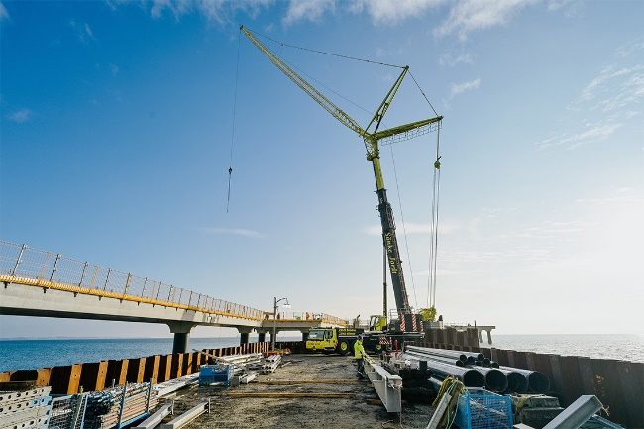
liebherr-ltm-1300-6-2-jordt-1.jpg
The LTM 1300-6.2 stands on a nine-metre-wide cofferdam and does its job.
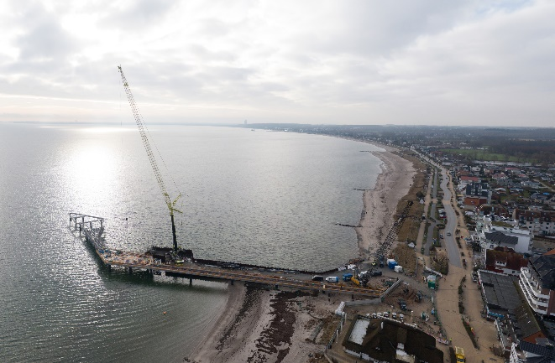
liebherr-ltm-1300-6-2-jordt-2.jpg
The new pier juts 230 metres into the Baltic Sea.
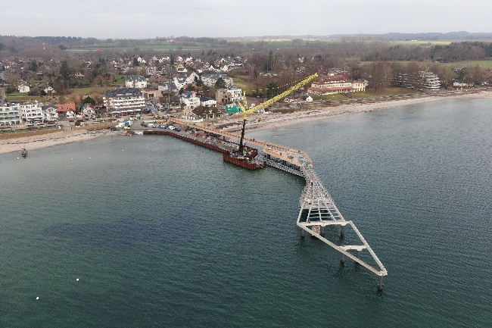
liebherr-ltm-1300-6-2-jordt-3.jpg
The LTM 1300-6.2 is equipped with a 70-metre-long luffing jib.
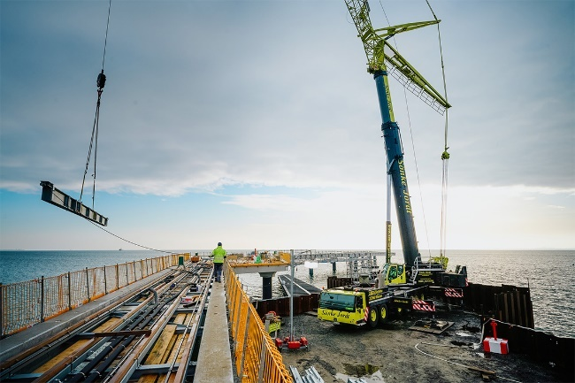
liebherr-ltm-1300-6-2-jordt-4.jpg
The LTM 1300-6.2 lifts a steel construction element on the nine-metre-wide cofferdam.
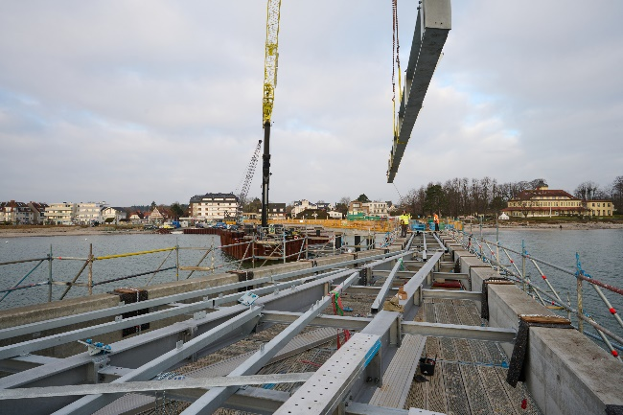
liebherr-ltm-1300-6-2-jordt-5.jpg
The heaviest loads during this project were steel construction elements weighing four tonnes each.

Contact
Berenike Nordmann
Marketing and Communication
Phone: +49 7391 / 502-0
Email: berenike.nordmann@liebherr.com
Published by
Liebherr-Werk Ehingen GmbH
Ehingen (Donau) / Germany
www.liebherr.com

