Press release

Liebherr-Components opens a new facility in China

⸺
Liebherr Components (Dalian) Co., Ltd. opens its production facility in Dalian (China)
On a total area of approximately 44,000 m², Liebherr manufactures gearboxes, slewing bearings and hydraulic cylinders
After breaking ground in 2021, Liebherr Components (Dalian) Co, Ltd. inaugurated its new production facility in Dalian (China) on March 19, 2024. On a gross surface area of around 44,000 m², Liebherr is not only consolidating the production of components in a new plant, but is also undertaking a major investment in the region.
Nussbaumen (Switzerland), April 17, 2024 – Following the groundbreaking ceremony held in 2021, Liebherr Components (Dalian) Co., Ltd. officially inaugurated its latest production facility in Dalian (China) on March 19, 2024. Spanning approximately 44,000 square metres, the new site does not only consolidate component production, but also makes a significant investment of €110 million in the region.
The opening ceremony was attended by prominent guests, such as family shareholders of the Liebherr Group, representatives of the local government, as well as of the German Consulate in Shenyang. In his opening speech, Fabian Wahl, Managing Director of Liebherr Components (Dalian) Co., Ltd., emphasised the company's long-term commitment to China: "For around 45 years, we have successfully supported our customers and partners in China. The Liebherr Group counts over 50,000 employees worldwide, including approximately 1,000 here, who strive every day towards solutions for the challenges that the market will present to our customers tomorrow."
The new facility currently employs around 210 people and has three state-of-the-art production lines that are geared towards highest quality standards. The product segment has been manufacturing gearboxes for the wind industry, earthmoving machinery, or other branches of industry locally since October 2023. The portfolio also includes slewing bearings, which are also primarily used in the wind industry and have been in series production since March 2024. The site also produces hydraulic cylinders specifically for construction machinery.
"I am very pleased about the opportunity to be even closer to our customers here in the country and to foster our partnerships even more intensively," says Fabian Wahl. "With our state-of-the-art and future-proof components facility, we look forward to many more successful years alongside our Chinese and international customers."

About the Liebherr-Components AG
In this segment, the Liebherr Group specialises in the development, design, manufacturing of high-performance components in the fields of mechanical, hydraulic and electric drive and control technology. Liebherr-Component Technologies AG, based in Bulle (Switzerland), coordinates all activities in the component product segment.
The extensive product range includes combustion engines, injection systems, engine control units, axial piston pumps and motors, hydraulic cylinders, slewing bearings, gearboxes and winches, switchgear, electronic and power electronics components, as well as software. The high-quality components are used in cranes and earthmoving machinery, in the mining industry, maritime applications, wind turbines, automotive engineering or in aviation and transport technology. Synergy effects with other product segments of the Liebherr Group are used to drive continuous technological development.
About the Liebherr Group – 75 years of moving forward
The Liebherr Group is a family-run technology company with a highly diversified product programme. The company is one of the largest construction equipment manufacturers in the world. It also provides high-quality, user-oriented products and services in a wide range of other areas. The Liebherr Group includes over 150 companies across all continents. In 2023, it employed more than 50,000 staff and achieved combined revenues of over 14 billion euros. Liebherr was founded by Hans Liebherr in 1949 in the southern German town of Kirchdorf an der Iller. Since then, the employees have been pursuing the goal of achieving continuous technological innovation, and bringing industry-leading solutions to its customers. Under the slogan ‘75 years of moving forward’, the Group celebrates its 75th anniversary in 2024.
Image
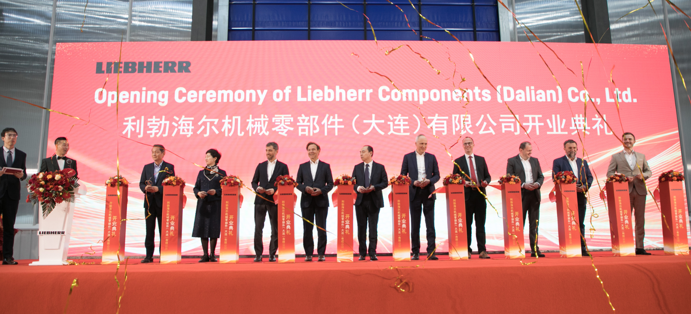
liebherr-opening-ceremony-dalian.jpg
The inauguration ceremony for the new components facility in Dalian (China) took place on March 19, 2024.

Contact
Alexandra Nolde
Senior Communication & Media Specialist
Phone: +41 56 296 4326
E-mail: alexandra.nolde@liebherr.com
Published by

Liebherr-Components AG

Nussbaumen / Switzerland
www.liebherr.com/components

