Press release

Made to build cities: Liebherr’s new hydraulic luffing jib crane is now available

⸺

NC-LH 12-55 now available to order

Developed for use in densely built-up cities

Reduced out-of-service position minimises space requirements

Liebherr is expanding its product range with its new hydraulic luffing jib crane, the NC-LH 12-55. The top-slewing crane excels in large cities and is optimised for countries outside Europe. With a minimal working radius of just three metres and an out-of-work position of ten metres, the crane can be optimally adapted to inner-city construction site conditions.

Biberach (Germany), 22 April 2024 – The hydraulic luffing jib crane combines the familiar performance of Liebherr luffing jibs with powerful hydraulics in a crane package that is specifically geared to market requirements outside Europe. The result is a top-slewing crane, for large cities in countries as diverse as Australia, Thailand, and the United Arab Emirates, that can be positioned centrally on site. Together with its high lifting capacity of up to twelve tonnes and the ability to lift 2,450 kilograms at its jib head, this complete package makes the NC-LH 12-55 a unique machine. “We provide a setup that’s strong in all aspects, from transport and assembly through to operation, and can offer our customers an outstanding overall concept for their sites,” says Markus Kinateder, Product Manager at Liebherr-Werk Biberach GmbH.

Developed for use in densely built-up inner-city areas

The NC-LH 12-55 can be optimally adapted to everyday conditions on site and requires very little space. This adaptability is achieved through being able to install the crane in lift shafts, its reduced out-of-service position and minimal swing radius, and the fact that the cabin is mountable on either side.

A lift shaft installation with subsequent internal climbing is no problem at all using the 16 EC 240 tower system. So the crane can be centrally positioned on site where it can lift up to 2,450 kilograms at its jib head at maximum radius. Its minimal working radius of just three metres also helps to ensure that all areas on site can be covered from a central point. In practical terms, this means that a smaller crane can be used on site rather than a larger machine that would need to be set up next to the building. Another option alongside the slim 16 EC 240 is the widely used 21 HC 290 tower system, which enables high hook heights and installation of the EasyUp 200 crane driver elevator. Both tower systems come prepared for climbing inside and outside buildings. Combining both systems together with a transition tower section makes it possible to achieve cost-efficient, high tower heights.

Another advantage is that cranes can be positioned closer together when several need to be used on site. This allows more cranes to fit into the available space as and when required. A reduced out-of-service position of ten metres for jibs 45 metres or longer makes it all possible. The jib can be extended in five metre increments. At maximum tower height, the out-of-service position measures up to 14.6 metres. Thought has also been given to tight spaces in terms of the crane’s swing radius: the counter-jib has a swing radius of just 7.9 metres and its ballast blocks are stackable.

The cabin can be mounted on either the left or right-hand side to meet individual site requirements and building proximity needs. It’s possible to position the crane closer to the building this way, which gives the crane operator a better view of the load and surrounding environment.

**Designed with transport in mind**

Transporting the crane into the city and through inner-city environments is designed to be as convenient and simple as possible. Four trucks or containers are enough to transport the NC-LH to its next job location. With the jib width being just 1.15 metres, three sections fit onto a standard truck or in one container. And length isn’t a problem either: the jib end section can be slid into the counter-jib, and all platforms and rails can stay attached to the counter-jib indefinitely. The hoist unit is also ready installed on the jib, meaning it stays in place during transport and is also protected. This all saves assembly time. The slewing platform and central unit can either be lifted onto the truck pre-assembled or part by part ready for individual assembly steps. The choice depends on which mobile crane is available for the later assembly of the components, which can weigh up to eight tonnes. A smaller mobile crane can be used for lifting component assemblies, while a more powerful mobile crane is capable of handling the pre-assembled jib and counter-jib unit in a single lift to save time. The crane’s jib can be completely pre-assembled on the ground. Even the hoist rope and hook block can be reeved ready for use so that working at great height isn’t required. This saves a lot of time and is also much safer than assembly up high.

Designed for efficient working

Liebherr’s luffing jib cranes are ideal partners for sites involving heavy components and high hook heights. Hydraulic luffing jibs score extra points with their powerful hydraulic unit and cylinder combination, and precision load positioning. The luffing system enables fast and precise luffing in under 90 seconds. Plus, the jib can be adjusted safely and at controlled speed with a load on its hook. Load-Plus is now available for luffing jibs thanks to the launch of the new crane. A load increase of up to 26 per cent can be achieved at the touch of a button for particularly heavy one-off lifts.

The NC-LH 12-55 also comes equipped with the new Tower Crane OS operating system. An easy-to-view menu bar ensures quick navigation and the user interface can be customised to suit different users.

About the Liebherr Tower Cranes Division

More than seven decades of experience have made Liebherr a recognised specialist for lifting technology on all types of construction sites. The range of Liebherr Tower Cranes encompasses an extensive selection of high-quality tower cranes that are used worldwide. This includes fast-erecting, top-slewing, luffing jib and special-purpose cranes as well as mobile construction cranes. In addition to these products, Liebherr also offers a wide range of services that complete the company’s portfolio: Tower Crane Solutions, the Tower Crane Center and Tower Crane Customer Service.

About the Liebherr Group – 75 years of moving forward

The Liebherr Group is a family-run technology company with a highly diversified product programme. The company is one of the largest construction equipment manufacturers in the world. It also provides high-quality, user-oriented products and services in a wide range of other areas. The Liebherr Group includes over 150 companies across all continents. In 2023, it employed more than 50,000 staff and achieved combined revenues of over 14 billion euros. Liebherr was founded by Hans Liebherr in 1949 in the southern German town of Kirchdorf an der Iller. Since then, the employees have been pursuing the goal of achieving continuous technological innovation, and bringing industry-leading solutions to its customers. Under the slogan ‘75 years of moving forward’, the Group celebrates its 75th anniversary in 2024.

Images

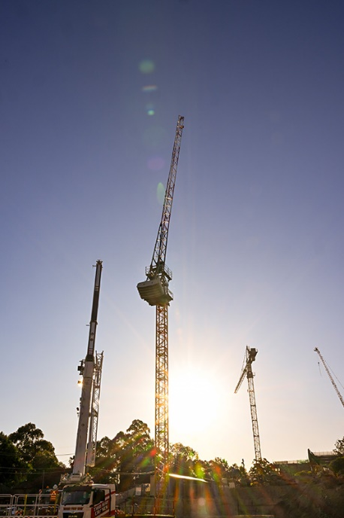

liebherr-nc-lh-12-55-01.jpg  
Made for large cities: Liebherr’s new hydraulic luffing jib crane, the NC-LH 12-55.

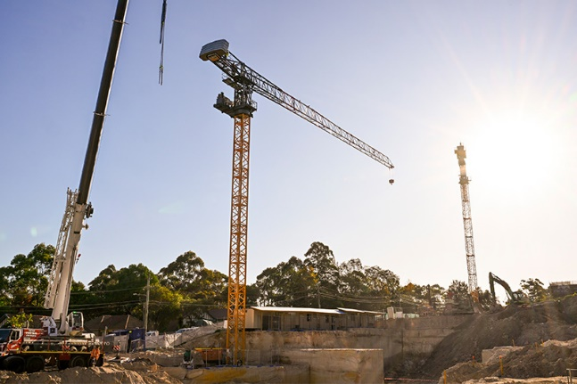

liebherr-nc-lh-12-55-02.jpg  
Optimised for assembly: the hydraulic luffing jib crane is quick and easy to erect.

Contact

Astrid Kuzia  
Communication Specialist  
Phone: +49 7351 / 41– 4044  
Email: astrid.kuzia@liebherr.com

Published by

Liebherr-Werk Biberach GmbH  
Biberach / Germany  
www.liebherr.com