Press release

Intermat 2024: Liebherr provides low-emission solutions with innovative drive technologies

⸺

Technology-neutral approach: ecological and economical solutions for customers

Electrified products for use in cities and indoor areas

Same utilisation properties and same performance with hybrid concepts

Hydrogen engine: low emissions for machines with high power density

Mixture of drives makes significant contribution to climate-neutral construction site of the future and to climate protection

In addition to the around 20 exhibits, Liebherr also presents three theme pavilions at the Intermat booth in trade show area Ext 6 C 051. In the ‘Drive technologies’ pavilion, the Group showcases its technology-neutral approach — an approach Liebherr is adopting as it looks to the future. This includes, in particular, work in the development areas of electric, hydrogen-based drives and alternative fuels. In this way, Liebherr offers its customers and partners from a wide variety of industries the best possible support in achieving their ecological and economic objectives — with the optimal drive solution for every machine and every application.

Paris (France), 24 April 2024 – As one of the world’s largest manufacturers of construction machinery, Liebherr is aware of its responsibility towards the environment. At the trade show, the Group showcases itself under the motto ‘On your site’, thus highlighting that Liebherr always stands by its customers and partners, wherever they are, wherever they go. The work on a large number of different drive technologies is one part of the Group’s range of services that provides its customers with comprehensive solutions. Owing to the large range of products used in diverse industries and in different ways, a restriction to one or only a few drive technologies is not possible. Each drive technology has its own strengths and weaknesses, influenced by the region of use with its usable conditions, and thus requires a specific infrastructure. The more precisely drive technology, application and region of use are coordinated, the greater the contribution to both the added value of the customers and the contribution to climate neutrality. The Group’s technology-neutral approach enables it to combine the highest possible efficiency and emission reduction.

At Intermat, Liebherr presents a wide range of electrically operated machines as well as hybrid solutions. In addition, with the 9-litre 4-cylinder hydrogen combustion engine H964, the Group provides insights into its work in the area of hydrogen-based drives and shows alternative fuels in conjunction with conventional combustion engines. Liebherr is concerned with a range of other energy conversion technologies and the suitable energy carriers that are available today and in the foreseeable future. The energy conversion technologies include a full range of highly efficient engines and drives, some of which are developed and produced by Liebherr itself. With its in-house development of differentiated drives, Liebherr shows its pioneering spirit and is driving technological progress in the construction machine industry.

Future construction sites will be electrified to a higher degree. The reduction of local CO2 and noise emissions are decisive advantages of electrified products for people and the environment. Particularly powerful batteries are required to ensure the energy supply for mobile machines on construction sites with limited or no mains supply. The hydrogen combustion engine impresses in terms of performance and emissions where there is minimum charging infrastructure for electric drives of machines or if battery capacities are still not sufficient. Green hydrogen is a virtually greenhouse gas-neutral energy source that ist almost CO2 neutral during combustion.

**Electrically operated exhibits and hybrid concepts**

Electrification is a great solution for a wide range of applications, particularly for work in cities or indoor areas. Mains-powered machines have long been familiar and used at Liebherr. Today, it is also possible to transport concrete quietly and electrically to construction sites, for example with the Liebherr truck mixer ETM 1205 with electric drum drive, which is showcased at Intermat with an electric chassis. Liebherr is working on powerful, battery-operated machines as for example the Liebherr L 507 E wheel loader that is already available. They can be operated in a climate-neutral way if the power used is derived from renewable energy sources. On job sites located in remote places and with insufficient infrastructure with electronic supply, hybrid or fully electric construction machines and cranes can be operated or charged with zero local emissions using the Liduro Power Port mobile energy storage system. At Intermat, with the mobile construction crane MK 140-5.1, the fast-erecting crane 125 K and the compact crane LTC 1050-3.1E, Liebherr presents three electric cranes that can be used in combination with the Liduro Power Port.

Another area of development is the combination of battery and mains connection, for example in earthmoving and material handling machines and in mobile and crawler cranes. For example, the crane functions of the uppercarriage on Liebherr’s LTC 1050-3.1 compact crane with additional electric drive can be fed by either a combustion engine or an electric motor. The undercarriage is driven by a combustion engine, which can be filled with hydrotreated vegetable oil (HVO). With the overall concept, the crane can be moved on site with zero emissions and can be transported from one construction site to another with virtually no emissions. This means that the hybrid version offers the same utilisation properties and the same performance as a classic combustion engine. The ecological and future-proof hybrid power concept enables all mobile construction cranes to be operated fully electrically using either site power or another external power source. The crane thus works particularly quietly, which is especially beneficial on construction sites operating at night in cities. Both the superstructure and undercarriage of the mobile construction cranes can be operated with HVO, making them independent of conventional fuels.

H964 hydrogen engine: potential for the future

With its technology-neutral approach, Liebherr also forms a basis for driving the development of greenhouse gas-neutral energy source. The Group continues its research and development activities in the hydrogen area and is working on achieving the same performance data for machines with high to very high energy requirements. Liebherr is setting a milestone in drive systems with green hydrogen with the first prototypes of the hydrogen engines.

The extremely compact 9-litre 4-cylinder hydrogen engine H964 is an ideal solution for off-road applications and has impressed with regard to the high power density and low emissions. In the 4-cylinder engine with direct injection, the hydrogen is injected directly into the combustion chamber. The direct injection offers higher potential concerning combustion efficiency and performance. This makes hydrogen engines an attractive alternative to diesel engines when it comes to more demanding applications. In addition, the H964 impresses with its dynamics and high robustness against dust, dirt and vibrations. Apart from the interfaces comparable with a diesel engine (thermal and mechanical), the clear advantages of the hydrogen engine are the minimum outlay for air and hydrogen purity, and less effort overall for the long maintenance intervals. It is already exhibiting virtually ‘zero’ CO2 emissions in the development phase and the NOx emissions are well below the current limit values. Liebherr presents its hydrogen combustion engine H964 and gives visitors to Intermat the opportunity to take a closer look at the engine.

**Reducing emissions with alternative fuels**

With the mixture of drives to save emissions, sustainable, synthetic fuels are playing an increasingly important role at Liebherr. E-fuels and hydrotreated vegetable oil (HVO) are other alternatives to fossil diesel. E-fuels are manufactured synthetically from renewable electricity, water and CO2, and are therefore an emission-free alternative. HVO is made of hydrotreated vegetable oils and waste animal fats. In comparison to conventional diesel, they reduce CO2 emissions by up to 90 %. Liebherr customers can therefore lower their emissions without having to invest heavily in new products and, at the same time, achieve their ecological and economic objectives.

Climate-friendly solutions, which customers can already use today in conjunction with existing drives, play an important role for Liebherr. This is because synthetic fuels such as HVO can drive conventional combustion engines as an admixture or pure fuel. Alternative fuels such as HVO also enable older Liebherr machines with combustion engines to be operated in a largely climate-neutral manner – and without retrofitting measures. Due to the high product quality and the associated long life of the Liebherr machines, this results in a significant reduction of CO2 emissions during the utilisation phase.

Liebherr engines are already ready for use with HVO and can be operated with alternative fuels. Liebherr-Werk Ehingen GmbH and Liebherr-Hydraulikbagger GmbH deliver all machines with HVO as standard ex works. A complete changeover to HVO was also introduced for factory traffic. The Liebherr Werk Biberach GmbH also delivers its mobile construction cranes fuelled with HVO. The saving of fossil diesel and greenhouse gas enables Liebherr to make an important contribution to climate protection.

About the Liebherr Group – 75 years of moving forward

The Liebherr Group is a family-run technology company with a highly diversified product programme. The company is one of the largest construction equipment manufacturers in the world. It also provides high-quality, user-oriented products and services in a wide range of other areas. The Liebherr Group includes over 150 companies across all continents. In 2023, it employed more than 50,000 staff and achieved combined revenues of over 14 billion euros. Liebherr was founded by Hans Liebherr in 1949 in the southern German town of Kirchdorf an der Iller. Since then, the employees have been pursuing the goal of achieving continuous technological innovation, and bringing industry-leading solutions to its customers. Under the slogan ‘75 years of moving forward’, the Group celebrates its 75th anniversary in 2024.

Images

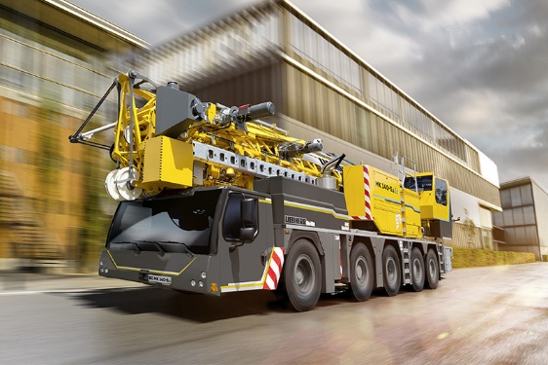

liebherr-mk-140-5.1-01.jpg  
With the hybrid power concept of the MK 140-5.1 mobile crane, all-electric crane operation is possible with construction site power or another external power source.

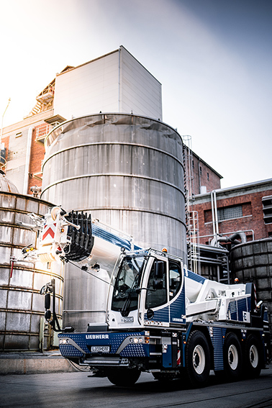

liebherr-ltc-1050-3.1e.jpg  
The crane movements of the LTC 1050-3.1E compact crane are driven by an electric motor. The undercarriage is equipped with a combustion engine, which can be filled with hydrotreated vegetable oils (HVO).

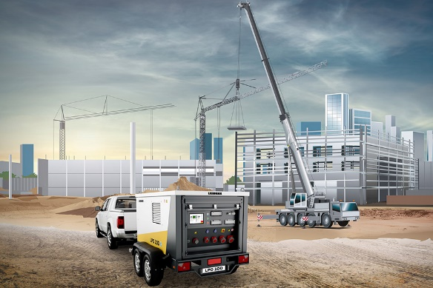

liebherr-lpo-construction-site.jpg  
At remote locations where there is no electronic supply due to the infrastructure, the machines and cranes can be operated or charged with the mobile energy storage system Liduro Power Port.

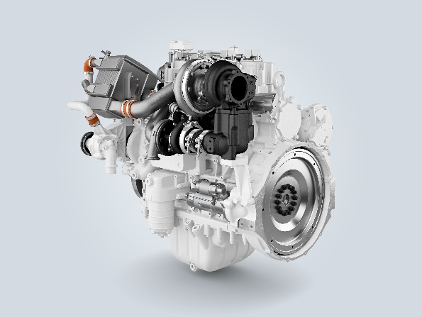

liebherr-combustion-engine-H964-DI.jpg  
The H964 hydrogen combustion engine with direct injection scores points for its high power density and low emissions as well as its dynamics and high robustness

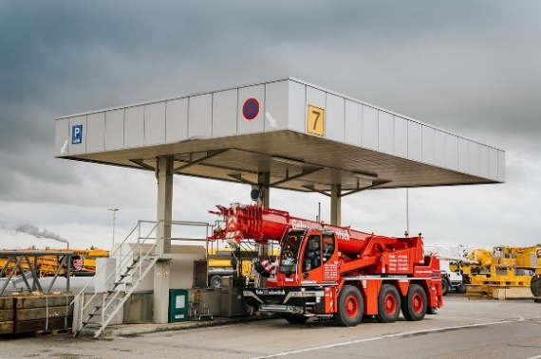

liebherr-hvo-filling-station.jpg  
Liebherr plants in Ehingen and Kirchdorf have completely converted to HVO for all factory transport.

Contact

Larissa Lunitz  
Head of Public Relations

Phone: + 41 79 645 70 67

Email: larissa.lunitz@liebherr.com

Published by

Liebherr-International AG

General-Guisan-Strasse 6

5415 Nussbaumen, Switzerland

www.liebherr.com