Press release

Liebherr’s R 924 G8 crawler excavator presented at the Intermat show

⸺

Liebherr generation 8: ergonomics, comfort and performance

Precision and efficiency with Leica Geosystems semi-automatic machine control system

New options: Skyview 360° and urea filling pump

Liebherr will be presenting the R 924 G8 crawler excavator at the Intermat show in Paris from 24 to 27 April 2024. Powerful and versatile, the 24 tonne machine effectively combines high productivity, flexible operation and precision. The R 924 G8 presented at Intermat is equipped with a Leica Geosystems semi-automatic machine control system factory-fitted in Colmar (France), along with the following new options: a Skyview 360° camera and a urea filling pump

Colmar (France), 24 April 2024 − The R 924 crawler excavator is part of the generation 8 range of 22 to 45 tonne crawler excavators developed at Liebherr-France SAS in Colmar (France). Launched in 2019, these excavators are distinguished by their modern design, enhanced performance, versatility and low fuel consumption.

Liebherr G8 crawler excavators are the result of intensive research and improvement work together with over 60 years’ experience in the development and manufacturing of crawler excavators. This generation features modern design and modular architecture. It has been revamped to offer the best possible ergonomics and performance, as well as improved safety.

**The Leica Geosystems machine control system**

The R 924 will be equipped with a semi-automatic machine control system. This machine control assistance system is the key to precise and efficient work. The strategic partnership between Liebherr and Leica Geosystems allows both companies’ expertise to be made available to customers, thus providing more advanced and reliable solutions.

Thanks to the generation 8 crawler excavator’s electro-hydraulic controls, there is no need for any additional hydraulic components, as communication takes place via CANbus. Factory installation offers the advantage of ensuring that all components are optimally integrated. Pre-calibration of the control system is also performed at the factory. This greatly simplifies commissioning at the client’s location. This new integrated assistance system allows productivity on construction sites to be considerably increased.

**New options: Skyview 360° and urea filling pump**

The R 924 G8 crawler excavator is equipped with Skyview 360°, an option that will be available to order in autumn 2024. This system allows the operator to monitor the whole working area around the machine on a single screen, providing a bird's eye view with no blind spots. At a single glance, the operator can see through 360° and rapidly identify danger areas, thus improving the machine’s safety and productivity.

The R 924 G8 presented at Intermat will also be equipped for the first time with a urea filling pump, which will receive its world premiere at the same show. This pump considerably reduces the need to access the uppercarriage, by enabling filling up with urea at ground level, which is quicker and safer for the operator. In addition to reducing the risk of falling, this device features an anti-overflow system to avoid soiling and pollution.

The R 924 G8 presented at Intermat is equipped with a 5.70 m gooseneck boom and a 2.90 m stick, and features an LC undercarriage and 2,390 mm track with 3 chain guides. The machine also comes with the SOLIDLINK quick coupling system, which allows tools to be changed easily and quickly. The machine also has a 1.00 m3 ditch-cleaning-bucket fitted.

About Liebherr-France SAS

Liebherr-France SAS, based in Colmar, has been responsible for development and production of Liebherr Group crawler excavators since 1961. Its current product range includes around 30 crawler excavator models, from the R 914 Compact to the R 998 SME, designed for earthmoving and stone quarrying. The product range also includes a whole series of special working attachments designed for specific tasks such as demolition works, materials transport and maritime or tunnel applications, as well as large-capacity electric excavators. With their operating weight of 14 to 100 tonnes, the crawler excavators are equipped with Liebherr engines with power ratings from 90 to 420 kW. Liebherr-France SAS employs over 1,260 staff and generates annual sales of 692 million euros.

**About the Liebherr Group – 75 years of moving forward**

The Liebherr Group is a family-run technology company with a highly diversified product programme. The company is one of the largest construction equipment manufacturers in the world. It also provides high-quality, user-oriented products and services in a wide range of other areas. The Liebherr Group includes over 150 companies across all continents. In 2023, it employed more than 50,000 staff and achieved combined revenues of over 14 billion euros. Liebherr was founded by Hans Liebherr in 1949 in the southern German town of Kirchdorf an der Iller. Since then, the employees have been pursuing the goal of achieving continuous technological innovation, and bringing industry-leading solutions to its customers. Under the slogan ‘75 years of moving forward’, the Group celebrates its 75th anniversary in 2024.

Photo

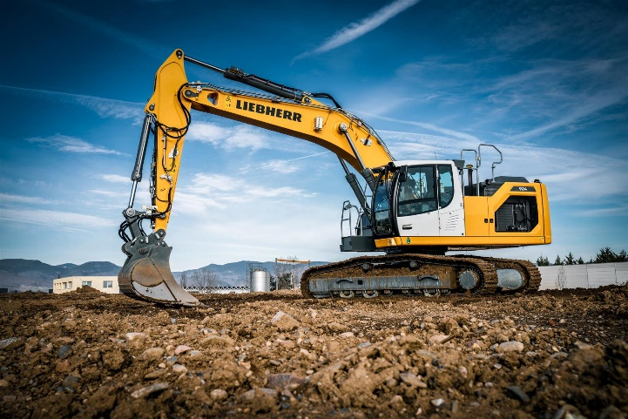

R-924-Leica-Intermat.jpg  
The R 924 G8 crawler excavator is distinguished by its high productivity, versatility and optimal operator comfort.

Contact

Alban Villaumé  
Marketing and Communication  
Telephone: +33 3 89 21 36 09  
Email: alban.villaume@liebherr.com

Published by

Liebherr-France SAS  
Colmar, France  
[www.liebherr.com](http://www.liebherr.com)