Press release

It's a matter of control:
Another Liebherr mobile crane with new LICCON3 control system
⸺
LTM 1300-6.4: 300-tonne crane converted to LICCON3
Liebherr is successively converting existing crane types to the new control system and new design
Performance parameters and load capacities remain unchanged
Liebherr is preparing to unveil another crane model equipped with the new LICCON3 control system: the LTM 1300-6.3 is becoming the LTM 1300-6.4. Three models in the LTM series are now characterised by the company's new trend-setting crane design. Liebherr will present the LTM 1300-6.4 at Intermat in Paris.
Ehingen (Donau) (Germany), 23 April 2024 – The family of Liebherr mobile cranes boasting the company's latest crane design and next-generation LICCON3 control system is growing. Not only will all completely new crane types receive the new control system, but Liebherr will also successively upgrade its existing crane types with the new technology. To signify the changes, the last digit of the type designation is incremented by one: the LTM 1300-6.3 is now the LTM 1300-6.4. The performance parameters and lifting capacities of the cranes remain unchanged.
LICCON3 crane control system
The third generation of the LICCON control system (Liebherr Computed Control) is based on proven operation, but with completely new software and programming language as well as a faster data bus, significantly more memory and higher computing power. Crane operators who are familiar with the previous control system will quickly and easily get to grips with the new version, as the recognition value is very high.
Proven hardware components, such as the mobile operating and display unit BTT, have been adopted. The touchscreen function on the large new display in the superstructure cab means that it is now even easier and more comfortable to control. The way in which the information is shown has also been revised and simplified. In addition, LICCON3 cranes are prepared for telemetry and fleet management as standard. In the future, crane contractors will be able to view and evaluate all the relevant data using the MyLiebherr customer portal.

New driver's cabin and crane cab
As a result of the high synergy effects involved, Liebherr is launching the new driver's cabin at the same time as the LICCON3 control system. The modern design features premium materials and timeless lines as well as delivering a whole host of improvements for the crane driver. These include the new multifunction steering wheel, side roller blind on the driver’s door, improved instruments and modules as well as new displays. Additional convenience is offered by options such as a central locking system with remote key and the "Coming and Leaving Home" function.
A completely new, modern automatic heating and air-conditioning system in both the driver's cab and the crane operator's cab ensures a high level of comfort. A sun sensor detects strong sunshine and automatically adjusts the heating settings. The lighting packages for the crane cab, the superstructure, the rear of the vehicle, the front headlights and the telescopic boom as well as the lattice fly jib have been optimised and can be operated with LEDs. The benefits of LED technology include a longer service life and superior lighting performance.
LTM 1300-6.4 – Reaching new heights
In 2022, Liebherr expanded its range of all-terrain cranes with another 300-tonne machine, the LTM 1300-6.3. With its 90-metre telescopic boom, it set new standards in the 6-axle class and still far surpasses the current cranes on the market today – hence its slogan "Reaching new heights". It is designed to be used as a fast-erecting crane with a high capacity at great hoist heights and steep boom angle. This makes it ideal for erecting tower cranes and antennae as well as for wind turbine maintenance work.

About Liebherr-Werk Ehingen GmbH
Liebherr-Werk Ehingen GmbH is a leading manufacturer of mobile and crawler cranes. Its range of mobile cranes extends from 2-axle 35 tonne cranes to heavy duty cranes with a lifting capacity of 1200 tonnes and a 9-axle chassis. Its lattice boom cranes on mobile or crawler travel gear deliver lifting capacities of up to 3000 tonnes. With universal boom systems and extensive additional equipment, they can be seen in action on construction sites throughout the world. The Ehingen site has a workforce of 4,300. An extensive, global service network guarantees the high availability of Liebherr mobile and crawler cranes. In 2022, the Liebherr plant in Ehingen recorded a turnover of 2.37 billion euros.
About the Liebherr Group – 75 years of moving forward
The Liebherr Group is a family-run technology company with a highly diversified product programme. The company is one of the largest construction equipment manufacturers in the world. It also provides high-quality, user-oriented products and services in a wide range of other areas. The Liebherr Group includes over 150 companies across all continents. In 2023, it employed more than 50,000 staff and achieved combined revenues of over 14 billion euros. Liebherr was founded by Hans Liebherr in 1949 in the southern German town of Kirchdorf an der Iller. Since then, the employees have been pursuing the goal of achieving continuous technological innovation, and bringing industry-leading solutions to its customers. Under the slogan ‘75 years of moving forward’, the Group celebrates its 75th anniversary in 2024.

Image
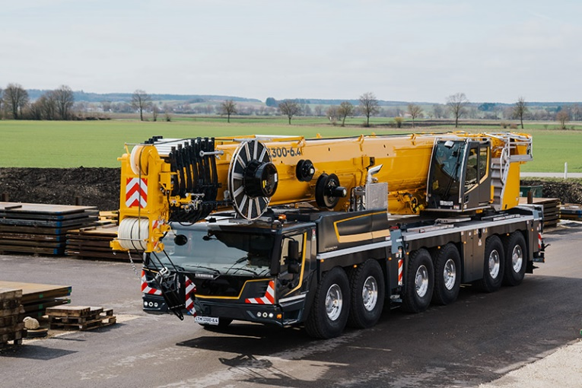

liebherr-ltm1300-6.4.jpg
The LTM 1300-6.4 is a further crane in the Liebherr all-terrain crane portfolio that feature the company’s new LICCON3 control system and latest crane design.

Contact
Wolfgang Beringer
Marketing and Communication
Phone: +49 7391/502 - 3663
Email: wolfgang.beringer@liebherr.com
Published by
Liebherr-Werk Ehingen GmbH
Ehingen (Donau) / Germany
www.liebherr.com

