Press release

On an icy mission: HS 8200

⸺

Around 250 kilometres north of the Arctic Circle, Liebherr is part of the largest construction project in Greenland's history. Munk Civil Engineering is carrying out dredging work for two airport projects with the HS 8200 duty cycle crawler crane. The Arctic conditions and logistics pose a particular challenge.

Nenzing (Austria), 9 April 2024 - Two airport projects are being realised in the coastal towns of Ilulissat and Nuuk in the western part of Greenland. To date, only propeller-driven aeroplanes could land here. The new airports will make it possible for larger aircraft to fly directly from the European or American mainland.

The new runway in Ilulissat is partly in the sea. A thick layer of clay sediment has to be removed from the seabed before it can be backfilled. Otherwise, settlement may occur over time. The Danish company Munck Civil Engineering, the main contractor for the two projects, is using the HS 8200 duty cycle crawler crane from Liebherr for this dredging work. "In one day shift, our extraction rate can be up to 1,000 m³ of excavated clay material," explains construction manager Kevin van den Bos.

The 200-tonne duty cycle crawler crane is operating with a 35-metre long boom and a clamshell grab with a capacity of 3.5 m3. To achieve high productivity, the HS 8200 is equipped with Liebherr's Dredging Assistant, which shows the operator the position and fill level of the grab, the number and duration of work cycles or the handling performance in real time. The system also makes it easier to calculate the amount of material needed to fill the area for the runway.

Munck Civil Engineering finds all the rock material used for this within the project boundaries. "In total, we have to drill and blast around 5.5 million cubic metres of rock material. We then transport this to the construction section so that we can subsequently build a 2-kilometre long runway." After dredging, the duty cycle crawler crane is equipped with a stone grab to place stones along the new runway as part of the coastal protection programme.

Arctic conditions

The average temperature in this region in summer is plus 8 degrees Celsius. In winter, it can drop to minus 35 degrees. "It is very important for us to complete the dredging work before the ice spreads in the bay and makes our work impossible." The duty cycle crawler crane was supplied with the Liebherr cold package to ensure that it is also operational in these very cold climatic conditions.

In addition to the icy conditions, the logistics are a major challenge. The region is only supplied by a ship once a week and also brings parts and equipment for Munck Civil Engineering. A large store and the ability to repair everything itself is therefore particularly important for the company in this remote region.

Munck Civil Engineering operates the HS 8200 six days a week in ten-hour shifts. Kevin van den Bos is delighted with the good performance of the duty cycle crawler crane, "The machine runs really well and has exceeded our expectations. We will finish even earlier than anticipated. That is really positive."  
  
Film: [HS 8200 on an icy mission | Liebherr (youtube.com)](https://www.youtube.com/watch?v=hi86j1yRXAs)   
Dredging Assistant: [Liebherr - Dredging Assistant - YouTube](https://www.youtube.com/watch?v=BMFz-26r4Nk)

About the Liebherr Group – 75 years of moving forward

The Liebherr Group is a family-run technology company with a highly diversified product programme. The company is one of the largest construction equipment manufacturers in the world. It also provides high-quality, user-oriented products and services in a wide range of other areas. The Liebherr Group includes over 150 companies across all continents. In 2023, it employed more than 50,000 staff and achieved combined revenues of over 14 billion euros. Liebherr was founded by Hans Liebherr in 1949 in the southern German town of Kirchdorf an der Iller. Since then, the employees have been pursuing the goal of achieving continuous technological innovation, and bringing industry-leading solutions to its customers. Under the slogan ‘75 years of moving forward’, the Group celebrates its 75th anniversary in 2024.

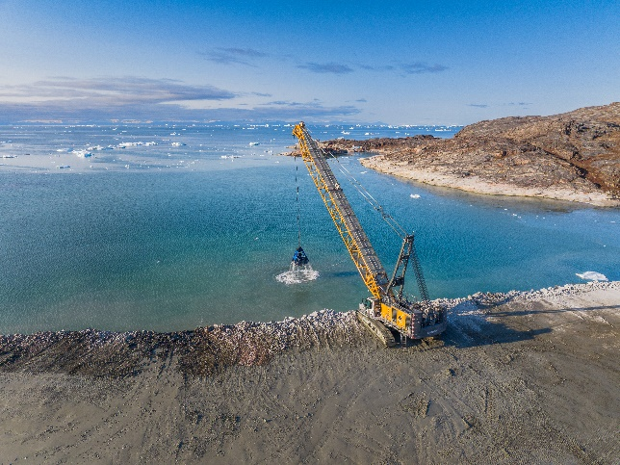Images

liebherr-hs 8200_1.jpg   
The HS 8200 defies even arctic climatic conditions beyond the Arctic Circle.

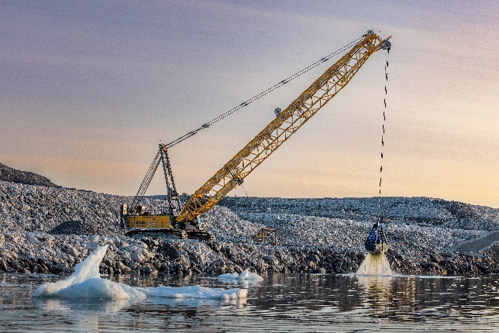

liebherr-hs 8200_2.jpg  
The HS 8200 dredges around 1,000 m³ of clay sediment per day from the sea.

Contact

Gregor Griesser  
Strategic Marketing and Communications  
Email: [gregor.griesser@liebherr.com](mailto:gregor.griesser@liebherr.com)

Wolfgang Pfister  
Head of Strategic Marketing and Communications  
Tel.: +43 50809 41-444  
Email: [wolfgang.pfister@liebherr.com](mailto:wolfgang.pfister@liebherr.com)

Published by

Liebherr-Werk Nenzing GmbH  
Nenzing/Austria  
[www.liebherr.com](http://www.liebherr.com)