Press release

Budrovich Contracting Co. takes delivery of the first Liebherr LTM 1110-5.2 equipped with LICCON3 in the US

⸺

Budrovich Contracting Co. takes delivery of the Liebherr LTM 1110-5.2 mobile crane

The LTM 1110-5.2 is equipped with the new LICCON3 crane control system

A second LTM 1110-5.2 mobile crane will be delivered in the spring of 2024

Midwest based, Budrovich Contracting Co. received the first Liebherr LTM 1110-5.2 mobile crane outfitted with LICCON3 in the United States. With another LTM 1110-5.2 mobile crane on the way, Budrovich attributes excellent training and successful implementation of Liebherr machines as valuable criteria during the purchasing process.

Newport News, VA (USA), Liebherr USA, Co., April 25, 2024 – Featuring a max. load capacity of 125 USt (110 t) and a telescopic boom reaching 197 ft (60 m), the Liebherr [LTM 1110-5.2 mobile crane](https://www.liebherr.com/en/gbr/products/mobile-and-crawler-cranes/mobile-cranes/liebherr-mobile-cranes/ltm-1110-5.2.html) is an ideal solution for Budrovich Contracting Co.’s hosting needs. The company purchased two Liebherr LTM 1110-5.2 mobile cranes at Conexpo 2023. The mobile crane features an updated cab design, gearbox, and the third generation crane control system, [LICCON3](https://www.liebherr.com/en/usa/products/mobile-and-crawler-cranes/mobile-cranes/mobile-crane-technology/liccon3-crane-control-system.html).

With Budrovich’s recent handover in St. Louis, MO, this is the first LTM 1110-5.2 outfitted with LICCON3 to be delivered in the United States.

Building with Tradition

Founded in 1945, Budrovich Contracting Co. is comprised of 9 business units specializing in crane rental, excavating and grading, land development, site utilities, marine services, mechanical insulation, rebar, equipment repair, and structural steel. The company provides support and services across the Midwest offering one of the largest and most diverse crane rental fleets in the St. Louis area. Currently, Budrovich has 100+ carry deck, rough terrain, crawler, and hydraulic truck cranes ranging in size from 8.5 – 550 t. The company will also take delivery of an additional Liebherr LTM 1110-5.2 mobile crane and an LTM 1230-5.1 mobile crane in the spring of 2024.

“Liebherr’s willingness to train our operators and mechanics along with the successful implementation of recent Liebherr cranes into our fleet has been valuable in our purchasing process,” said Sam Harper, Assistant Operations Manager for Budrovich Cranes.

As experts in commercial and industrial crane hoisting, Budrovich's services include project evaluation and coordination, crane placement modeling, engineered lift plans, and providing safe, effective lift solutions for their customers. The Liebherr LTM 1110-5.2 provides Budrovich with a modern solution to meet their customer needs and evolving industry standards.

Engineered for the future

The Liebherr LTM 1110-5.2 mobile crane combines existing strengths with modern innovations to deliver greater safety and comfort to the operator. The mobile crane is equipped with the third generation of the LICCON control system. LICCON3 takes the familiar crane controls to a new level featuring new, impressive technologies such as a fast data bus, significantly more storage space, greater computing power, and preparation for telematics and fleet management systems.

Additional new features of the Liebherr LTM 1110-5.2 include an updated operator’s cab design equipped with automatic heating and climate control, as well as an improved dashboard and display. The 5-axel crane is also outfitted with the ZF TraXon DynamicPerform gearbox, an oil-cooled multi-disk clutch on this gearbox has undergone intensive testing and is ready for use on Liebherr mobile cranes. Each of these new features represents the future of Liebherr’s all-terrain series.

About Liebherr USA, Co.

[Liebherr USA, Co](https://www.liebherr.com/en/usa/start/start-page.html). based in Newport News, VA provides sales and service on behalf of ten different Liebherr product segments: earthmoving, material handling, mining, mobile and crawler cranes, tower cranes, concrete technology, deep foundation machines, maritime cranes; components, and refrigeration and freezing.

About the Liebherr Group – 75 years of moving forward

The [Liebherr Group](https://www.liebherr.com/en/usa/about-liebherr/about-liebherr.html) is a family-run technology company with a highly diversified product portfolio. The company is one of the largest manufacturers of construction equipment in the world. It also provides high-quality, user-oriented products and services in a wide range of other areas. The Liebherr Group includes over 150 companies across all continents. In 2023, it employed more than 50,000 staff and achieved combined revenues of over 14 billion euros. Liebherr was founded by Hans Liebherr in 1949 in the southern German town of Kirchdorf an der Iller. Since then, the staff has been pursuing the goal of achieving continuous technological innovation and bringing industry-leading solutions to its customers. Under the slogan ‘75 years of moving forward’, the Group celebrates its 75th anniversary in 2024.

Images

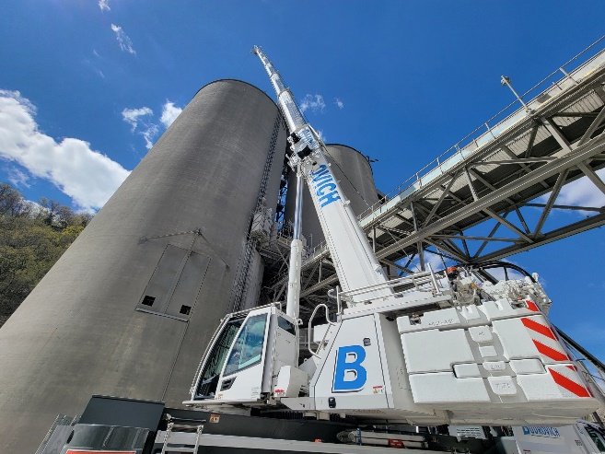

liebherr-usa-budrovich-1.jpg  
Budrovich Contracting Co. takes delivery of the first Liebherr LTM 1110-5.2 equipped with LICCON3 in the US.

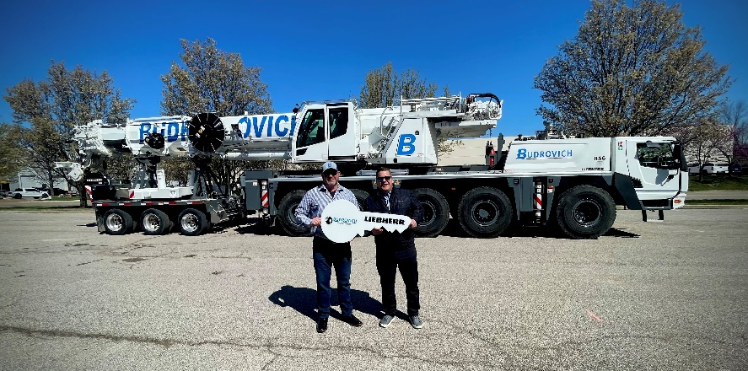

liebherr-usa-budrovich-2.jpg  
Budrovich provides support and services across the Midwest offering one of the largest and most diverse crane rental fleets in the St. Louis area.

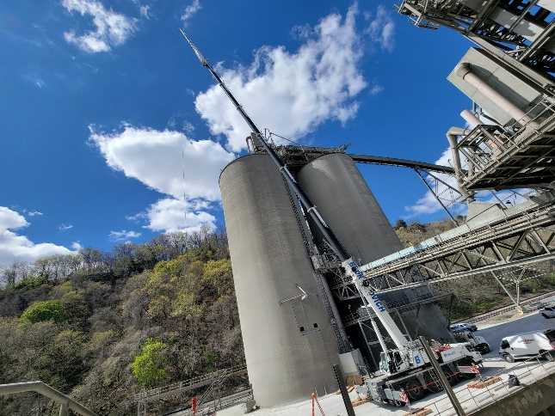

liebherr-usa-budrovich-3.jpg  
The Liebherr LTM 1110-5.2 mobile crane combines existing strengths with modern innovations to deliver greater safety and comfort to the operator.

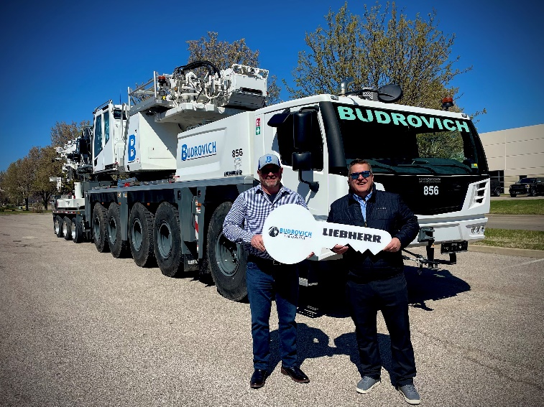

liebherr-usa-budrovich-4.jpg  
Budrovich purchased two Liebherr LTM 1110-5.2 mobile cranes at Conexpo 2023.

Contact

Ana Cabiedes   
Head of Marketing

Liebherr USA, Co  
E-Mail: ana.cabiedes@liebherr.com

Published by

Liebherr USA, Co.   
Newport News / USA  
www.liebherr.com