Press release

Expertise and Liebherr power in a two-pack

⸺

LTM 1650-8.1 and LTM 1450-8.1 from MSG Krandienst assemble a huge lock gate

LICCON work planner enables precise preparation in advance

Minimum distance to the lock chamber requires a 42-metre luffing jib

**A refurbished lock gate at the Gambsheim Rhine lock (France) on Europe's most important waterway had to be reinstalled in the large lock system last autumn after ten months of repairs. The company commissioned with the crane work, MSG Krandienst GmbH, based in Kehl (Baden-Württemberg), arrived on site with four mobile cranes. MSG sent two of its state-of-the-art Liebherr mobile cranes to the lock structure on the French side of the Rhine to lift the 84-tonne gate into place.**

Ehingen (Danube) (Germany), 5 February 2024 – An extremely limited working area, significant minimum distances between the cranes and the lock basin, and a gross load of 94 tonnes: these factors made the installation of a barrier gate at the Gambsheim Rhine lock near Strasbourg quite a challenge for the crane experts from MSG. "Due to the ongoing renovation work, we had very little space available for our cranes. That was the crux of this job," explains Christian Spreuer, responsible for project planning for large crane operations at MSG and in charge of the tricky job on the Upper Rhine.

During a period of almost four years, the 50-year-old weir, which has two huge chambers, is being completely renovated. On average, almost 100 ships – including large barges and long pushed convoys – use this lock on the Upper Rhine every day to overcome just over ten metres of elevation on the Rhine Canal. The two channels of the system are being maintained and repaired one after the other. To do this, the mighty lock gates must be lifted out and then reinstalled afterwards.

**Crane operates over crane**

During this assembly work, the limited space available for the two eight-axle mobile cranes from Liebherr meant that an extremely complex lifting process was required. The cranes had to be set up so close together that it was not possible to swing the huge lock gate between the vehicles due to the required radius of the LTM 1650-8.1.

First, the massive steel gate had to be erected together with two small auxiliary cranes and then taken over by the large cranes. After rotating the component by 180 degrees, the gate was guided in a wide arc around the LTM 1450-8.1 and swivelled over the water's surface towards the destination. This precise interaction between the two Liebherr machines demanded a high degree of concentration from crane operators Klaus Himmelsbach and Ralf Göltzer. The LTM 1650-8.1 operated and slewed over the smaller mobile crane with its 42 metre long lattice jib on the slightly extended telescopic mast.

The luffing jib also provided the necessary radius of 40 metres when inserting the gate into the lock chamber. Once again, the men in the crane operator's cab had to be extremely precise. The eight-metre-high, 24-metre-wide lock gate had to be lowered into the chamber just a few hand widths away from the cantilevered roof of the system's "tower", and positioned precisely in its anchorage.

**"LICCON work planner** – **my absolute favourite tool"**

"I planned this lifting operation here at the lock with the help of the LICCON work planner," says Christian Spreuer. "It lets you see which exact load capacity values are available any point for this crane with this configuration. My absolute favourite tool and sometimes simply indispensable," says the graduate engineer.

The complex job on the Upper Rhine certainly went smoothly. "Everything is perfect," was the succinct comment from Julie Wolf, who is managing the renovation work for the French consortium Altrad-Endel. The overhaul of the lock will continue until 2026. As soon as the first of the 270-metre-long basins has been overhauled and tested, it will be the turn of the gates for the second channel.

Next year at the latest, therefore, the blue mobile cranes from MSG Krandienst and its subsidiary MSG Levage, based in Strasbourg, will once again be on their way to Gambsheim to provide the lifting power required to replace the remaining steel doors. And once again, Liebherr cranes will be used.

MSG Krandienst GmbH, a crane, project logistics and heavy haulage company with 145 employees that is celebrating its 30th anniversary this year, has long been operating across borders on the French and German markets with its distinctive blue machines. The company operates a sizeable fleet of 50 crane vehicles, around half of which are Liebherr mobile cranes. Among them is its flagship and the most powerful large lifting machine in its pool: an LTM 1750-9.1.

**About Liebherr-Werk Ehingen GmbH**

Liebherr-Werk Ehingen GmbH is a leading manufacturer of mobile and crawler cranes. Its range of mobile cranes extends from 2-axle 35 tonne cranes to heavy duty cranes with a lifting capacity of 1200 tonnes and a 9-axle chassis. Its lattice boom cranes on mobile or crawler travel gear deliver lifting capacities of up to 3000 tonnes. With universal boom systems and extensive additional equipment, they can be seen in action on construction sites throughout the world. The Ehingen site has a workforce of 4,300. An extensive, global service network guarantees the high availability of Liebherr mobile and crawler cranes. In 2022, the Liebherr plant in Ehingen recorded a turnover of 2.37 billion euros.

**About the Liebherr Group**

The Liebherr Group is a family-run technology company with a widely diversified product range. The company is one of the largest manufacturers of construction machines in the world. However, it also supplies high quality, user-focused products and services in many other sectors. The group currently comprises more than 140 companies based in every continent of the world. In 2022, it had a workforce of over 50,000 and recorded a consolidated total turnover of more than 12.5 billion euros. The company was founded in 1949 in Kirchdorf an der Iller in southern Germany. Since then, its aim has been to win customers by supplying high quality solutions and to contribute to technological progress.

**Images:**

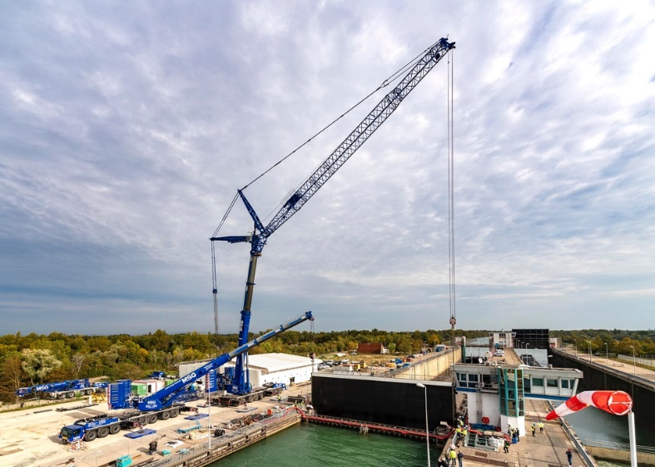

liebherr-ltm-1650-8-1-&-ltm-1450-8-1-msg-01.jpg  
Almost at its destination: the 84-tonne lock gate is lowered into the chamber.

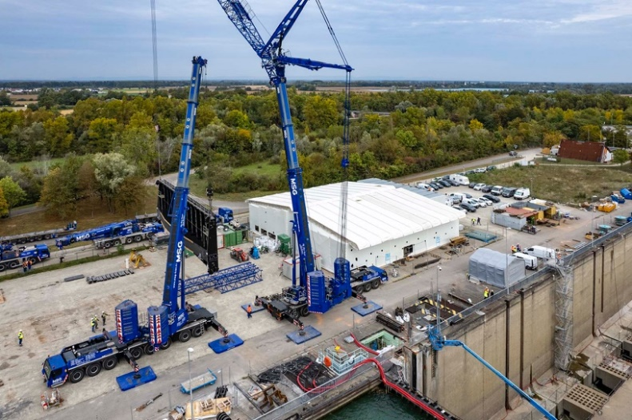

liebherr-ltm-1650-8-1-&-ltm-1450-8-1-msg-02.jpg   
After being lifted by four mobile cranes, the...

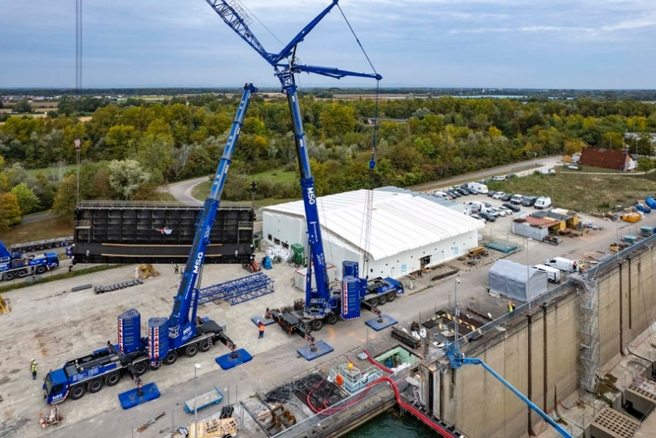

liebherr-ltm-1650-8-1-&-ltm-1450-8-1-msg-03.jpg   
... barrier gate is first turned by the Liebherr cranes...

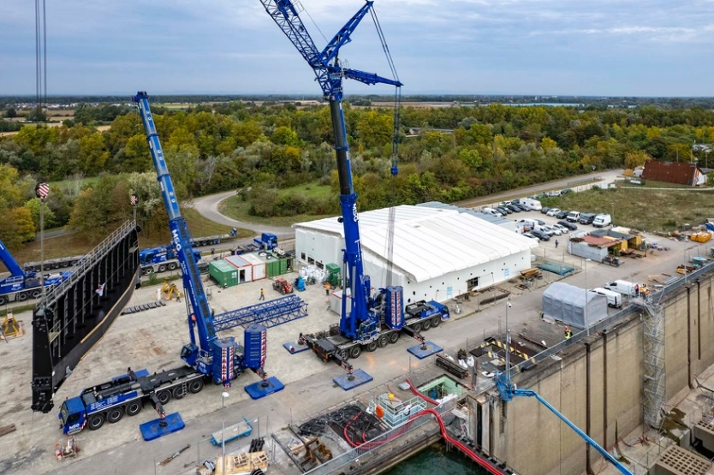

liebherr-ltm-1650-8-1-&-ltm-1450-8-1-msg-04.jpg  
... and finally swivelled in an arc...

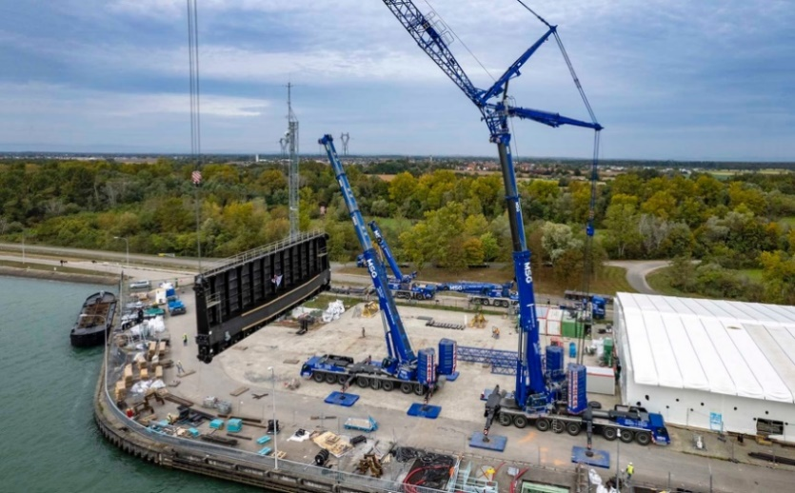

liebherr-ltm-1650-8-1-&-ltm-1450-8-1-msg-05.jpg   
... around the LTM 1450-8.1.

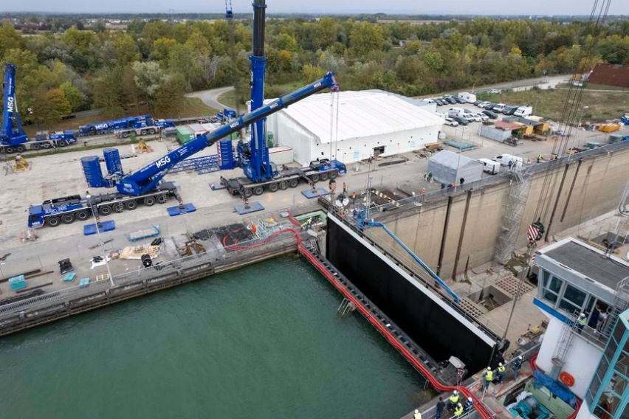

liebherr-ltm-1650-8-1-&-ltm-1450-8-1-msg-06.jpg   
Precision lifting work right next to the control centre building.

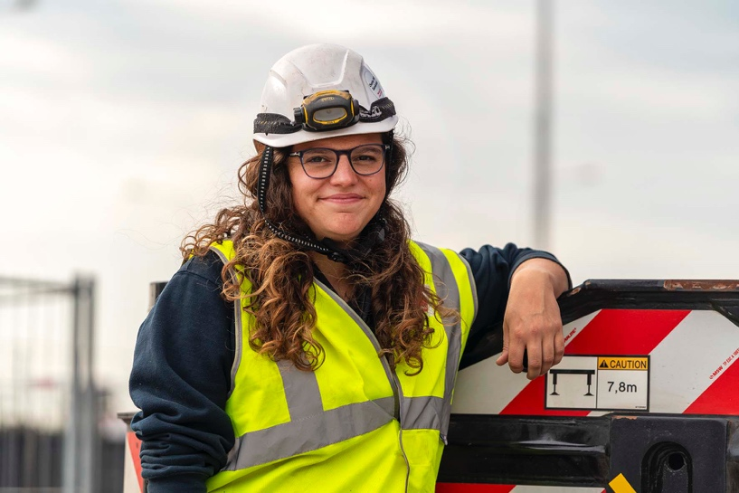

liebherr-ltm-1650-8-1-&-ltm-1450-8-1-msg-07.jpg   
"Everything is perfect." Julie Wolf is managing the refurbishment work for the French company Altrad Endel.

**Contact**

Wolfgang Beringer  
Marketing and Communication  
Phone: +49 7391/502 - 3663  
Email: wolfgang.beringer@liebherr.com

**Published by**

Liebherr-Werk Ehingen GmbH  
Ehingen (Donau), Germany  
[www.liebherr.com](http://www.liebherr.com)