Press release

Impressive qualities: Hans Dömkes GmbH continues to rely on Liebherr wheel loaders

⸺

High Lift arms on XPower wheel loaders prove their worth in loading processes

Fuel savings from the XPower machine concept are a key selling point

Impressive machine quality, easy maintenance and reliable customer service

For more than ten years, Liebherr wheel loaders have been used at the premises of the recycling company Hans Dömkes GmbH in Duisburg. Three wheel loaders – an L 538, an L 566 XPower® and an L 576 XPower® with High Lift arms – handle some of the material processed at the site. The specialists in recycling building materials state the fuel efficiency and excellent workmanship of the wheel loaders as the main reason for the long-standing business relationship with Liebherr. In addition, Liebherr's sales and service partner for the region, WBI Bau- und Industriemaschinen GesmbH, offers trusty and reliable service.

Duisburg (Germany), 7th February 2024 – The recycling specialists at Hans Dömkes GmbH process more than 160,000 tonnes of mineral waste each year. Three Liebherr wheel loaders feed the delivered construction waste to the screening and crushing plants and heap the sorted material at the numerous storage areas on the site. The recycled building materials are then loaded onto trucks by an L 576 XPower® with High Lift arms. The High Lift variant, available on customer request, offers increased reach and efficient loading at height. The recycled building materials are then reused in road construction and concrete mixing, as well as in gardening and landscaping.

Fuel efficiency of Liebherr wheel loaders as a purchasing criterion

More than a decade ago, Udo Dömkes, Managing Director of Dömkes GmbH, opted for a Liebherr wheel loader, leading to a partnership that continues to this day. "Back then, as now, we were impressed by the much lower fuel consumption yet higher performance compared to other wheel loaders in the same class size. Our XPower wheel loaders currently consume an average of eleven and a half to twelve litres of fuel per hour when heaping, reloading, and when feeding the screening and crushing plants," says the entrepreneur.

The fuel efficiency of the XPower generation of wheel loaders is due to the power-split XPower travel drive, which combines hydrostatic and mechanical propulsion. Hydrostatic power dominates when starting up and during short loading operations. When travelling at higher speeds and uphill, mechanical power comes more into play. Together, both components always transmit 100 percent of the diesel engine power, while only the ratio between them changes. This means the wheel loader always operates at maximum performance and efficiency, whatever it is being used for. The result is fuel savings of up to 30 percent compared to conventionally driven wheel loaders.

Markus Schepers, Liebherr wheel loader operator at Dömkes GmbH, adds: "The XPower drive system not only ensures low fuel consumption, but also a very comfortable ride. When heaping material, the wheel loader automatically and smoothly shifts between travel ranges, depending on how much force is required. This makes the work easier for the operator. In addition, numerous systems provide day-to-day assistance and ensure a safe working environment. An example of this is the active personnel detection with brake assistant, which reacts as soon as anyone comes close to the rear of the wheel loader. An alarm sounds and the brake assist system automatically reduces the speed of the wheel loader."

Impressive machine quality and rapid support

The intelligent installation of the components and cleverly designed access to the engine compartment ensure efficient maintenance work on the Liebherr wheel loaders. All installed parts, which need to be serviced can be reached safely and quickly. This saves time and money. Udo Dömkes is also convinced of this: "The quality of the Liebherr machines speaks for itself. Very rarely do we need a Liebherr service technician on site and when we do, help is guaranteed within 24 hours. This means that downtimes can be minimised. We feel excellently looked after."

About Hans Dömkes GmbH

Like Liebherr, Hans Dömkes GmbH is a family-run company. Founded in 1930, it is already in the hands of the fourth generation and is a reliable partner for its customers. The certified waste disposal company specialises in the recycling and sale of building materials. The processed materials are mainly used in road construction or in gardening and landscaping.

About the Liebherr Group

The Liebherr Group is a family-run technology company with a highly diverse product portfolio. The company is not only one of the largest construction equipment manufacturers in the world, but also provides high-quality and user-oriented products and services in a wide range of other areas. The Liebherr Group now includes over 140 companies across all continents. In 2022, the group employed more than 50,000 staff and achieved combined revenues of over €12.5 billion. Liebherr was founded in 1949 in Kirchdorf an der Iller, Germany. Since then, staff have pursued the goal of contributing to technological advancement and bringing industry-leading solutions to its customers.

Images

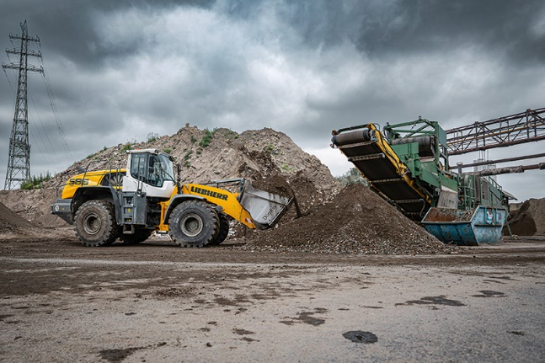

liebherr-xpower-wheel-loader-operation-report-doemkes.jpg  
A long-standing business relationship speaks for itself: Dömkes GmbH is convinced of its Liebherr wheel loaders.

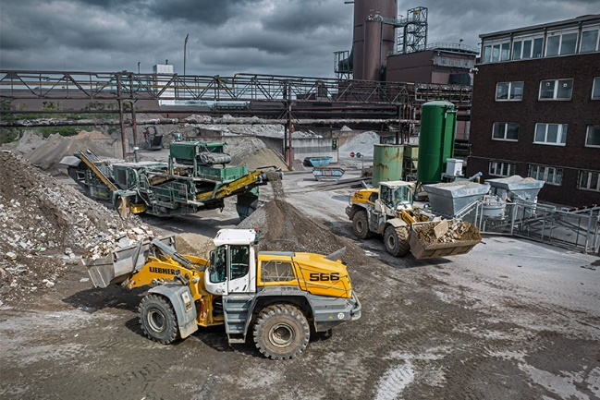

liebherr-xpower-wheel-loader-operation-report-doemkes-germany.jpg  
The excellent workmanship of Liebherr wheel loaders results in reduced downtime and increased productivity.

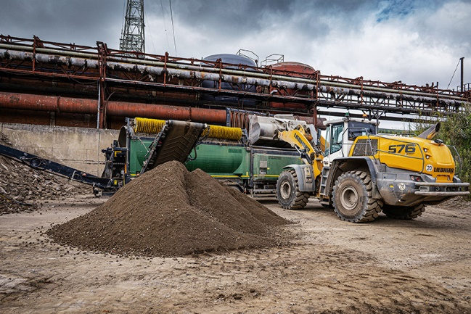

liebherr-l576-xpower-wheel-loader-operation-report-doemkes.jpg  
Loading the screening and crushing systems is one of the main uses of the Liebherr wheel loaders at Dömkes GmbH.

Contact

Martin Koller  
Marketing and Public Relations  
Phone: +43 50809 11475  
email: [martin.koller.lbh@liebherr.com](mailto:martin.koller.lbh@liebherr.com)

Published by

Liebherr-Werk Bischofshofen GmbH  
Bischofshofen/Austria  
[www.liebherr.com](http://www.liebherr.com)