Press release

Liebherr LTM 1650-8.1 installs chiller units against the backdrop of the Frankfurt skyline

⸺
LTM 1650-8.1 from Eisele replaces chiller units on Kastor tower block in Frankfurt am Main
Main road had to be fully closed over the weekend
Minimal support forces permitted during crane use

Kastor and Pollux are twin towers in Frankfurt am Main. They bear the names of an inseparable pair of brothers from Greek mythology. The two towers form the "Forum" high-rise complex on the Platz der Einheit and are part of the Frankfurt skyline. In mid-January, a crane boom with a length of over 120 metres was added to the silhouette – an LTM 1650-8.1 from crane and heavy haulage contractor Eisele AG replaced chiller units on Kastor. Assembly and removal of the eight-axle crane, as well as all the lifting work, had to be completed over one weekend.
Ehingen (Donau) (Germany), 9 February 2024 – Friedrich-Ebert-Anlage is one of the main roads in Frankfurt. The road had to be fully closed for the crane operation, as it was the only place where the LTM 1650-8.1 could be set up for the lifts onto the tower block. A tight schedule was specified in order to minimise traffic disruption.
On Friday at 2.30 p.m., assembly of the special support plates and the access ramp for the LTM 1650-8.1 began during the partial road closure. To ensure exact positioning of the support plates, a surveyor marked the dimensions of the LTM 1650-8.1's supports in the area of the pavement and the road on the basis of the approved structural installation plan.
Then, at 23:00 on Friday evening, work began on erecting the LTM 1650-8.1 in the T3YV2EN configuration with 150 tonnes of ballast and a 77-metre-long luffing jib.
The challenge of support pressure
Due to the presence of an underground railway line under the crane site, the support pressure was limited to two tonnes per square metre. The chosen solution was a combination of steel plates and bongossi timbers – around 100 load distribution plates were placed under the crane and the outriggers.
The lifting work began at eight o'clock on Saturday morning – the telescopic boom was extended to 51 metres. With a lattice extension and luffing jib, the LTM 1650-8.1 reached the required lifting height of 120 metres to remove the old chillers from the 95-metre-high Kastor tower and install the new units. The purpose of the lifting work was to modernise the air conditioning system in the high-rise building, which was completed in 1997. The heaviest components weighed five tonnes. During the assembly work, the LTM 1650-8.1 had to cope with a radius of up to 62 metres.
All the work had to be completed on Sunday and the crane had to be dismantled immediately to ensure that traffic could flow again on this important road on Monday morning. A logistical masterstroke!
About Eisele AG (part of the Hüffermann Group)
The Hüffermann Group is an association of companies based throughout Germany in the crane, heavy haulage and engineering sectors. Twelve locations in six federal states enable the companies to act as a full-service provider and offer comprehensive services "from a single source". The group includes the crane service providers Hüffermann Krandienst, the Thömen Group and Knaack-Krane in the North, as well as Autodienst West and the Eisele AG – Crane & Engineering Group in Maintal / Frankfurt a.M. The group also includes velsycon GmbH, a manufacturer of silo handling systems and vehicle builder based in Wildeshausen.
Continuous acquisition of the latest technologies and state-of-the-art equipment makes the group a reliable partner for projects and large construction sites throughout Germany and Europe. In total, the group has more than 1,200 cranes, lorries and rental machines. Its fleet also includes mobile cranes and crawler cranes (up to 1,000 tonnes), mobile construction cranes, electric cranes and loader cranes as well as 280 Liebherr tower cranes (up to 20 tonnes). In addition, it offers truck-mounted working platforms (up to 103 metres), heavy-duty assembly and project engineering solutions as well as forwarding services including heavy-duty and special transport. With its Heavy Lifting Technology – the Jack-Up System from Enerpac – and the modular self-propelled transporters, SPMT (Self-Propelled-Modular Transporter) from Cometto, Hüffermann is ideally positioned, especially in the infrastructure, bridge construction and wind power sectors. The group's portfolio also includes various types of rental equipment such as mobile trailer cranes, mini cranes and glass installation equipment, a comprehensive permit service, as well as all aspects of construction site safety and traffic engineering.
About Liebherr-Werk Ehingen GmbH
Liebherr-Werk Ehingen GmbH is a leading manufacturer of mobile and crawler cranes. Its range of mobile cranes extends from 2-axle 35 tonne cranes to heavy duty cranes with a lifting capacity of 1200 tonnes and a 9-axle chassis. Its lattice boom cranes on mobile or crawler travel gear deliver lifting capacities of up to 3000 tonnes. With universal boom systems and extensive additional equipment, they can be seen in action on construction sites throughout the world. The Ehingen site has a workforce of 4,300. An extensive, global service network guarantees the high availability of Liebherr mobile and crawler cranes. In 2022, the Liebherr plant in Ehingen recorded a turnover of 2.37 billion euros.
About the Liebherr Group
The Liebherr Group is a family-run technology company with a widely diversified product range. The company is one of the largest manufacturers of construction machines in the world. However, it also supplies high quality, user-focused products and services in many other sectors. The group currently comprises more than 140 companies based in every continent of the world. In 2022, it had a workforce of over 50,000 and recorded a consolidated total turnover of more than 12.5 billion euros. The company was founded in 1949 in Kirchdorf an der Iller in southern Germany. Since then, its aim has been to win customers by supplying high quality solutions and to contribute to technological progress.

Images
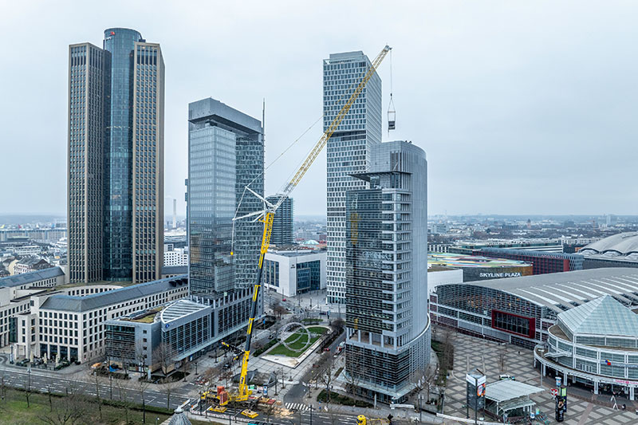
liebherr-ltm1650-eisele-01.jpg
The LTM 1650-8.1 from Eisele AG replaces chiller units on the 95-metre-high Kastor tower. On the left is its 130-metre-high brother, Pollux. A light sculpture by Swiss artist Christian Herdeg can be seen on the small green space between the two unequal twins.
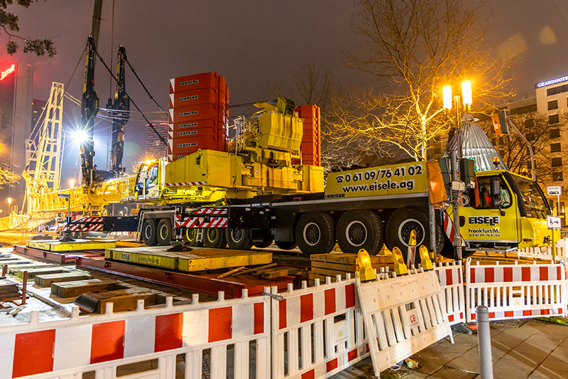
liebherr-ltm1650-eisele-02.jpg
Due to the tight time window, the crane was erected during the night. An underground railway line under the crane set-up area made it necessary to install around 100 load distribution plates underneath the crane and supports.

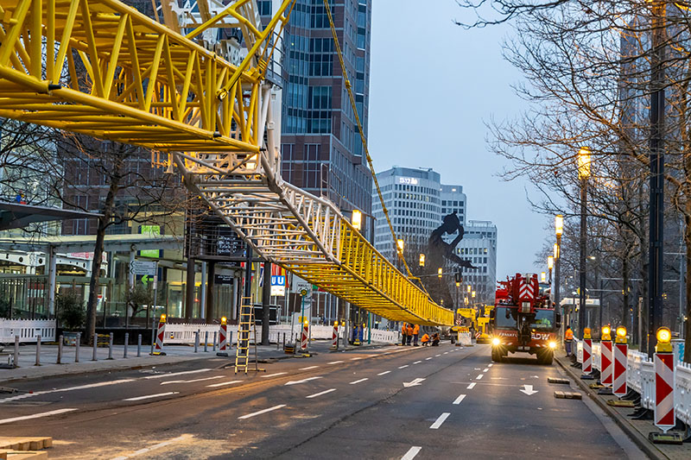
liebherr-ltm1650-eisele-03.jpg
The 77-metre-long luffing jib was erected on the fully closed Friedrich-Ebert-Anlage, one of the main roads in Frankfurt.

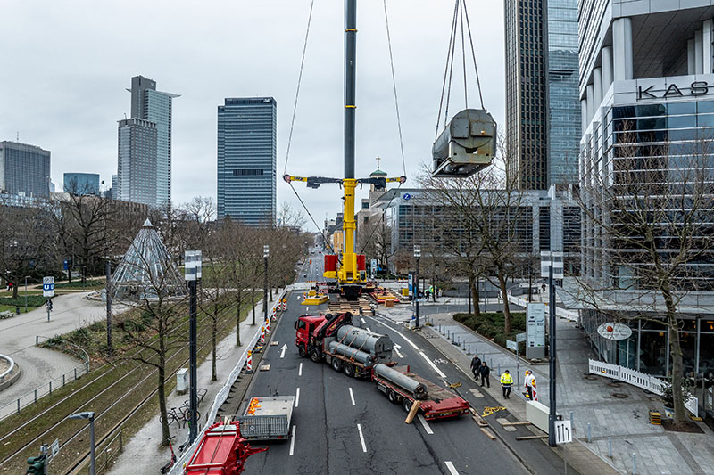
liebherr-ltm1650-eisele-03.jpg
The heaviest components of the refrigeration plant weighed five tonnes.

Contact
Wolfgang Beringer
Marketing and Communication
Phone: +49 7391/502 - 3663
Email: wolfgang.beringer@liebherr.com
Published by
Liebherr-Werk Ehingen GmbH
Ehingen (Donau) / Germany
www.liebherr.com

