Press release

Liebherr partners with Rijeka Gateway Future Container Terminal to supply remote yard cranes

⸺
Liebherr to supply 15 electric rubber tyre gantry cranes and two rail mounted gantry cranes to Rijeka Gateway in Croatia
The cranes will be operated using Liebherr’s Remote Operator Stations
The remote all electric cranes deliver sustainability for the future

Liebherr Container Cranes partners with Rijeka Gateway for 15 electric rubber tyre gantry cranes and two rail-mounted gantry cranes. Revolutionising container handling, these remotely operated, emission-free machines exemplify a commitment to safety, efficiency, and environmental sustainability at the cutting edge of industry standards.
Killarney (Ireland), February 2024 – Liebherr Container Cranes Ltd. is pleased to announce its partnership with Rijeka Gateway, supplying the terminal in Croatia with remote control yard cranes. As part of this landmark project, Liebherr will supply the terminal with 15 electric rubber tyre gantry cranes (ERTGs) and two rail mounted gantry cranes (RMG). These cutting-edge machines showcase the latest advancements in technology, allowing for seamless remote operation and control. As a pioneering terminal, the remote operation of the cranes will revolutionise container handling operations, advancing safety, efficiency, and sustainability. Rijeka Gateway is a joint venture between and APM Terminals (51%) and Enna Logic (49%) and is located on Croatia’s North Adriatic coast.
Liebherr's ERTGs are powered by electric busbar technology with drive-in auto-connect functionality. The elimination of all hydraulics and the utilisation the Liebherr Liduro Power Port, a mobile lithium-ion battery that provides power for cross-travelling between stacks ensures emission free operation, in line with the terminals’ ambitious decarbonisation roadmap and Terminal of the Future concept. The electric powered RTGs are supplemented by two advanced RMGs for intermodal handling at the terminal. This innovative solution, ensures a completely emission-free operation at the port, demonstrating Liebherr's commitment to environmental sustainability.

Remote control for comfort
The Liebherr ERTGs and RMGs feature dedicated Liebherr Remote Operator Stations (ROS), enabling crane control from a convenient office setting. This integration of cutting-edge technology not only improves safety and productivity but also sets the stage for a potential future transition to fully automated operation. Liebherr's advanced no-sway reeving, and simultaneous motion of all drives is supplied as standard, making sure that remote operators experience immediate benefits, ensuring high productivity right from the start. The inclusion of scanners and safety features guarantees a secure and efficient operation.
In keeping with the terminal’s commitment to sustainability, the adoption of remotely controlled cranes eliminates the need for operators to be physically present on the cranes, reducing the risk of accidents and injuries.
Sustainable solutions
Declan O’Sullivan, General Manager – Sales at Liebherr Container Cranes Ltd., commented: “Sustainability is at the core of our solution. We understand the importance of environmentally responsible practices, and we strive to be a leader in sustainable supply chains. With our Liebherr solution, customers can not only achieve operational excellence but also contribute to a more sustainable future.”
He expressed his firm belief that by embracing advanced technology and sustainable practices, Liebherr can reshape the industry and drive positive change for generations to come. “The partnership between Liebherr Container Cranes and Rijeka Gateway exemplifies the shared commitment to innovation and sustainability. By leveraging remote operations and advanced equipment, the terminal is establishing new benchmarks for operational efficiency, safety, and environmental responsibility in the Adriatic region.”

About Liebherr Container Cranes
Liebherr Container Cranes Ltd. Is one of the world’s leading manufacturers of ship to shore container cranes, rail mounted gantry cranes and rubber tyre gantry cranes. From a base in Killarney, Ireland, Liebherr Container Cranes Ltd designs, builds and exports container cranes worldwide. Founded in 1958 as the first Liebherr factory outside of Germany, today, container cranes manufactured by Liebherr in Ireland are renowned for their quality, longevity, and productivity.
About the Liebherr Group
The Liebherr Group is a family-run technology company with a highly diversified product portfolio. The company is one of the largest construction equipment manufacturers in the world. It also provides high-quality and user-oriented products and services in a wide range of other areas. The Liebherr Group includes over 140 companies across all continents. In 2022, it employed over 51,000 staff and achieved combined revenues of over 12.6 billion euros. Liebherr was founded in Kirchdorf an der Iller in Southern Germany in 1949. Since then, the employees have been pursuing the goal of achieving continuous technological innovation, and bringing industry-leading solutions to its customers.

Images
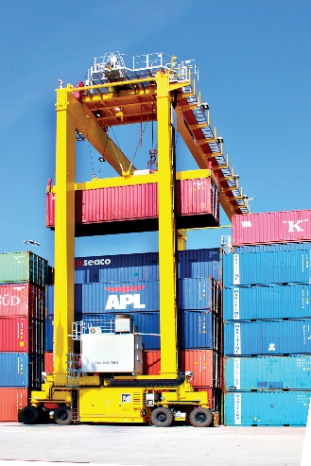
Liebherr-automated-rtg.jpg
A cabinless Liebherr rubber tyre gantry crane (RTG)
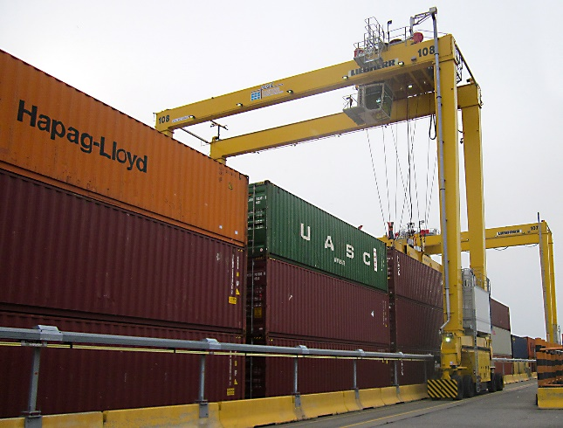
Liebherr-ERTG.jpg
A busbar powered electric rubber tyre gantry crane (ERTG)
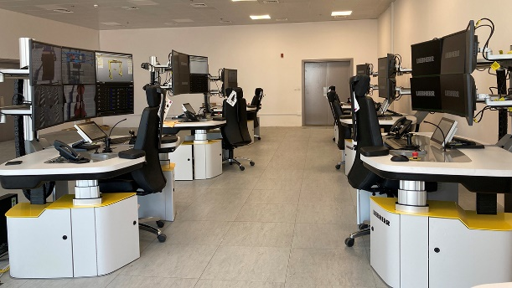
Liebherr-ros-desks.jpg
Liebherr Remote Operator Stations, enabling crane control from a convenient office setting.

Contact
Trevor O’Donoghue
Marketing Manager
Telefon: +353 64 66 80459
E-Mail: trevor.odonoghue@liebherr.com
Published by
Liebherr Container Cranes Ltd.
Killarney / Ireland
www.liebherr.com

