Press release

Liebherr R 956 special excavator impresses in Austria

⸺

With a high lift capacity and high working height, the R 956 takes on the challenges offered by the Ragginger company’s construction sites

A crawler excavator tailor-made for impact driving sheet pile walls, developed at Liebherr-France SAS in Colmar

A comfortable, high-performance machine with low fuel consumption

To carry out material handling and piledriving work for sheet pile walls, the Austria-based Ragginger company has picked the R 956 crawler excavator. The machine has been specifically designed for best possible management of these special tasks.

Colmar (France), 20 February 2024. Liebherr‘s Austrian customer Ragginger uses the R 956 crawler excavator for material handling and piledriving work for sheet pile walls. The 72-tonne excavator features a high lift capacity and a 15 m hook height to handle a variety of sheet pile walls and minimise the travel required. In addition, the VH-HD undercarriage with hydraulically adjustable gauge ensures excellent stability when removing sheet pile walls, while at the same time allowing easier transportation by road.

**Specially developed for large construction sites**

The crawler excavator is equipped with a special long, height-adjustable boom suitable for this application. The boom’s kinematics are ideal for piledriving work along sheet pile walls, ensuring a high working height close to the machine. Additionally, the boom makes possible a relatively low transport height for an excavator of this size – a key point for the customer, who needs to be mindful of the restrictions of moving construction machines by road, especially through tunnels.

Liebherr has increased the size of certain cylinders in the attachment, to ensure best possible handling of sheet pile walls. The hydraulic system has been specially designed for use with the piling tool. The hydraulic cab elevation gives the operator the best possible view, increasing site safety. With its versatile equipment, the R 956 VH-HD is even being used by the customer for demolition work with appropriate tools (pulveriser, concrete shear, sorting grapple or bucket).

**A machine tailor-made at our Colmar site**

Since 2020, the Liebherr Application Center has been designing customised products for a range of customers and developing tailor-made crawler excavators at the Liebherr-France SAS site in Colmar. One of these machines is the R 956 for Ragginger. It was developed to suit the company’s exact requirements. Special equipment for the crawler excavator ensures maximum productivity for our Austrian customers, who are also impressed by the quality and reliability of Liebherr machines.

**Maximum performance with low fuel consumption**

The R 956 crawler excavator combines maximum performance with low fuel consumption, which is a necessity for our customer’s challenging construction sites. The machine is also equipped with a comfortable operator's cab offering a large number of functions for precision and safe work.

Ragginger is a company specialising in earthworks, heavy loads, metalling and working with sheet pile walls. Sheet piling wall installation and removal and impact driving require high-precision handling of special tools and equipment. Our customer has a variety of Liebherr machines at its disposal for successful execution of different types of construction projects.

**About Liebherr-France SAS**

Liebherr-France SAS, founded in 1961, is responsible for the development and production of crawler excavators for the Liebherr group of companies in Colmar, France. The current product range includes around 30 crawler excavator models, from the R 914 Compact to the R 998 SME, for use in earthworks and quarries. Its products also include a range of special equipment for specific tasks such as demolition, material handling and maritime/tunnel applications, as well as large-capacity electric excavators. Crawler excavators with an operating weight of 14 to 100 tonnes are equipped with Liebherr engines with an output of 90 to 420 kW. Liebherr-France SAS employs more than 1,260 people and generates a turnover of 692 million euros.

About the Liebherr Group

The Liebherr Group is a family-run technology company with a highly diversified product portfolio. The company is one of the largest construction equipment manufacturers in the world. It also provides high-quality and user-oriented products and services in a wide range of other areas. The Liebherr Group includes over 140 companies across all continents. In 2022, it employed more than 50,000 staff and achieved combined revenues of over 12.5 billion euros. Liebherr was founded in Kirchdorf an der Iller in Southern Germany in 1949. Since then, the employees have been pursuing the goal of achieving continuous technological innovation, and bringing industry-leading solutions to its customers.

Images

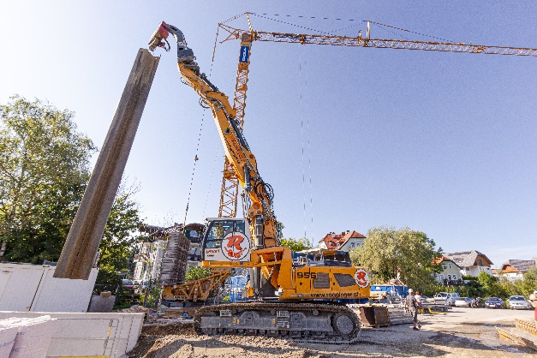

R956-Ragginger-1.jpg  
With a 15 m hook height, the R 956 crawler excavator is capable of lifting even large sheet piling walls.

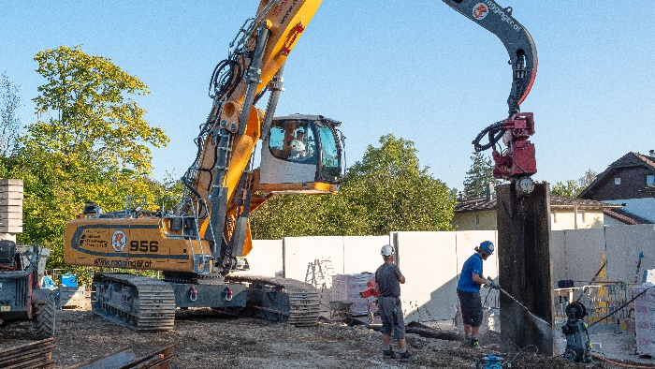

R956-Ragginger-2.jpg  
The operator's cab with hydraulic cab elevation offers the best possible view of the work area.

Contact

Alban Villaumé  
Marketing and communication  
Telephone: +33 3 89 21 36 09  
E-mail: alban.villaume@liebherr.com

Published by

Liebherr-France SAS  
Colmar, France  
[www.liebherr.com](http://www.liebherr.com)