Press release

Special excavators: the Liebherr R 980 SME in slag handling operations

⸺

This R 980 SME crawler excavator was specifically designed for use in our customer’s operations

The machine was developed by the Liebherr Application Center in Colmar

Fuel-efficient, super-comfortable, and very safe for the operator

Backes Transport und Schlackenaufbereitung GmbH, a firm based in Dillingen in the Saarland, uses the Liebherr R 980 SME crawler excavator for loading hot and cold slag. To meet the challenges of this kind of operation, the machine was specially built per our customer’s requirements.

Colmar (France), 27. February 2024. Loading hot slag is challenging work exposing the machine to constant very high temperatures. The R 980 SME crawler excavator produced by Liebherr for the Saarland firm Backes Transport und Schlackenaufbereitung GmbH was specially designed to fulfil such demands. Its dump bucket can handle large volumes of slag. For slag loading work, the machine is equipped with special safety devices such as a fire-fighting system. Exposed lines and hoses are covered with heat shielding. This crawler excavator features a wide walkway on the operator’s side, which can be accessed via a retractable ladder. Both features ensure safe access to the elevated operator's cab and the machine's engine compartment.

**Development tailored to customer requirements**

The R 980 SME for Backes was developed by Liebherr Application Center which was set up in 2020 at the Liebherr-France SAS site in Colmar. Specific requirements and customers’ special requests are analysed there, and the analysis is used for building tailor-made machines. Customer requests received through the sales network are systematically analysed by a team of specialists with a thorough understanding of both our products and their potential areas of application. This allows them to develop the best solution for the customer’s requirements. This diverse, multidisciplinary team can respond to customer requests quickly enough to allow them to be perfectly integrated into Liebherr-France SAS production processes. The steel used to build the crawler excavator is supplied by Stahl-Holding-Saar GmbH & Co. KGaA in Dillingen. Liebherr-France SAS orders about 7,000 tonnes of steel from this firm annually, which comes to about 70 percent of our total requirement.

**Our crawler excavator impresses with its productivity, user-friendliness and low fuel consumption**

Slag specialist Backes anticipates that the R 980 SME crawler excavator’s characteristics will facilitate efficient working and thus increase productivity. Despite its 100 tonne-plus weight, the machine stands out for its manoeuvrability, simple and intuitive operation, and comfortable, ergonomically designed operator's cab. In addition, our customer reports that the R 980 SME consumes five to six litres less fuel than the previous model, which is also used by the Saarland firm for transport and slag-handling. The firm loads slag from steel production into dump trucks. The dump trucks take the slag away for processing, which starts after it has cooled. For these operations, Backes currently uses two R 980 SMEs, and two older-model Liebherr R 984 C crawler excavators.

About the Liebherr-France SAS

Liebherr-France SAS, founded in 1961, is responsible for the development and production of Liebherr Group crawler excavators in Colmar, France. The current product range includes around 30 crawler excavator models, from the R 914 Compact to the R 998 SME, for use in earthworks and quarries. Its products also include a range of special equipment for specific tasks such as demolition, material handling and maritime/tunnel applications, as well as large-capacity electric excavators. Crawler excavators with an operating weight of 14 to 100 tonnes are equipped with Liebherr engines with an output of 90 to 420 kW. Liebherr-France SAS employs more than 1260 people and generates a turnover of 692 million euros.

About the Liebherr Group

The Liebherr Group is a family-run technology company with a highly diversified product portfolio. The company is one of the largest construction equipment manufacturers in the world. It also provides high-quality and user-oriented products and services in a wide range of other areas. The Liebherr Group includes over 140 companies across all continents. In 2022, it employed more than 50,000 staff and achieved combined revenues of over 12.5 billion euros. Liebherr was founded in Kirchdorf an der Iller in Southern Germany in 1949. Since then, the employees have been pursuing the goal of achieving continuous technological innovation, and bringing industry-leading solutions to its customers.

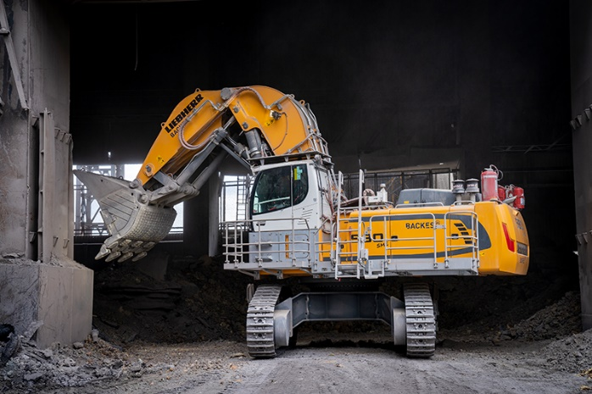Images

R980-SME-Backes-1.jpg  
This Liebherr R 980 SME crawler excavator has been specially designed for use in our customer’s operations.

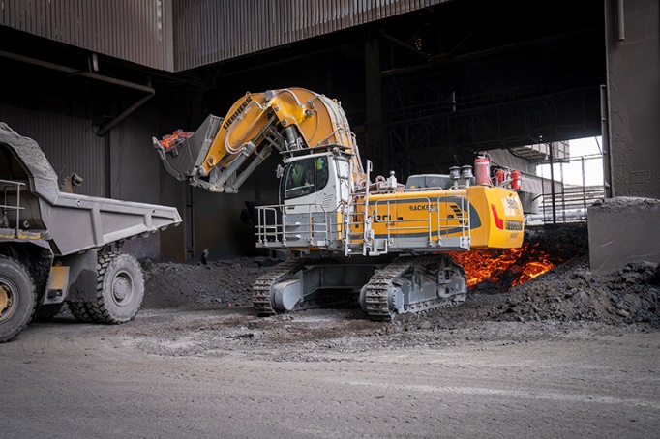

R980-SME-Backes-2.jpg  
The R 980 SME’s dump bucket can handle large volumes of slag.

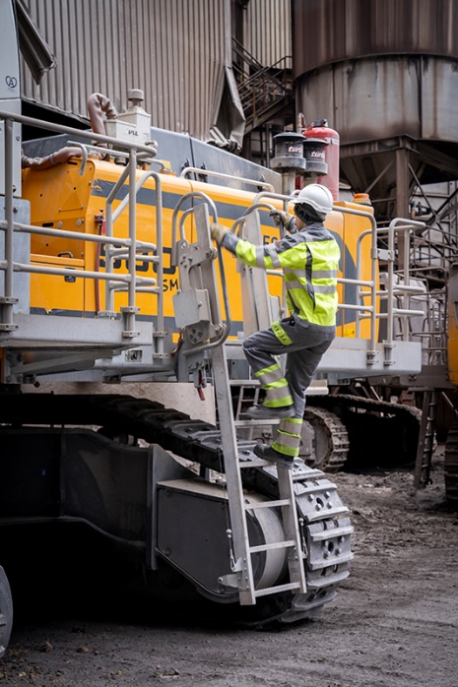

R980-SME-Backes-3.jpg  
The retractable ladder and wide walkway on the operator’s side allow the operator safe access to the workspace.

Contact

Alban Villaumé  
Marketing and communication  
Phone: +33 3 89 21 36 09  
E-mail: alban.villaume@liebherr.com

Published by

Liebherr-France SAS   
Colmar / France  
www.liebherr.com