Press release

Liebherr 81 K.1 fast-erecting crane stands tall on Vancouver Island

⸺
Complex disassembly successfully achieved
81 K.1 with 2 fall hoist rope and Load Plus feature for efficient lifting
Managing director of crane hire business Bigfoot Crane Company sees great potential for fast-erecting cranes in North America
A challenging job for a Liebherr fast-erecting crane in Canada: limited space on site resulted in a spectacular crane disassembly. The British Columbia-based crane hire company engaged in the project was particularly impressed by the fast-erecting crane’s flexibility and efficiency.
Nanaimo (Canada), 29 February 2024 – An apartment complex is taking shape not far from Departure Bay in the Canadian coastal town of Nanaimo. The Liebherr 81 K.1 fast-erecting crane involved in the project was supplied by crane hire provider Bigfoot Crane Company Inc. Working in tight conditions, the machine proved what it is capable of in Vancouver Island’s second largest city.
Construction of the Departure Bay apartment building presented Bigfoot Crane and the contractor Westurban Developments Ltd. with several challenges, largely due to the complex nature of the structure and the conditions on site. Meticulous planning beforehand, followed by precise implementation, was crucial for the crane's successful operation.
Challenging conditions expertly handled
Cale Anderson, managing director at Bigfoot Crane, describes the project's specific challenges, “It's easy to get a crane onto site when there isn't a building yet. But additional challenges arise once the building is erected because of its structure. When we're planning a project, we always start by looking at how to remove the crane at the end.”
The site’s access road was used for assembling the fast-erecting crane. But disassembling the 81 K.1 proved to be a tougher challenge. “The completed building was in the way as far as normal dismantling was concerned,” explains Anderson. “This meant the fast-erecting crane had to be lifted over the newly constructed building. A large Liebherr mobile crane was used to safely set the 81 K.1 down on the other side of the building.” This job was all about flexibility, technical expertise and being able to think outside the box. “As well as the challenges on site requiring the right equipment, we also needed a team willing to find creative and innovative solutions,” adds Anderson.
Efficient performance through Liebherr technology
The Liebherr crane’s work on the construction site in British Columbia demonstrates the efficiency and versatility of modern crane technology. Cale Anderson is impressed by the Liebherr crane's features and sees great potential for fast-erecting cranes in North America. The hoist rope's 2-fall operation and the Load Plus feature have particularly caught his attention. Both functions ensure fast lifting speeds and allow heavy loads to be lifted, “Our customers especially appreciate the crane's speed and performance that these features make possible,” says Anderson. The fast-erecting crane has played an integral role in various construction tasks, including trailer unloading, concrete work and the installation of rooftop equipment. While working in British Columbia, the 81 K.1 proved to be the ideal lifting partner when used with several other cranes on site. Its maximum hook height of 38.9 metres combined with 2.4 metre tower sections meant it was able to maintain the necessary safety distance between other cranes and buildings in its vicinity, and to slew above or below other cranes, depending on the circumstances.
The 81 K.1 can lift up to 6,000 kilograms. It can reach a maximum radius of 48 metres and has a jib head lifting capacity of 1,350 kilograms.
Partnership providing innovation and quality
Bigfoot Crane has 36 cranes in its fleet, six of them are from Liebherr. Tailored Liebherr solutions make all the difference for the crane hire company. “The flexibility and adaptability of Liebherr cranes are key elements in our success. Liebherr understands what we need and works closely with us to ensure we always get the best equipment and service. The versatility of Liebherr cranes allows us to efficiently handle a broad range of projects,” explains managing director Cale Anderson. “Liebherr offers innovation, quality and exceptional service, all of which are a perfect match for our requirements.”
About Bigfoot Crane
Based in Abbotsford, Canada, not far from Vancouver, Bigfoot Crane Company Inc. is a full-service provider for the sale, rental and maintenance of tower cranes and fast-erecting cranes. The company also offers training for crane operators and construction site workers and is also active in the areas of anti-collision systems, crane camera systems, and construction hoists. Bigfoot Crane was established in 2014 and provides services in Western Canada and North America.
About the Liebherr Tower Cranes Division
More than seven decades of experience have made Liebherr a recognised specialist for lifting technology on all types of construction sites. The range of Liebherr Tower Cranes encompasses an extensive selection of high-quality tower cranes that are used worldwide. This includes fast-erecting, top-slewing, luffing jib and special-purpose cranes as well as mobile construction cranes. In addition to these products, Liebherr also offers a wide range of services that complete the company’s portfolio: Tower Crane Solutions, the Tower Crane Center and Tower Crane Customer Service.

About the Liebherr Group
The Liebherr Group is a family-run technology company with a highly diversified product portfolio. The company is one of the world's largest manufacturers of construction machinery. It also offers high-quality, user-oriented products and services in multiple other areas. Today, the group consists of more than 140 companies across all continents. In 2022, it employed more than 50,000 people and achieved combined revenues of over 12.5 billion euros. Liebherr was founded in 1949, in Kirchdorf an der Iller in southern Germany. Ever since then, the company’s employees have been committed to satisfying customers with advanced solutions and to helping drive technological progress.

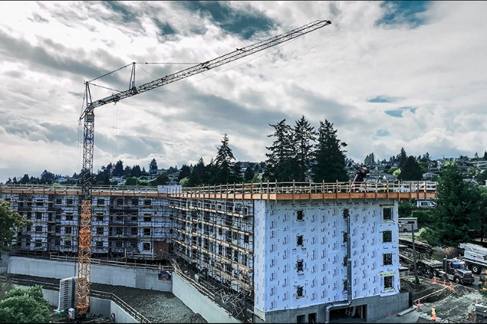
Images

liebherr-81-k-1-bigfoot-01.jpg
The 81 K.1 fast-erecting crane was in action in British Columbia for close to a year.

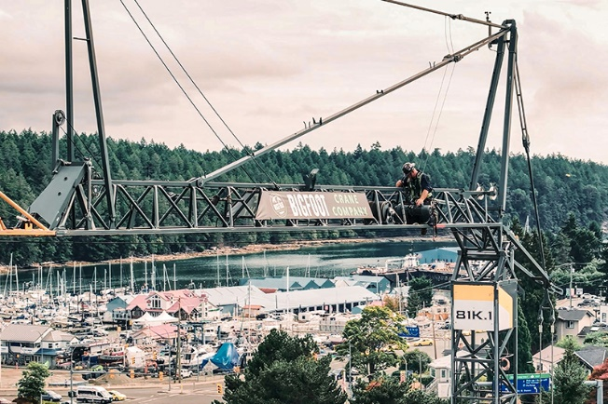

liebherr-81-k-1-bigfoot-02.jpg
Getting ready for disassembly: employees of the crane hire provider Bigfoot Crane Company Inc. prepared for a special disassembly.

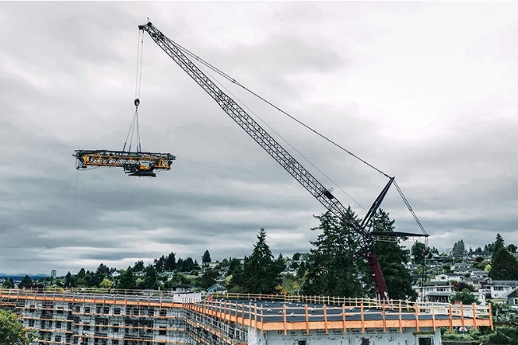

liebherr-81-k-1-bigfoot-03.jpg
The Liebherr crane left the site in an unusual way. As there wasn't enough space to dismantle the fast-erecting crane once the building was erected, it was lifted over the building by mobile crane.

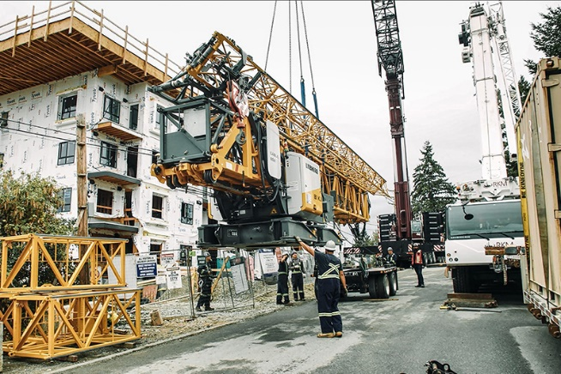

liebherr-81-k-1-bigfoot-04.jpg
Preparation and planning for the job paid off: the crane was carefully set down on the other side of the building.
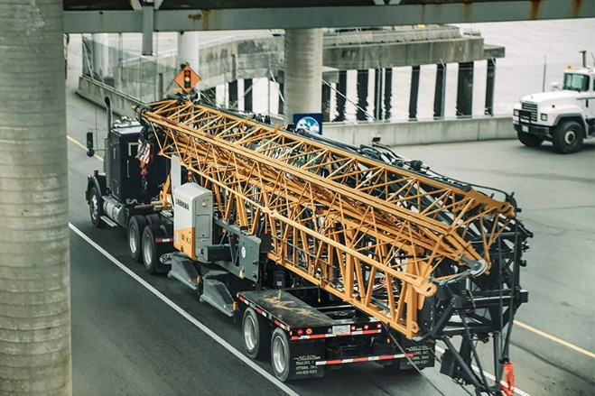

liebherr-81-k-1-bigfoot-05.jpg
Liebherr fast-erecting cranes are optimised for transport. The crane is transported as a complete, ready-to-erect unit. Its small wheel gauge of just 6.05 metres makes the crane compact and agile.

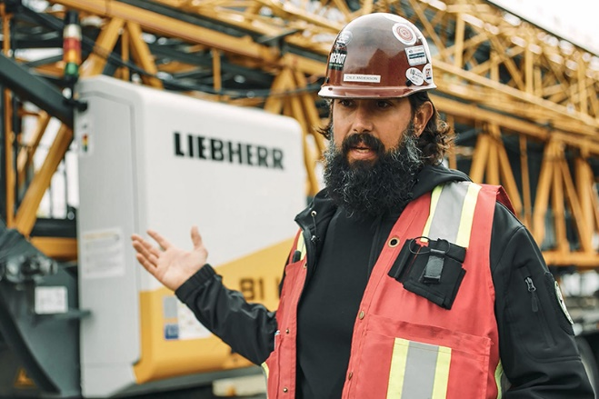

liebherr-81-k-1-bigfoot-06.jpg
Managing director Cale Anderson emphasises how important Liebherr's technology expertise and reliable service are, especially when it comes to complex construction projects.

Contact
Astrid Kuzia
Communication Specialist
Phone: +49 7351 / 41– 4044
Email: astrid.kuzia@liebherr.com
Published by
Liebherr-Werk Biberach GmbH
Biberach / Germany
www.liebherr.com

