Press release

Liebherr at 2024 ISRI Convention & Expo

⸺

Liebherr exhibits at the 2024 ISRI Convention and Expo showcasing specialized machines for scrap and industrial material handling.

Liebherr’s earthmoving and material handling technology team exhibits at the 2024 ISRI Convention and Exposition showcasing the LH 40 M Industry material handler, L 550 XPower wheel loader and an R 922 powerhand crawler excavator at booth #B8.

Newport News, VA (USA), Liebherr USA, Co., February 15, 2024 – The 2024 ISRI Convention and Expo takes place in Las Vegas, NV from April 15-18, 2024. Liebherr displays multiple machines at their booth including the [LH 40 M Industry material handler](https://www.liebherr.com/en/usa/products/material-handling-equipment/mobile-material-handling-machines/details/68065.html), [L 550 XPower wheel loader](https://www.liebherr.com/en/usa/products/construction-machines/earthmoving/wheel-loaders/details/69217.html), and [R 922 powerhand crawler excavator](https://www.liebherr.com/en/usa/products/construction-machines/earthmoving/crawler-excavators/details/186332.html). Liebherr experts are also on-site at booth #B8 to answer any questions and provide assistance with equipment.

Liebherr specialized machines are strong, reliable and designed for high performance and maximum efficiency in industrial material handling. This is accomplished through production of its components. The demands of industrial material handling are taken into account during the development stage of these components, and well-prepared Liebherr specialized machines for any application. Handling scrap, steel and other metals is one of the toughest operational areas, whether loading or unloading HGVs, loading shredder conveyors or sorting out different kinds of metals, the Liebherr specialized machines are perfect machines for operationally effective scrap material handling.

LH 40 M Industry material handler

The LH 40 M Industry is considered a top performer in its class. With the patented ERC System (energy recovery system), the maximum handling capacity is guaranteed while lowering the overall fuel consumption. This enables a more powerful machine with faster work cycles. The attachment of the machine is available in a variety of versions and is always optimally matched to your respective application including scrap, waste, and recycling.

Performance is extremely important in handling scrap materials. Whether sorting out mixed scrap material, loading and unloading HGVs and ships or loading shredders, shears and press plants, the Liebherr material handling machines are designed for the highest performance in a variety of work applications. High lift capacities and fast work cycles are essential for efficient handling operations. The optimum interplay between the hydraulics and electronics guarantees powerful, fast movements during handling while working with precision on challenging sorting tasks.

Performance data

|  |  |
| --- | --- |
| Model: | LH 40 M |
| System performance: | 211 hp |
| Operating weight: | 85,000 lbs. |
| Reach: | 47 ft. |
| Grapple: | 1.4 yd3 |
| Magnet: | 57 |
| Eye level: | 18 ft. |

L 550 XPower wheel loader

The high-performance Liebherr XPower wheel loaders are highly productive and can handle a wide range of materials including scrap. With strong lift arm variants and application-specific attachments, they are versatile and universally deployable.

In addition to the different types of machines, you can choose between industrial and z-bar kinematics within the L 550 – L 566 XPower wheel loaders and the L 580 XPower. This means the right machine is always available for specific operations such as transporting and loading steel and metal scrap or loading the shredder systems. This increases the utilization of the machine and increases productivity by keeping job sites on time and within budget.

Performance data

|  |  |
| --- | --- |
| Model: | L 550 XPower |
| Engine power: | 219 hp / 163 kW |
| Bucket capacity: | 4.5 yd3 |
| Operating weight: | 40,895 lbs. |
| Breakout force: | 37,095 lbs. |
| Tipping Load: | 27,560lbs. |

R 922 Powerhand crawler excavator

The R 922 crawler excavator showcases a completely updated design with characteristics of the new range of Liebherr "generation 8" machines. And in order to provide even greater comfort, better ergonomics and more enhanced performance.

The Powerhand VRS 200 (Vehicle Recovery System) enables you to get the maximum value out of your junk car before they are scrapped. Traditional manual methods of removing and separating high value materials from recycled vehicles are labor intensive and costly. At Liebherr, we are able to equip our R 922 excavators with a preparation kit that virtually makes the Powerhand System a plug and play hook up.

The benefits of using a R 922 from Liebherr is that the machine comes preprogrammed from the factory to control the unit and the clamp functions are controlled by the joystick and not foot pedals, making it easier for the operator to control.

Liebherr offers a wide range of crawler excavators with operating weights from 50,930 lbs. to 198,640 lbs. Each is designed with one goal in mind, to meet the demands and specifications of our customers in terms of performance, reliability, and efficiency, as well as safety and comfort.

Performance data

|  |  |
| --- | --- |
| Model: | R 922 |
| Engine power: | 163 hp / 120 kW |
| Engine torque: | 503 lbf ft at 1,400 rpm |
| Dig depth: | 22 ft. 2 in. |
| Operating weight: | 50,930 lbs. |
| Breakout force: | 35,970 lbs. |

About Liebherr USA, Co.

[Liebherr USA, Co](https://www.liebherr.com/en/usa/start/start-page.html). based in Newport News, VA provides sales and service on behalf of ten different Liebherr product segments: earthmoving, material handling, mining, mobile and crawler cranes, tower cranes, concrete technology, deep foundation machines, maritime cranes; components, and refrigeration and freezing.

About the Liebherr Group

The [Liebherr Group](https://www.liebherr.com/en/usa/about-liebherr/about-liebherr.html) is a family-run technology company with a highly diversified product portfolio. The company is one of the world's largest manufacturers of construction machinery. It also offers high-quality, user-oriented products and services in multiple other areas. Today, the group consists of more than 140 companies across all continents. In 2022, it employed more than 50,000 people and achieved combined revenues of over 12.5 billion euros. Liebherr was founded in 1949, in Kirchdorf an der Iller in southern Germany. Ever since then, the company’s employees have been committed to satisfying customers with advanced solutions and to helping drive technological progress.

Images

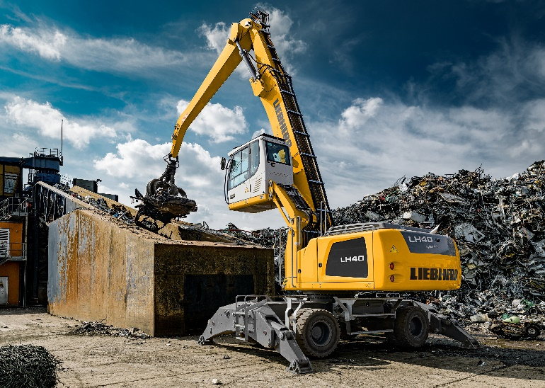

liebherr-LH40M-Industry.jpg  
The LH 40 M Industry is considered a top performer in its class, offering maximum handling capacity with lower fuel consumption.

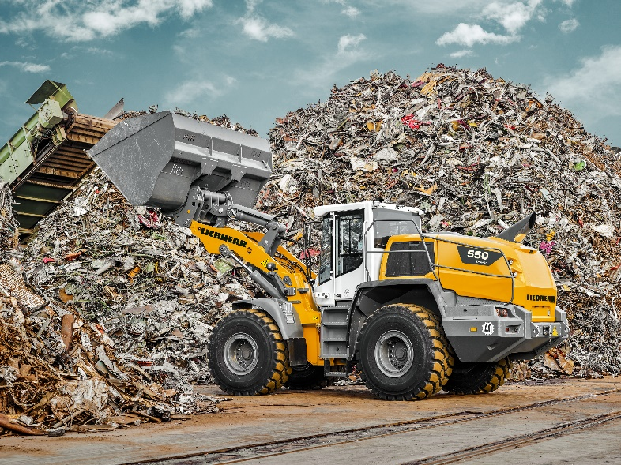

liebherr-L550.jpg  
The high-performance XPower wheel loaders are highly productive and can handle a wide range of materials including scrap.

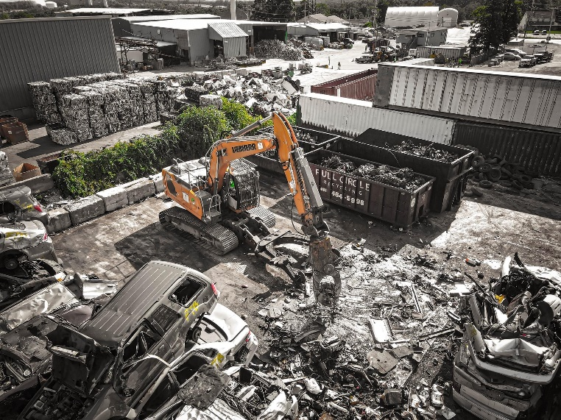

liebherr-R922.jpg  
The R 922 crawler excavator showcases the new generation 8 design offering greater comfort, ergonomics, and performance.

Contact

Ana Cabiedes   
Head of Marketing

Liebherr USA, Co  
E-Mail: ana.cabiedes@liebherr.com

Published by

Liebherr USA, Co.   
Newport News / USA  
www.liebherr.com