Press release

Intermat 2024: Towards emission-free construction sites with Liebherr energy storage systems

⸺
- Liebherr now offers a mobile energy storage system for the energy supply of construction sites.
- The newly developed power unit allows the operation and charging of construction machinery with zero local emissions.
- Liduro Power Port provides for high power density and constant power output of up to 160 kW.
The Liduro Power Port (LPO) is a mobile energy storage system for the supply of construction sites. Hybrid or fully electrically powered construction machinery and equipment can be operated or charged locally emission-free with the mobile energy storage system. The high power density and compact design of the LPO enable efficient and flexible supply to machines and construction sites with a wide range of power requirements. Its constant power output reaches up to 160 kW.
Paris (France), January 18, 2024 – Construction sites will see an increasing need for further electrification in the coming years, as local and global climate targets for emission reduction are being imposed on the construction sector worldwide. Construction site operators, therefore, have a dynamically growing demand for energy to supply all-electric and hybrid construction machines with local emissions-free power, in line with the existing and upcoming emissions regulations.
The battery-based energy storage system "Liduro Power Port" (LPO) enables locally emission-free operation and charging of electrified machines and, thus, supports the reduction of overall emissions in cities. Emissions, such as engine noise, particulate matter, CO2 and others are still primarily caused not only by mobile machinery, but also by diesel generators.

Efficiency and market-leading power density
Construction sites often have limited access to grid supply, sometimes none at all. Therefore, the challenges on electrified construction sites are the operation of machines at maximum power, charging of numerous machines during break times, and smoothing of load peaks. With a current market-leading power and energy density, the LPO offers a highly efficient solution for the mobile supply of machines with a wide range of power and load peaks.
Starting from 2024, the series product will be available in various power ranges with up to 160 kW/ kWh. It can be charged at up to 32 A and deliver power to loads via multiple connections that can be used simultaneously: 16 A / 32 A / 63 A / 125 A. The LPO can also be charged and discharged at the same time. The energy and condition monitoring is handled via the local control and, additionally, via a remotely available app for smartphones and tablets.
Economy and mobility
The energy storage system can supplement an insufficient grid connection or be used as an isolated grid when there’s no available grid connection. By using the LPO as a supplement to the grid connection, the dimensioning of the grid connection power can be significantly reduced, as the energy storage unit covers the load peaks of the machines. In isolated operation, the LPO is a flexible and highly efficient solution: On construction sites, high load peaks and, on the other hand, longer periods with very low power requirements are common - for example, for lighting or small appliances. The mobile energy storage system supplies power on demand and without surplus, offering an optimal price-performance ratio. Compared to a diesel generator, which has a consistently high consumption of fossil energy regardless of its consumers, the LPO delivers power with a significantly higher efficiency and without idle phases.
The LPO can be transported to urban or peripherally located construction sites with an optionally available trailer chassis or standard trailers for user-friendly operation. On site, if required, it can be moved by crane or excavator, using suspension points, and lifted and moved from all sides by a forklift. The basic dimensions of the LPO are 2,434 x 1,520 x 1,433 mm (L x W x H) or 3,903 x 2,031 x 1,899 mm with a trailer.
About Liebherr-Electronics and Drives GmbH
Liebherr-Electronics and Drives GmbH develops and manufactures high-quality components in the fields of electrical drive and control technology, as well as electronics at two locations, Lindau and Biberach (Germany). In Lindau, the focus is on durable electronics for industry and aviation. The products are used in numerous machines of the company group worldwide. Numerous external customers also rely on the company's cross-industry expertise. Test and qualification services for electronics, Electronics Manufacturing Services (EMS), as well as development services complete the extensive portfolio.

About Liebherr-Components
In this segment, the Liebherr Group specialises in the development, design, manufacturing of high-performance components in the field of mechanical, hydraulic and electric drive and control technology. Liebherr-Component Technologies AG, based in Bulle (Switzerland), coordinates all activities in the Components product segment.
The extensive product range includes combustion engines, injection systems, engine control units, axial piston pumps and motors, hydraulic cylinders, slewing bearings, gearboxes and winches, switchgear, electronic and power electronics components, and software. The high-quality components are used in cranes and earthmoving machinery, in the mining industry, maritime applications, wind turbines, automotive engineering or in aviation and transport technology. Synergy effects in s other product segments of the Liebherr Group are used to drive continuous technological development.
About the Liebherr Group
The Liebherr Group is a family-run technology company with a highly diversified product portfolio. The company is one of the largest construction equipment manufacturers in the world. It also provides high quality and user-oriented products and services in a wide range of other areas. The Liebherr Group includes over 140 companies across all continents. In 2021, it employed more than 49,000 staff and achieved combined revenues of over 11.6 billion euros. Liebherr was founded in Kirchdorf an der Iller in Southern Germany in 1949. Since then, the employees have been pursuing the goal of achieving continuous technological innovation and bringing industry-leading solutions to its customers.

Images
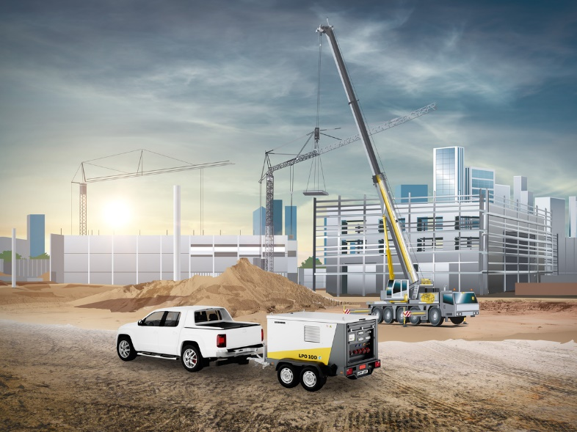
liebherr-liduro-power-port-construction-site_01.jpg
Series: Liduro Power Port – LPO 100.
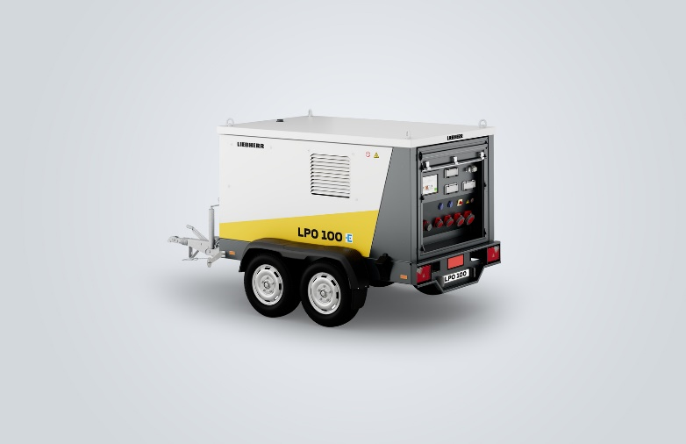
liebherr-liduro-power-port-trailer-side-print.jpg
Series: Liduro Power Port – LPO 100 with a trailer.
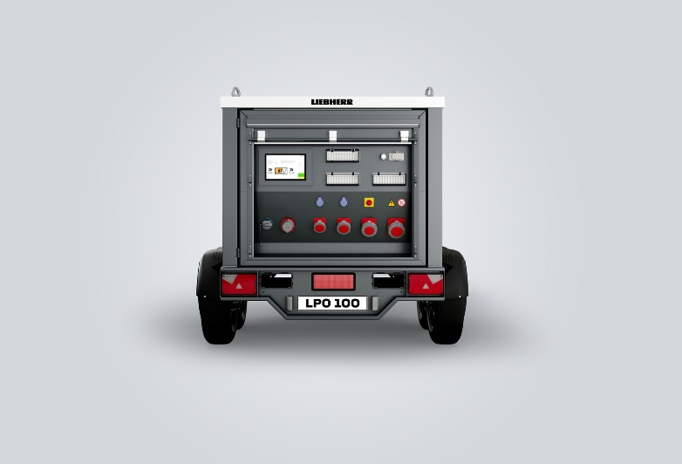
liebherr-liduro-power-port-output-slots.jpg
Series: Liduro Power Port – LPO 100, connections and the control panel.
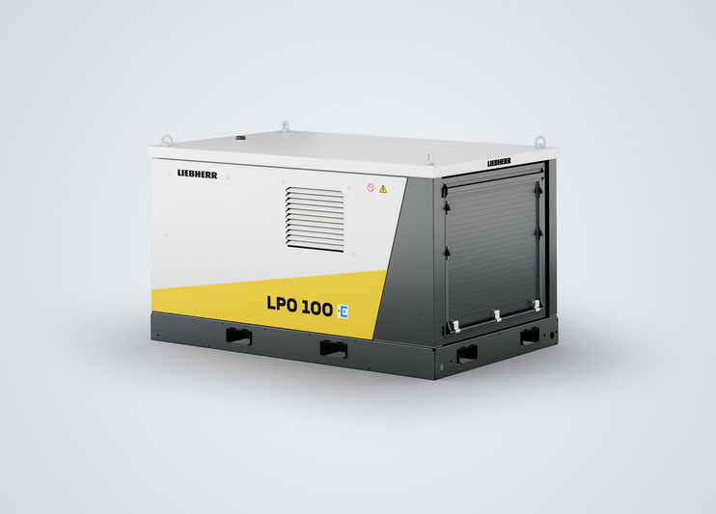
liebherr-liduro-power-port-side-view-closed.jpg
Series: Liduro Power Port – LPO 100 without a trailer, with a closed roller shutter.

Contact
Alexandra Nolde
Senior Communication & Media Specialist
Phone: +41 56 296 4326
E-mail: alexandra.nolde@liebherr.com

Published by
Liebherr-Components AG
Nussbaumen / Switzerland
www.liebherr.com
Liduro Power Port | Liebherr

