Press release

Powerful, robust and safe: The Liebherr TA 230 Litronic dump truck at Intermat 2024

⸺
Powerful all-terrain machine, specially designed for use in the extraction industry
Robust, rugged design ensures high machine availability
Optional equipment and assistance systems ensure comfort and safety
Liebherr will unveil the TA 230 Litronic articulated dump truck at Intermat 2024. This powerful all-terrain machine is specially designed for efficient use in the mining industry and for overburden transport. In addition to a static exhibit, the trade fair visitors can look forward to a live demo of this robust and durable machine during the show.
Paris (France), 18th January 2024 – Liebherr's articulated truck is characterised above all by its robust and durable design, which ensures high machine availability. At the same time, the machine combines excellent performance and profitability with a high degree of safety and comfort in daily use.
The TA 230 Litronic is an articulated truck in the 30-tonne class. The machine is designed to transport the extracted raw materials in opencast mining and ensure the removal of rocky debris during overburden removal so that the extracted material can be efficiently mined. The machine can remove up to 28 tonnes of material per loading operation with a maximum dump box capacity of 18.1 m³. Under the bonnet, a 6-cylinder construction machinery engine with 12 litres displacement and 265 kW / 360 hp capably does its job. The machine has a top speed of up to 57 km/h in forward travel and up to 16 km/h in reverse. Since the machine will be largely exposed to abrasive materials in punishing quarry applications, Liebherr offers optional equipment to minimise wear and tear and extend the vehicle's service life.
A robust and powerful vehicle that impresses thanks to maximum efficiency
Liebherr's articulated truck is a powerful yet robust machine that is designed for tough off-road applications in the mining and overburden transport industry. With its power-efficient drivetrain, permanent 6x6 all-wheel drive, reliable traction control and massive axle suspension, the machine can plough dynamically through any terrain. It is characterised by exceptional driving characteristics and concentrated traction, which allows more material to be moved in a shorter time and thus increases productivity.

Machine concept ensures outstanding comfort in daily use
The Liebherr dump truck is based on a machine concept that prioritises a high level of user comfort. Long working shifts are thus possible without fatigue. The spacious operator's cab, for example, offers the best conditions for comfortable working. Various storage areas, stowage compartments (one of which is air-conditioned) and bottle holders expand the available space immensely. Thanks to the clearly and intuitively arranged control elements, the machine operators can find their way around easily and are quickly ready to start their shift. Staggered steps and a generous driver's door provide pleasant yet safe access to the operator's cab.
Liebherr shock absorbers on the front axle and the viscoelastic suspension on the cab also optimally absorb the vibrations that occur in tough quarry operations, thereby increasing driving comfort. The soundproofed operator's cab reduces the interior noise level to just 72 dB(A).
Increased safety thanks to an innovative lighting and visibility concept
The lighting and visibility concept of the TA 230 ensures optimum visibility and safety – both for the machine operator and for anyone working nearby. Thanks to the excellent all-round glazing without blind-spot-inducing pillars and the short, sloping engine bonnet, the machine operator always has an optimum view of the machine's driving, working and articulation areas from the operator's cab. A rear camera is integrated into the touch display, providing a clear view of the area behind the vehicle.
The travel path and working area are illuminated by LED low beam headlights with integrated high beam and extra powerful LED headlights on the front of the cab. This innovative lighting concept creates optimal conditions for working in the dark. At the same time, it ensures that the machine is always clearly visible to everyone else on the construction site. The lighting at the rear of the body and another light package on the mudguards ensure optimum illumination of the manoeuvring areas at night.
Modern assistance systems increase productivity and safety during operation
Liebherr offers numerous, modern driver assistance systems for the TA 230 that support the machine operator and thus increase productivity and safety. For example, the innovative weighing device, which is installed as standard, records the loaded weight in real time. During the loading process, the current payload is shown on the display in the operator's cab in both numerical form and as an easily identifiable symbol. All collected data is displayed in LiDAT, Liebherr's data transmission and location system. A loading light is also available as an option, which is mounted on the rear of the cab and thus makes the loading status of the dumper externally visible as well. With the weighing device, optimal loading of the machine can always be ensured, its productivity measured and at the same time overloading of the machine components can be prevented.
The speed maintenance assistant, also fitted as standard, limits the truck's maximum travel speed. Activated via a button on the retarder lever, the system monitors the current speed when the accelerator is pressed and automatically adjusts it to the set value. When driving downhill, the vehicle decelerates automatically using the engine brake and retarder. The standard Hill Start Assist intelligently regulates the starting torque and thus eliminates the risk of rolling backwards on slopes.

About the Liebherr Group

The Liebherr Group is a family-run technology company with a highly diversified product portfolio. The company is one of the largest construction equipment manufacturers in the world. It also provides high-quality and user-oriented products and services in a wide range of other areas. The Liebherr Group includes over 140 companies across all continents. In 2021, it employed more than 49,000 staff and achieved combined revenues of over 11.6 billion euros. Liebherr was founded in Kirchdorf an der Iller in Southern Germany in 1949. Since then, the employees have been pursuing the goal of achieving continuous technological innovation, and bringing industry-leading solutions to its customers.

Images
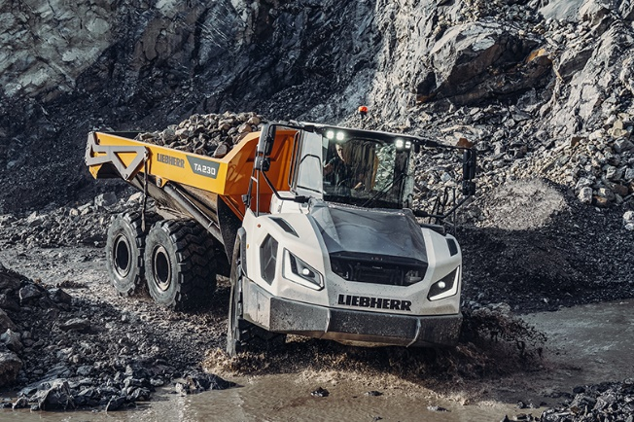

liebherr-TA230-intermat-1.jpg
The TA 230 Litronic is designed for demanding off-road applications, especially in the mining industry, and impresses with its outstanding off-road capability, maximum traction and focused pulling power.

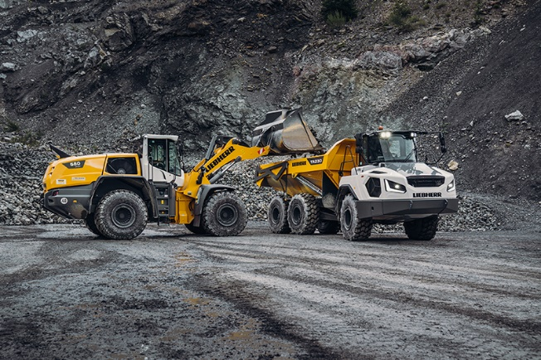
liebherr-TA230-intermat-2.jpg
A powerful machine in the 30-tonne class: the dump truck can remove up to 28 tonnes of material per loading operation with a maximum dump box capacity of 18.1 m³.
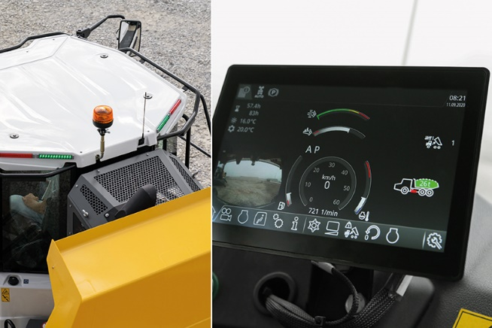
liebherr-TA230-intermat-3.jpg
The standard weighing system records the loaded weight in real time and shows it on the machine display in the operator's cab. An optional loading light ensures that the loading status is also visible from outside the vehicle.

Contact
Marc Wiedenmann
Marketing
Telefon: +49 7354 / 80 - 8494
E-Mail: marc.wiedenmann@liebherr.com
Published by
Liebherr-Hydraulikbagger GmbH
Kirchdorf/Iller / Germany
www.liebherr.com

