Press release

Liebherr’s R 972 crawler excavator presented at the Intermat show

⸺

The R 972 is part of the new range of 70 to 100 tonne crawler excavators

Improved productivity with the Liebherr Bucket Fill Assist system

New tried-and-tested operating modes and increased power

A versatile high-performance machine presented on the Liebherr stand at Intermat

The R 972 crawler excavator will be presented at the Intermat show, Paris Nord Villepinte, on stand Ext6 C 051 from 24 to 27 April 2024. A must-attend event in France’s construction sector, Intermat will bring together large numbers of professionals from the sector and present the latest solutions and technologies for more sustainable construction sites.

Colmar (France), January 18 2024 − The R 972 crawler excavator is part of the G 6.2 generation of 70 to 100 tonne crawler excavators developed by Liebherr-France SAS in Colmar (France) and recently presented at Bauma 2022 in Munich. The R 966, R 970 SME, R 976 and R 980 SME have been replaced by the R 972, R 978 SME, R 992 and R 998 SME respectively.

The R 972 is distinguished by its productivity, operator comfort and modern design. With its low fuel consumption and innovative assistance functions, the R 972 is a machine perfectly suited to the demands of mass earthmoving or quarrying sites.

**Liebherr Bucket Fill Assist**

Our R 972 crawler excavator is equipped with the Liebherr Bucket Fill Assist (BFA) assistance system. This innovative system, developed by Liebherr and also available on our mining excavators, enables a higher bucket filling level, faster cycles and better penetration into the digging material. Besides reducing bucket wear, BFA lowers fuel consumption by up to 10% and limits vibration for maximum operator comfort.

**Improved operator comfort**

The R 972 is equipped with the Modetronic function, which allows the operator to adjust a machine’s hydraulic performance to the application and the operator’s own driving style. The nine-inch screen and additional controls also improve operator comfort and increase the machine's accuracy. In addition, the crawler excavator has more engine power.

**The R 972 at the Intermat show**

For the 2024 Intermat show, the R 972 G 6.2 crawler excavator will have an operating weight of about 72 tonnes. Powered by a Liebherr 330 kW/449 hp engine, the machine will be equipped with a 2,730–3,390 mm gauge LC-V undercarriage with a continuous chain guide and 600 mm track pads. Operator comfort and safety are key considerations in the R 972’s cab, which has a Premium operator's seat and FOPS and FGPS protection grids. The crawler excavator is equipped with the Bucket Fill Assist assistance system and a 4.50 m3 capacity backhoe bucket. For performance in applications such as quarrying, the machine is equipped with a 7 m gooseneck boom and a 2.60 m stick.

About Liebherr-France SAS

Liebherr-France SAS, based in Colmar, has been responsible for development and production of Liebherr Group crawler excavators since 1961. Its current product range includes around 30 crawler excavator models, from the R 914 Compact to the R 998 SME, designed for earthmoving and stone quarrying. The product range also includes a whole series of special working attachments designed for specific tasks such as demolition works, materials transport and maritime or tunnel applications, as well as large-capacity electric excavators. With their operating weight of 14 to 100 tonnes, the crawler excavators are equipped with Liebherr engines with power ratings from 90 to 420 kW. Liebherr-France SAS employs over 1,260 staff and generates annual sales of 692 million euros.

About the Liebherr Group

The Liebherr Group is a family-owned engineering company offering a highly diverse range of products. The company is among the biggest manufacturers of construction machines in the world. But it also offers high-quality, value-focused products and services in many other areas. Today, the group includes more than 140 companies on all continents. In 2022, it employed more than 50,000 people and achieved total consolidated sales of more than 12.59 billion euros. Liebherr was founded in 1949 in Kirchdorf an der Iller, southern Germany. Since then, Liebherr’s employees have pursued the goal of satisfying customers with outstanding solutions while contributing to technological progress.

Photo

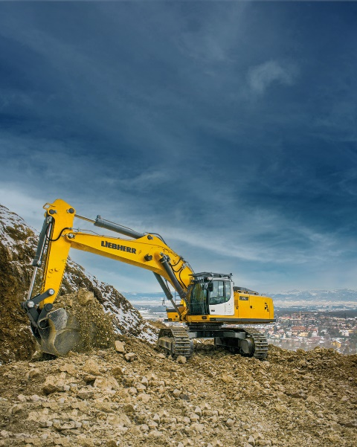

R972-2.jpg  
Versatility and power are the R 972 crawler excavator’s watchwords.

Contact

Alban Villaumé  
Marketing and Communication  
Telephone: +33 3 89 21 36 09  
Email: alban.villaume@liebherr.com

Published by

Liebherr-France SAS  
Colmar, France  
[www.liebherr.com](http://www.liebherr.com)