Press release

Electric truck mixer from Liebherr at Intermat

⸺

Electrically powered vehicles are almost commonplace on the roads. This trend is also recognisable in the construction industry and on building sites. Concrete deliveries to construction sites are already possible today - electrically driven and quietly. With the ETM truck mixer series, Liebherr has proven solutions for this in its programme.

Bad Schussenried (Germany), 18 January 2024 - Liebherr responded to the issue of electric drives in the construction industry many years ago. The group of companies offers an extensive range of construction machinery with environmentally friendly drives - including for the ready-mix concrete sector. The new ETM truck mixer series with electric drum drive, combined with an electric chassis, enables emission-free transport of concrete. The concrete is also unloaded environmentally friendly and quietly on the construction site. The ETM bodies are offered as fixed bodies or as semi-trailers. At Intermat 2024, an ETM 1205 all-electric articulated semi trailer will be on display at the Liebherr stand. The electric tractor unit from Volvo and the electric semi-trailer from Liebherr harmonise perfectly.

About Liebherr-Mischtechnik GmbH

Liebherr-Mischtechnik GmbH is a global manufacturer and supplier of high-quality concrete mixing plants, concrete pumps and ready-mix truck mixers. The company belongs to the Liebherr Group and is based in Bad Schussenried, Germany.

Picture

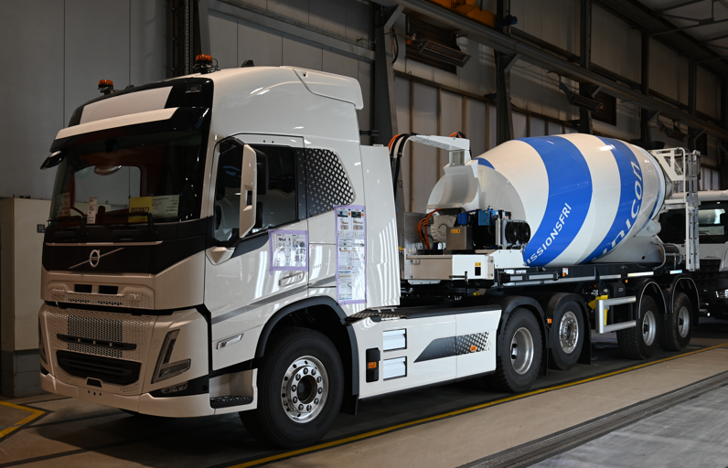

liebherr-ETM truck mixer.jpg

Liebherr truck mixer as a fully electric articulated semi trailer during the final inspection at the manufacturing plant.

Contact us

Klaus Eckert  
Sales Promotion Manager  
Phone: +49 7583 949-328  
E-mail: [klaus.eckert@liebherr.com](mailto:klaus.eckert@liebherr.com)

Published by

Liebherr-Mischtechnik GmbH   
Bad Schussenried / Germany  
[www.liebherr.com](http://www.liebherr.com)