Press release

LRB 23 continues the success story of piling and drilling rigs for Liebherr

⸺

* Higher efficiency thanks to engine power of 600 kW
* Kelly drilling unique for this size of machine
* New assistance systems: innovative Kelly visualization and drilling assistant

The piling and drilling rig type LRB 23 closes the gap between the LRB 16 and the long-established LRB 355. The compact size makes the machine a perfect all-rounder in the deep foundation sector. Innovative assistance systems simplify operation on the jobsite and ensure a high level of safety.

Paris (France), January 18th, 2024 - The new all-rounder for deep foundation work offers an impressive engine output of 600 kW. It delivers the necessary capacity for all common deep foundation operations, such as Kelly drilling, double rotary drilling, full displacement drilling, and continuous flight auger drilling, as well as soil mixing and applications with a vibrator or hydraulic hammer.

The compact design of the piling and drilling rig type LRB 23 allows for transportation in one piece, so simplifying mobilization between jobsites and enhancing flexibility. The remote control simplifies the loading process for transportation as well as the assembly of the machine.

The advantages of the rigid leader are proven in operation. As it can withstand high torques, even Kelly drilling is possible - a unique feature for a machine of this size! The rotary drive BAT 300 delivers a maximum torque of 300 kNm.

Highest efficiency and safety through digital assistance systems

Locking of the Kelly bar’s telescopic sections is made significantly easier with the aid of the Kelly visualization system in the LRB 23. Thanks to the real time display of the Kelly bar’s locking recesses on the cabin monitor, the operator is constantly informed about the actual distance to the next locking recess. Colour indications inform when the bar can be locked. Furthermore, false positioning of the Kelly bar during the shake-off process is indicated through a warning signal.

During continuous flight auger drilling the concreting process is automated thanks to the drilling assistant. All assistance systems contribute to time savings, higher availability of the machine and a significant increase in safety during operation. The newly designed piling and drilling rig convinces through precision, high performance, and a long service life.

Insights of the LRB 23 in operation: [Liebherr - The all-rounder: LRB 23 - YouTube](https://www.youtube.com/watch?v=stTSbdbeNos&t=57s)

Image

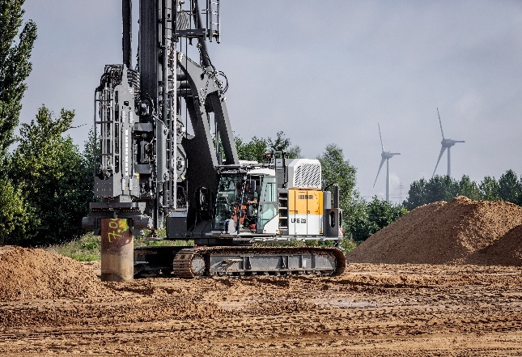

liebherr-lrb23.jpg  
The compact piling and drilling rig from Liebherr: LRB 23

Contact

Gregor Griesser  
Strategic Marketing and Communications  
Email: [gregor.griesser@liebherr.com](mailto:gregor.griesser@liebherr.com)

Wolfgang Pfister  
Head of Strategic Marketing & Communications  
Tel.: +43 50809 41444  
Email: [wolfgang.pfister@liebherr.com](mailto:wolfgang.pfister@liebherr.com)

Published by:

Liebherr-Werk Nenzing GmbH  
Nenzing/Austria  
[www.liebherr.com](http://www.liebherr.com)