Press release

Intermat 2024: Liebherr displays exhibits with alternative drives plus a wide range of digital solutions

⸺

Liebherr can be found in area Ext 6 C 051 of the Intermat in Paris, where they are exhibiting around 20 machines and a whole host of technologies that meet the individual requirements of customers, whatever their construction site

The booth, which measures an impressive 3,264 m2,will showcase machines spanning the product segments of tower cranes, mobile and crawler cranes, components, earthmoving machinery, material handling technology, deep foundation machines and concrete technology

Across three themed pavilions, Liebherr is also providing insights into its wide range of products and innovations in the fields of digitalisation, drives and service

From 24 to 27 April 2024 in area Ext 6 C 051 of the Intermat trade show, Liebherr is presenting around 20 machines from the product segments of tower cranes, mobile and crawler cranes, components, earthmoving machinery, material handling technology, deep foundation machines and concrete technology. Not only the static exhibits of products but also a showcase of the range and innovation work of the Group in the fields of digitalisation, drives and service will form the focus of the company’s 3,264 m2 booth at the trade show.

Nussbaumen (Switzerland), 18 January 2024 – The Intermat in Paris is the trade show for sustainable construction solutions and technologies. In keeping with the motto ‘On your site’, the Liebherr Group shows that it’s always on its customers’ side, wherever they are – whether by providing high-quality machines on the construction site itself or by providing tailored advice, global services and fully comprehensive solution concepts. Visitors to the booth, which measures 3,264 m2,will have the opportunity to get a close look at around 20 different machines spanning the product segments of tower cranes, mobile and crawler cranes, components, earthmoving machinery, material handling technology, deep foundation machines and concrete technology. Across three themed pavilions and through the exhibits themselves, Liebherr’s appearance at Intermat showcases a wide range of digital products and solutions, services and alternative drive technologies.

**Digitalisation: Customer-centric solutions from planning right through to maintenance**

At Liebherr, digitalisation is an important driver of innovation and new product development. On the one hand, it increases the efficiency of processes and therefore helps to conserve valuable resources. On the other hand, new information technologies and digital networking are opening up opportunities to develop products and services further and to implement customer-centric solutions along an entire customer journey: from planning to operation, performance and maintenance and even safety-relevant aspects.

**Local organisation of sales and services speeds up response times**

Liebherr is committed to having a strong on-the-ground presence, with local sales and service structures in those countries where the Liebherr Group operates. As such, the Group has a wide presence in France, for instance, thanks to its extensive customer services. This is in no small part due to the formation of Liebherr Distribution et Services France SAS in 2022, which combines the existing sales and service activities within one company as well as our broad and established network of dealers throughout France. This created synergy effects, streamlined structures and processes, and further improved response times. The segment-specific, shared sales expertise also makes it easier for staff to develop and implement solutions that are tailored to customers. This way, Liebherr further strengthens relations with its customers in France – one of the Group’s most important sales markets for more than 60 years.

**Embracing technology: e-drives as a key element in the future range of drives**

Another key commitment is the ongoing work in drive technologies, which form the basis for drives tailored to customers, delivering maximum power for minimum CO2 emissions. Given the variety of applications at play in the construction industry, a universal solution is not suitable, which is why Liebherr pursues an approach that embraces different technologies.

Such as the Liduro Power Port, a mobile energy storage system for supplying power to construction sites in remote locations which do not have an adequate e-infrastructure, a solution that is provided from Liebherr’s electrified product programme of the components product segment. With that, hybrid or fully electric construction machines and cranes can be operated or charged with zero local emissions. In this way, Liebherr supports its customers and partners in achieving their economic and ecological objectives – offering the optimal drive for every machine and every application.

**Liebherr Bucket Fill Assist in the R 972 crawler excavator**

On display at the Intermat 2024 is a R 972 of the generation 6.2 crawler excavator with operational capability of approx. 72 tonnes. What sets the R 972 apart is the productivity, driving comfort and modern design. The low fuel consumption and the innovative assistance functions make it an ideal machine for the requirements of large-scale construction sites and extraction sites.

The R 972 crawler excavator features the Liebherr assistance system Bucket Fill Assist (BFA). This innovative system, developed by Liebherr, facilitates a better fill level of the bucket, faster cycle times and better penetration of the material. As well as reducing the wear on the bucket, this reduces fuel consumption by up to 10 percent and reduces vibrations for improved driver comfort.

**Assistance systems simplify operation and enhance safety: LRB 23 piling and drilling rig**

With its LRB 23 piling and drilling rig, Liebherr presents an all-rounder for deep foundation, with an impressive engine output of 600 kW. This allows the machine to deliver the capacity needed for all common deep foundation applications. Since it is able to withstand high torques, it is even suitable for Kelly drilling – a unique property for a machine in this size class. The Kelly visualisation of the LRB 23 makes locking the telescopic sections of the Kelly bar much simpler. Plus, the concreting process is automated in continuous flight auger drilling by virtue of the drilling assistance feature.

**Ideal for specialist applications: TA 230 Litronic articulated dump truck**

Liebherr presents the TA 230 Litronic articulated dump truck at the Intermat 2024. The powerful off-terrain machine is designed for operational efficiency in the extraction industry and when transporting excavated material. The articulated dump trucks are also a useful assistant for larger infrastructure projects. Liebherr offers numerous cutting-edge driver assistance systems for the TA 230, which support the machine operator and, in turn, increase productivity and safety. One example of this is the innovative weighing device, installed as standard, which registers the loaded weight in real time.

**Fully electric crane drive now possible: MK 140-5.1 mobile construction crane**

Liebherr displays the MK 140-5.1, the strongest Liebherr mobile construction crane with a load capacity of up to 8,000 kilograms, at the Intermat. What makes it special, aside from its regular use as a trolley jib crane, is the VarioJib: This allows for operations in luffing mode and up to 65 metres of jib length. The ecological and future-proof hybrid power concept enables fully electric crane operation using either site power or another external power source. As a result, the crane works particularly quietly. It is compatible with the Liduro Power Port (LPO) from Liebherr, the mobile energy storage system for supplying power to construction sites.

**For short operations:** **125 K fast-erecting crane**

The 125 K fast-erecting crane offers maximum stroke capacity yet takes up only minimal space. It has a variety of hook heights, which means it can be adjusted to the site conditions for extra flexibility. With a jib length of 55 m and a hook height of up to approx. 66 m, the 125 K is currently the largest fast-erecting crane on the market. A meticulously designed assembly system and low logistics costs make the Liebherr cranes a particularly interesting option for shorter projects.

**For operations where noise and emissions must be kept to a minimum: the first electric Liebherr wheel loader, the L 507 E**

The Group’s first battery-electric wheel loader L 507 E, which is available in several European countries, will also be on display at the Intermat. It combines the well-known benefits of a Liebherr stereoloader with a Liebherr-developed battery-electric drive concept. The performance of the L 507 E is identical to Liebherr’s conventionally powered wheel loaders in the same size class. With its L 507 E, Liebherr is showing its commitment to a high-voltage battery system developed specially for wheel loader applications, which ensures a highly effective delivery of power and efficient loading operations.

**Electric truck mixer: ETM 1205**

The new ETM truck mixer series featuring electric drum drive, when combined with an electric chassis, renders it possible to transport concrete without producing emissions. The process of unloading concrete on the site is also clean and quiet. The ETM attachments are available as fixed superstructures and semi-trailers. Visitors to the Intermat will be able to see a fully electric articulated ETM 1205.

One machine, three drive options

The portfolio of international client operations using telescopic handlers and crawler dozers is hugely varied. True to its open-minded attitude to technology, Liebherr will be presenting at Intermat 2024 a range of alternative engines for telescopic forklift trucks, including a battery-electric machine in the 7-metre class. What makes the Liebherr telescopic handler stand apart is its choice of drive concepts that are aligned to the application or the market, as necessary: hydrotreated vegetable oils (HVO) as a low-emission counterpart or additive to fossil fuels, a battery-electric drive; or a hybrid drive consisting of a combustion engine and an electric motor.

**Featuring VarioBase® for the first time: LTR 1150 telescopic crawler crane celebrates its world premiere**

With the development of the LTR 1150, Liebherr expands its range of telescopic crawler cranes to include a 150-tonne model. Despite offering roughly 50 percent more load capacity than the LTR 1100, the new crane is as simple and economical to export as its 100-tonne counterpart: Available either complete with crawler frames, at a total weight of 60 tonnes and a transport width of 3.5 metres or alternatively without crawler frame, weighing just 38 tonnes in total and measuring just 3.0 metres in width. In a first for telescopic crawler cranes, the LTR 1150 features Liebherr’s VarioBase®, which the crane control uses to determine the best possible load capacity depending on the track width and angle of rotation.

**With newly developed pump drive: 36 XXT truck-mounted concrete pump**

The 36 XXT truck-mounted concrete pump benefits not only from a new five-part folding boom, but also from the Powerbloc drive unit and the semi-closed oil circuit. It is a versatile machine offering numerous comforts and safety features, such as the ergonomic steps and simplified access. An ultra-compact design without any boom overhang at the rear makes it extremely manoeuvrable in tight spaces. A particular highlight of the 36 XXT concrete pump is the newly developed ‘Powerbloc’ pump drive unit, which has the major benefit of all hydraulic switching and measuring elements being fully integrated.

About the Liebherr Group

The Liebherr Group is a family-run technology company with a highly diversified product portfolio. The company is one of the largest construction equipment manufacturers in the world. It also provides high-quality, user-oriented products and services in a wide range of other areas. The Liebherr Group includes over 140 companies across all continents. In 2022, it employed more than 50,000 staff and achieved combined revenues of over 12.5 billion euros. Liebherr was founded in Kirchdorf an der Iller in Southern Germany in 1949. Since then, the employees have been pursuing the goal of achieving continuous technological innovation, and bringing industry-leading solutions to its customers.

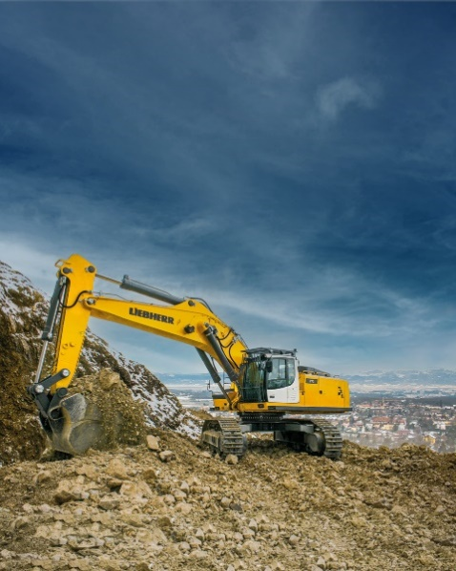Images

R972-2.jpg  
Versatility and performance are the key words for the R 972 crawler excavator.

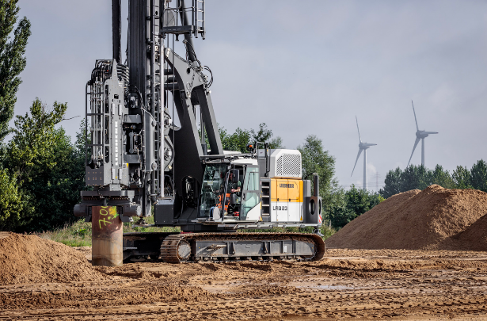

liebherr-lrb23.jpg  
The compact piling and drilling rig from Liebherr: the LRB 23

Ein Bild, das Fahrzeug, draußen, Landfahrzeug, Gelände enthält.

liebherr-TA230-intermat-1.jpg  
The TA 230 Litronic is designed for demanding offroad applications, such as the extraction industry. Cutting-edge assistance systems increase productivity and safety in operations.

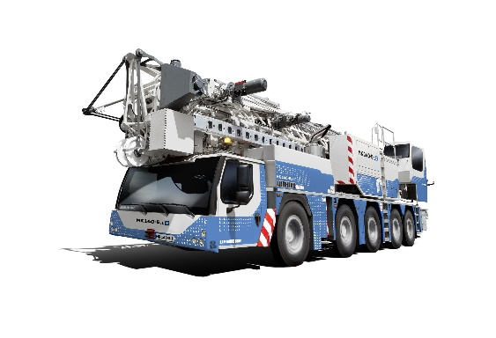

liebherr-mk140-5-1.jpg  
Liebherr displays the MK 140-5.1 – the strongest Liebherr mobile construction crane at a load capacity of up to 8,000 kilograms – at the Intermat.

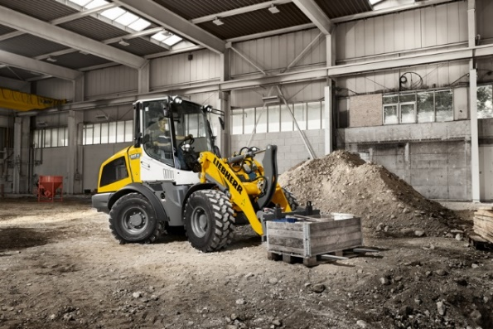

liebherr-l507e-indoor-application.jpg  
No local CO2 emissions: The L 507 E from Liebherr is also suitable for indoor operations.

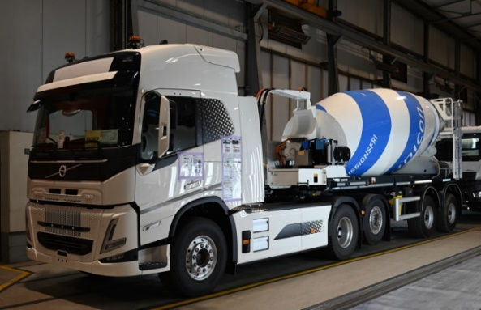

liebherr-ETM-1205-electric.jpg  
Liebherr’s ETM 1205 truck mixer in the fully electric articulated design in use for final inspection at a production site.

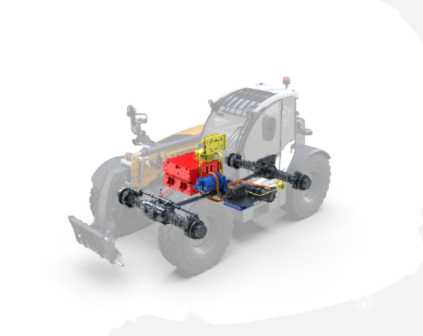

liebherr-teleskoplader BEV.jpgi  
One of three drive concepts: The battery-electric drive of the T 33-10 telescopic handler boasts impressive credentials, including zero emissions, optimised vibration behaviour and low noise emissions.

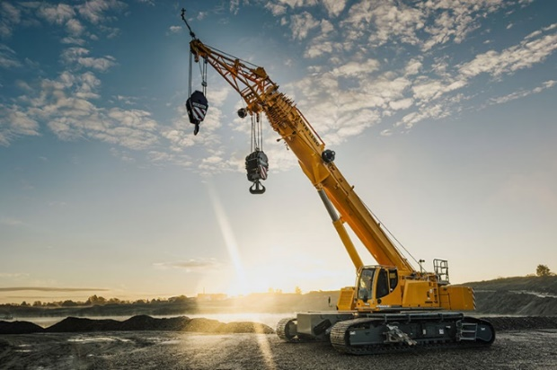

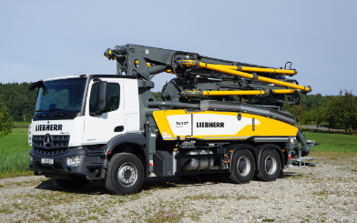liebherr-ltr1150-01.jpg  
The LTR 1150 is a new addition to Liebherr’s portfolio of telescopic crawler cranes.

liebherr-pump-36-XXT.jpg  
The new 36 XXT truck-mounted concrete pump is a real all-rounder.

Contact

Larissa Lunitz  
Head of Public Relations  
Tel: +41 79 645 70 67  
Email: larissa.lunitz@liebherr.com

Published by

Liebherr-International AG

General-Guisan-Strasse 6  
5415 Nussbaumen, Switzerland  
[www.liebherr.com](http://www.liebherr.com)