Press release

RL 650 with cutting-edge technology for Unity Platform

⸺

INEOS Forties Pipeline System (FPS) acquires new RL 650, which possesses attributes that make it particularly suitable for a Not Permanently Attended Installation (NPAI)

The crane will be deployed in the North Sea on the Unity Platform, which is operated by INEOS FPS

The Ram Luffing (RL) series is renowned for its compact, maintenance-friendly design

The currently installed RL crane has been in use on the Unity Platform since the 1990s and has proven itself over time. After more than 30 years of reliable service, INEOS FPS were looking to replace the crane, and following a technical visit to Liebherr’s manufacturing site in Rostock, selected their RL 650.

Rostock (Germany), January 2024 – INEOS FPS has selected Liebherr to supply its Unity Platform with a new crane. The RL 650 will fulfil all material handling for the offshore platform, from food and provisions to spare parts supply.

The Unity Platform is located in the North Sea in 122 metres of water and is operated remotely from an on-shore control centre. Teams regularly visit the platform to carry out periods of intensive maintenance work. Commenting on the decision to install a replacement Liebherr crane on Unity, Jason Duncan, Project Lead at INEOS FPS, says: “During our productive dialogue, we were able to convince ourselves of the advantages of the RL series. The fact that the entire crane solution is designed and manufactured in-house speaks for the consistently high quality of Liebherr cranes and their impressive longevity. The Unity Platform is a strategic asset to the UK and reliability is important to our customers and our business.”

With the acquisition of a new RL 650, INEOS FPS are using one of the most advanced cranes in the Liebherr product range in the offshore sector. The streamlined, compact design with the capacity to lift 15 tonnes and an outreach of 30 metres meets the needs of the Unity Platform operations.

Significant improvements through worldwide expertise

The RL series reflects all of Liebherr’s experience in the offshore industry. Customers from all over the world have influenced the product development and their insights and expertise have driven development forward at Liebherr. Liebherr RL cranes excel in offshore conditions, offering stability, versatile load-handling capabilities. Their design and construction ensure reliable performance in exacting conditions, making it a valuable asset in harsh offshore environments including those in the North Sea.

**A professional partnership built on mutual respect**

“We are pleased that INEOS FPS’ positive experience of our product has led to the acquisition of the RL 650 as the replacement crane for Unity. The relationship between INEOS FPS and Liebherr is one based on trust and the decades-long collaboration between the two companies demonstrates the importance of building and maintaining long-term business relationships,” adds Matti Basan, Senior Sales Manager Offshore Cranes.

Offshore cranes, such as those in the RL series, are specially designed, built and maintained to operate in challenging marine environments. The RL 650 is an ideal choice for demanding offshore tasks while meeting industry’s stringent requirements.

About Liebherr-MCCtec Rostock GmbH

Liebherr-MCCtec Rostock GmbH is one of the leading European manufacturers of maritime handling solutions. The product range includes ship, mobile harbour and offshore cranes. Reach stackers and components for container cranes are also included in the product portfolio.

About the Liebherr Group

The Liebherr Group is a family-run technology company with a highly diversified product portfolio. The company is one of the largest construction equipment manufacturers in the world. It also provides high-quality and user-oriented products and services in a wide range of other areas. The Liebherr Group includes over 140 companies across all continents. In 2022, it employed more than 50,000 staff and achieved combined revenues of over 12.5 billion euros. Liebherr was founded in Kirchdorf an der Iller in Southern Germany in 1949. Since then, the employees have been pursuing the goal of achieving continuous technological innovation, and bringing industry-leading solutions to its customers.

Images

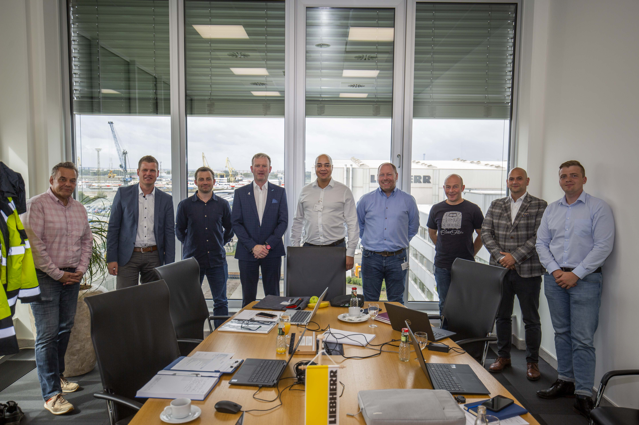

liebherr-rl-650-ineos-1.jpg  
INEOS FPS visited Liebherr Rostock for a kick-off meeting to discuss crane details (f.l.t.r.: Jens Qualmann, Technical Advisor Liebherr; Matti Basan, Senior Sales Manager Offshore Cranes Liebherr; Gavin Buchan, Lead Mechanical Engineer INEOS FPS; Stewart Boyle, Sales Manager Liebherr Great Britain; Jason Duncan, Project Manager INEOS FPS; Fraser Grove, Mechanical Engineer INEOS FPS; Paul McLeod, Crane Engineer INEOS FPS; Ilie Toma, Project Manager Liebherr; Martin Schulz, Junior Project Manager Liebherr).

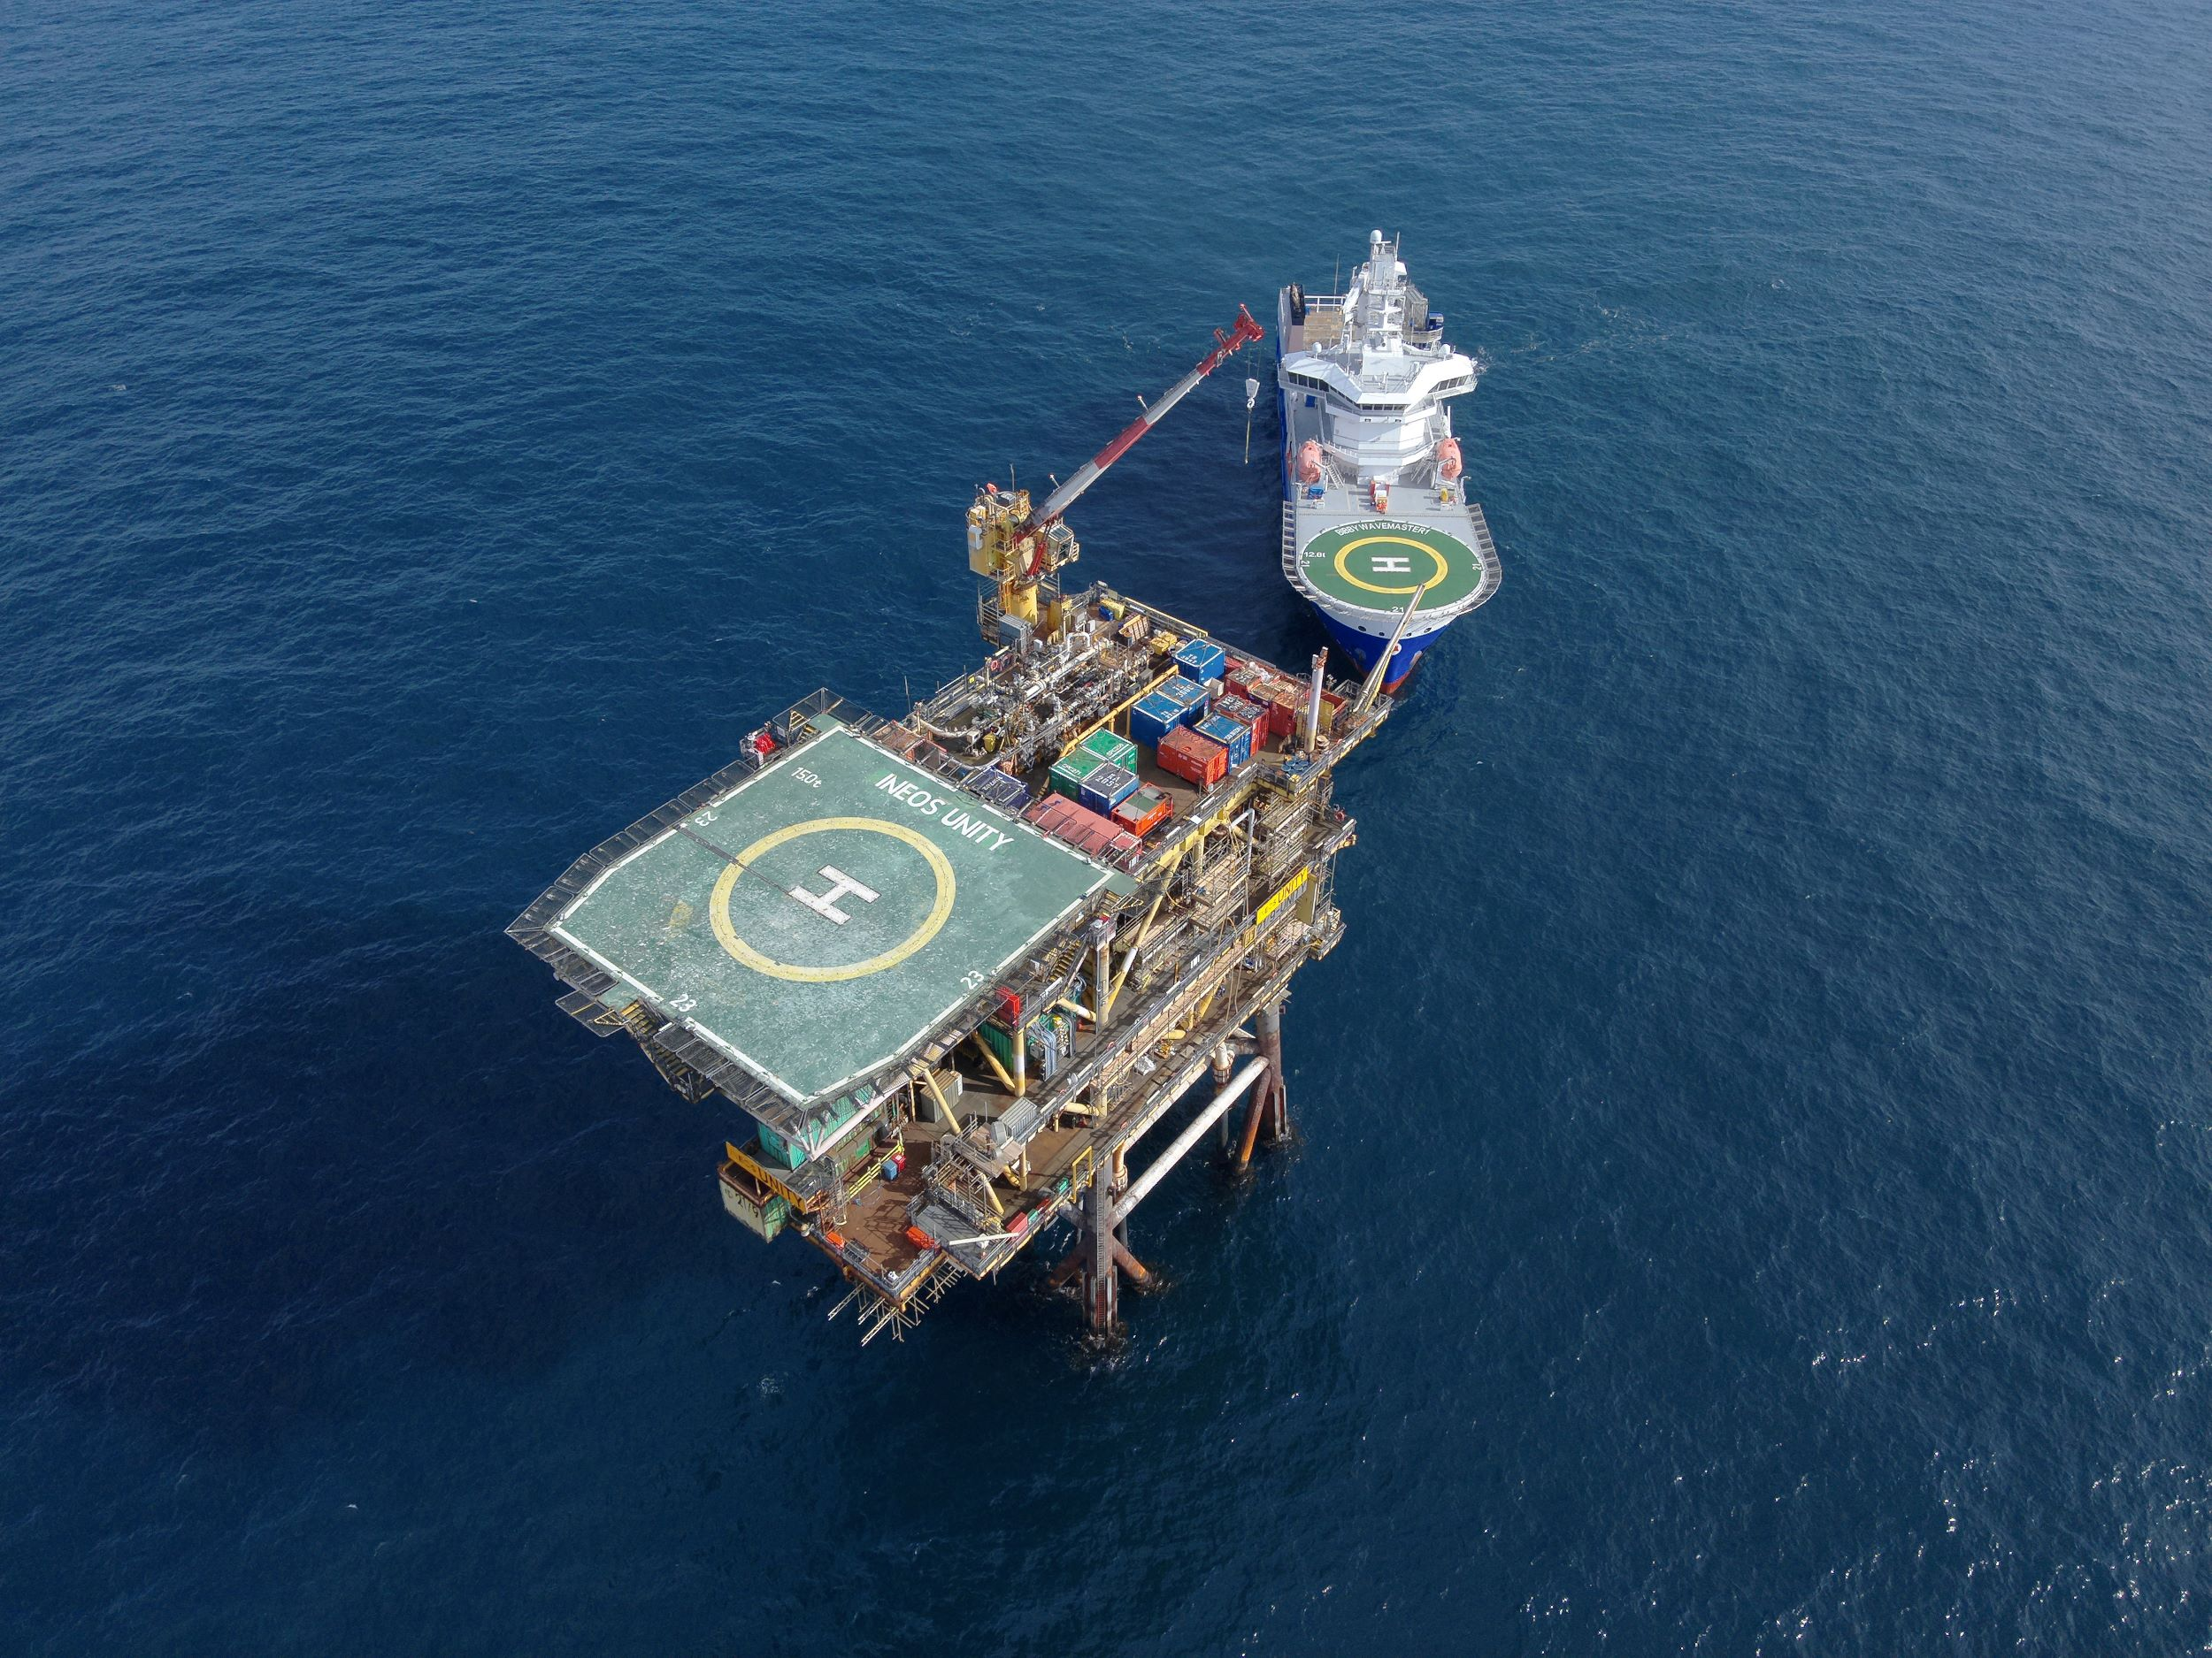

liebherr-rl-650-ineos-2.jpg  
The Unity Platform will be equipped with a new RL 650 from Liebherr. The RL series is one of the most compact series Liebherr offers in the offshore sector.

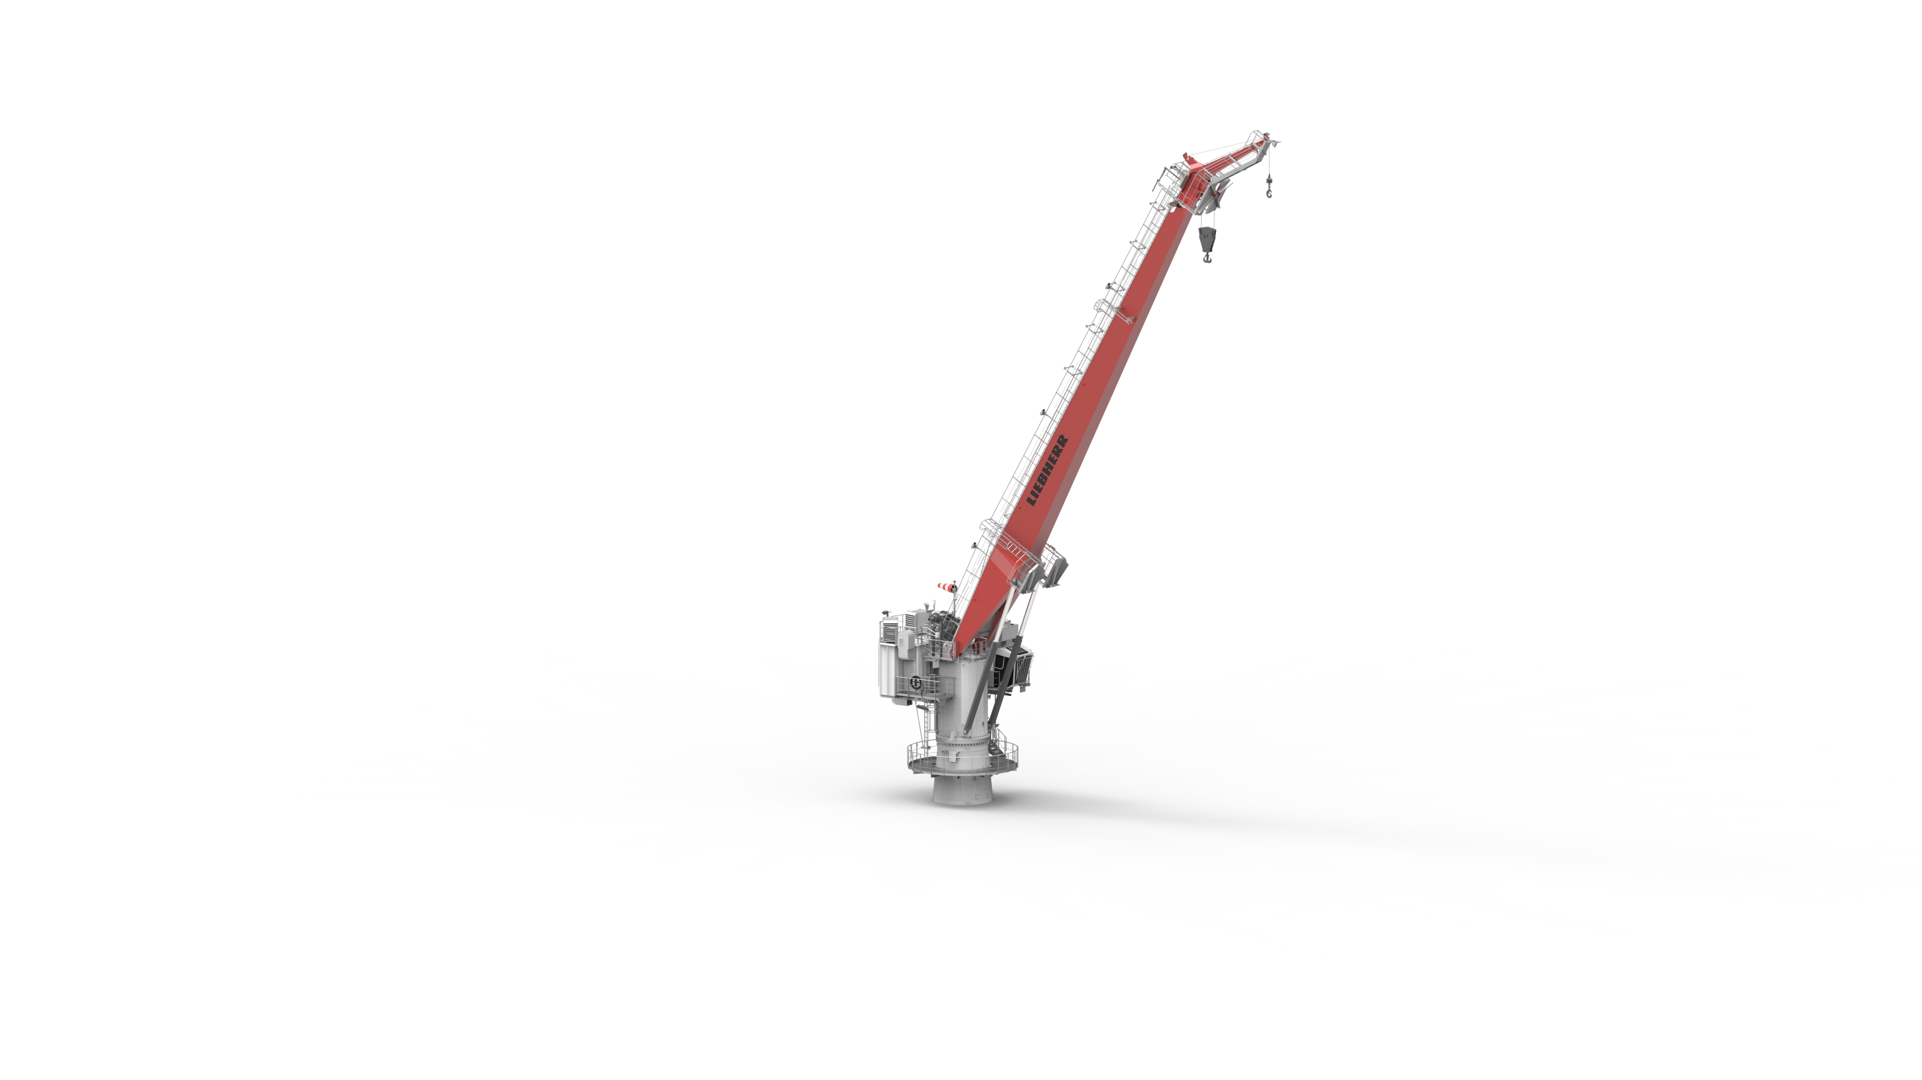

liebherr-rl-650-ineos-3.jpg  
The RL 650 has a maximum capacity of 15 tonnes and an outreach of 30 metres. The crane will fulfil all material handling on the offshore platform, from food or spare parts supply.

Contact

Constanze Jantsch

Marketing Manager – Offshore Cranes

Tel: +49 381 / 600650 - 22

Email: constanze.jantsch@liebherr.com

Published by

Liebherr-MCCtec Rostock GmbH

Rostock / Germany

www.liebherr.com