Press release

Hand in hand: Liebherr LTM 1650-8.1 and LTM 1450-8.1 mobile cranes master complex bridge renovation project

⸺
Mobile cranes assemble eight 85-tonne reinforced concrete girders over the Wupper river
Special tandem lift with triangular cross beam
The crane hooks were attached at height

Due to damage to the Hammesberg Wupper Bridge in Wuppertal Heckinghausen, built in 1965, it is now being replaced by a new bridge. After dismantling the old structure, two large Liebherr mobile cranes – an LTM 1650-8.1 from Autokrane Schares GmbH and an LTM 1450-8.1 from Dornseiff Autokrane & Schwertransporte GmbH – lifted eight 85-tonne precast concrete elements onto the abutments over the Wupper.
Ehingen (Donau) (Germany), 29 January 2024 – The damage to the Wupperbrücke Hammesberg bridge was so severe that it had to be closed to all vehicles weighing over 30 tonnes. In addition, a speed limit of 30 km/h was imposed on the bridge. To keep the closure of this important route as brief as possible, a construction method using prefabricated parts was chosen.
Meticulous planning for an exceptional tandem lift
However, as there was not enough space for a large crane to cope with the immense load on its own, the decision was made to use tandem lifts. On one side of the river, the LTM 1650-8.1 lifted the prefabricated reinforced concrete parts from the low-loaders across the Wupper up to its lifting capacity limit. At this point, the LTM 1450-8.1, which had been positioned on the other side of the river, came to the rescue. Working high in the air, technicians in a safety cage attached the hook of the 450-tonne crane to a special triangular cross beam.
Schares project manager Eric Reichmann explains: "Even the 800-tonne LTM 1750-9.1 wouldn't have been able to install the girders on its own. Furthermore, the transport vehicle would not have been able to drive alongside the crane. There was simply not enough space. So we had to use both banks of the river. The tandem lift solution required a 160-tonne triangular cross beam and an additional mobile crane with a safety cage. For this, we utilised our LTM 1100-4.1 with emergency take down system. When attaching the hook on the lifting gear below the triangular cross beam, different cable lengths were used to achieve a slight inclination of the concrete beams for installation on the slightly divergent abutment heights."
A total of eight reinforced concrete girders, each 32 metres long, were laid across the Wupper in two days using this unusual tandem method. The bridge is scheduled to reopen to traffic in the spring.
About Autokrane Schares GmbH
Autokrane Schares GmbH is an owner-managed company with 125 employees at four locations. Alongside framework agreements in the field of steel production and the chemical industry, as well as the maintenance and dismantling of wind turbines and the assembly of tower cranes, the company is strongly focused on structural engineering. In addition to two LTM 1650-8.1s and two LTM 1450-8.1s, it also operates 40 SPMT axles with four Power Pack units, up to twelve hydraulic lifting systems with capacities of 100 to 300 tonnes per unit. Three 3D CAD workstations equipped with AutoCAD are available for execution planning. This ensures precise time management for rail or motorway closures.
About Liebherr-Werk Ehingen GmbH
Liebherr-Werk Ehingen GmbH is a leading manufacturer of mobile and crawler cranes. Its range of mobile cranes extends from 2-axle 35 tonne cranes to heavy duty cranes with a lifting capacity of 1200 tonnes and a 9-axle chassis. Its lattice boom cranes on mobile or crawler travel gear deliver lifting capacities of up to 3000 tonnes. With universal boom systems and extensive additional equipment, they can be seen in action on construction sites throughout the world. The Ehingen site has a workforce of 4,300. An extensive, global service network guarantees the high availability of Liebherr mobile and crawler cranes. In 2022, the Liebherr plant in Ehingen recorded a turnover of 2.37 billion euros.
About the Liebherr Group
The Liebherr Group is a family-run technology company with a widely diversified product range. The company is one of the largest manufacturers of construction machines in the world. However, it also supplies high quality, user-focused products and services in many other sectors. The group currently comprises more than 140 companies based in every continent of the world. In 2022, it had a workforce of over 50,000 and recorded a consolidated total turnover of more than 12.5 billion euros. The company was founded in 1949 in Kirchdorf an der Iller in southern Germany. Since then, its aim has been to win customers by supplying high quality solutions and to contribute to technological progress.
Images
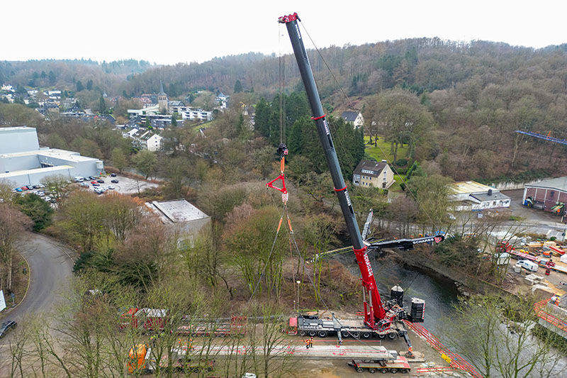
liebherr-ltm1650-schares-ltm1450-dornseiff-01.jpg
The LTM 1650-8.1 lifts the 85-tonne girders from the transport vehicle.
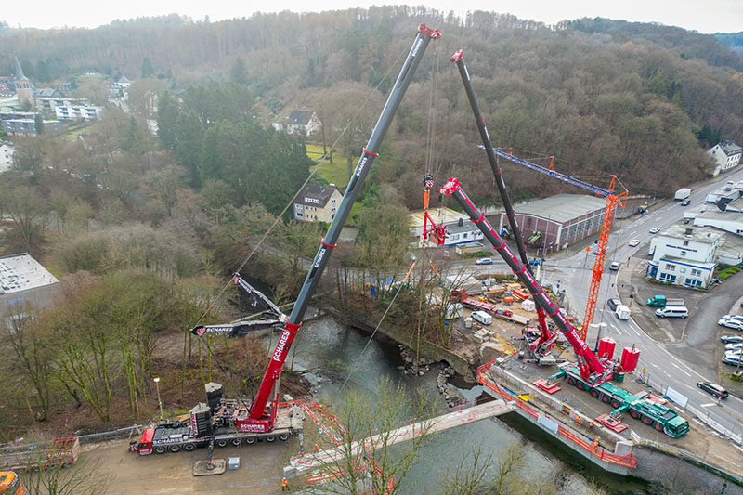
liebherr-ltm1650-schares-ltm1450-dornseiff-02.jpg
The LTM 1450-8.1 takes up part of the load over the Wupper. To do this, its hook is attached at height to a special triangular cross beam.
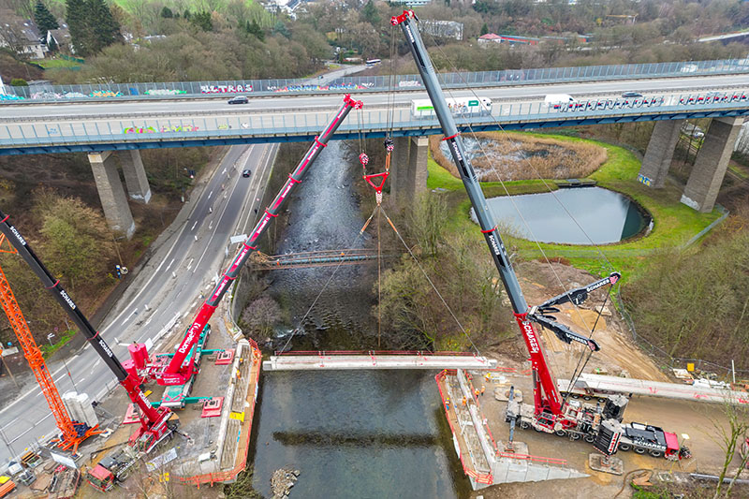
liebherr-ltm1650-schares-ltm1450-dornseiff-03.jpg
The reinforced concrete girders are placed on the abutments of the new bridge structure in a tandem lift.
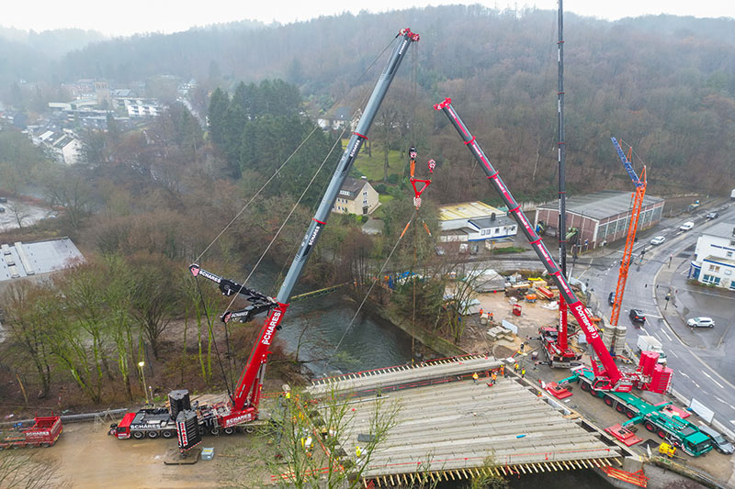
liebherr-ltm1650-schares-ltm1450-dornseiff-04.jpg
The two 8-axle mobile cranes finish their complex job with girder number eight.
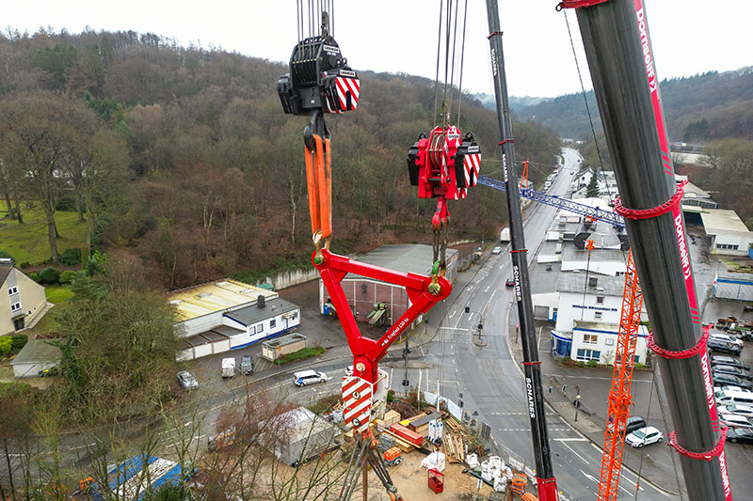
liebherr-ltm1650-schares-ltm1450-dornseiff-05.jpg
The gross load of the reinforced concrete girders including hook blocks and triangular cross beam was 95 tonnes. Depending on the radius, the LTM 1650-8.1 lifted 60 to 95 tonnes, while the LTM 1450-8.1 was required to lift 24 to 57 tonnes.

Contact
Wolfgang Beringer
Marketing and Communication
Phone: +49 7391/502 - 3663
Email: wolfgang.beringer@liebherr.com
Published by
Liebherr-Werk Ehingen GmbH
Ehingen (Donau) / Germany
www.liebherr.com

