Press release

Liebherr at Demolition San Antonio, March 6-9, 2024

⸺

Liebherr is the premier sponsor of the Live DEMOlition Event™ and the Operators Challenge at NDA’s Annual Convention and Expo

Liebherr showcases purpose-built demolition excavators and provides hands-on experience to participants

Liebherr’s earthmoving and material handling technology team exhibits at NDA’s annual Convention and Expo in March 2024 showcasing the R 930, R 934, and two R 938 crawler excavators. Attendees will also be able to get hands-on with these machines at the Live DEMOlition Event™ and Operators Challenge sponsored by Liebherr.

Newport News, VA (USA), Liebherr USA, Co, January 11, 2024 – The 50th anniversary of NDA’s annual Convention and Expo will take place in San Antonio, TX from March 6-9, 2024. Liebherr will showcase the [R 930](https://www.liebherr.com/en/usa/products/construction-machines/earthmoving/crawler-excavators/details/325349.html), [R 934](https://www.liebherr.com/en/usa/products/construction-machines/earthmoving/crawler-excavators/details/297243.html), and two [R 938](https://www.liebherr.com/en/usa/products/construction-machines/earthmoving/crawler-excavators/details/297252.html) crawler excavatos for attendees to operate outside and will have Liebherr experts on-site at booth #401.

Liebherr will also serve as the premier sponsor of the Live DEMOlition Event™ providing attendees a unique hands-on experience to test on-site equipment in real world applications. This live demo also includes a new Operators Challenge to test operators’ skill and knowledge of the equipment.

Liebherr crawler excavators: R 930, R 934, R 938

With more than 60 years of experience in the design and production of hydraulic crawler excavators, Liebherr is one of the major players in the manufacture of equipment for special applications including demolition, tunnel construction or handling as well as many other industry specific needs. Liebherr offers a wide range of crawler excavators with operating weights from 50,930 lbs. to 198,640 lbs. Each is designed with one goal in mind, to meet the demands and specifications of our customers in terms of performance, reliability, and efficiency, as well as safety and comfort.

The new R 930 provides customers with an option for the 66,000 lbs. class range. The new R 934 weighs approximately 70,000 lbs. and is positioned between the existing R 936 and the new R 938. The new R 938 crawler excavator replaces the previous R 946 at an operating weight of approximately 82,000 lbs. Each of these crawler excavators have been completely revamped as new Generation 8 machines. The Generation 8 update includes higher engine power, heavier counterweights for higher bucket capacities, and minimized fuel consumption. Other innovations include the boom concept with modified head, for better boom forces and an optimized load curve, which leads to fuel savings.

Performance data of the Liebherr crawler excavators

|  |  |  |  |
| --- | --- | --- | --- |
| Model: | R 930 | R 934 | R 938 |
| Engine power: | 245 hp / 180 kW | 272 hp / 200 kW | 299 hp / 220 kW |
| Dig Depth: | 24ft. 1in. | 24ft. 3in. | 24ft. 11in. |
| Operating weight: | 70,550 lbs. | 80,470 lbs. | 85,770 lbs. |
| Breakout force: | 45,860 lbs. | 50,130 lbs. | 53,510 lbs. |

About Liebherr USA, Co.

[Liebherr USA, Co](https://www.liebherr.com/en/usa/start/start-page.html). based in Newport News, VA provides sales and service on behalf of ten different Liebherr product segments: earthmoving, material handling, mining, mobile and crawler cranes, tower cranes, concrete technology, deep foundation machines, maritime cranes; components, and refrigeration and freezing.

About the Liebherr Group

The [Liebherr Group](https://www.liebherr.com/en/usa/about-liebherr/about-liebherr.html) is a family-run technology company with a highly diversified product portfolio. The company is one of the world's largest manufacturers of construction machinery. It also offers high-quality, user-oriented products and services in multiple other areas. Today, the group consists of more than 140 companies across all continents. In 2022, it employed more than 50,000 people and achieved combined revenues of over 12.5 billion euros. Liebherr was founded in 1949, in Kirchdorf an der Iller in southern Germany. Ever since then, the company’s employees have been committed to satisfying customers with advanced solutions and to helping drive technological progress.

Images

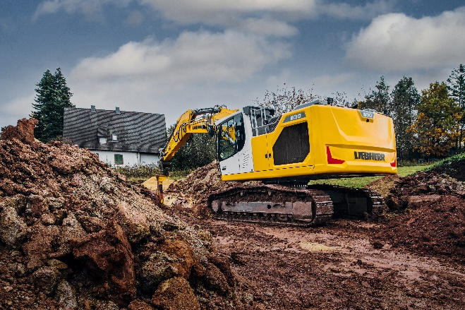

liebherr-R930.jpg  
The R 930 crawler excavator provides customers with an option for the 66,000 lbs. class range.

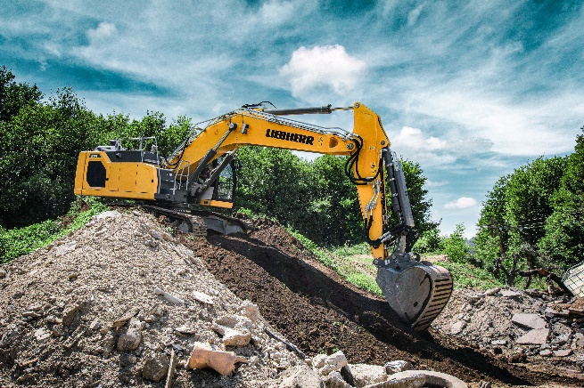

liebherr-R934.jpg  
The new R 934 weighs approximately 70,000 lbs. and is positioned between the existing R 936 and the new R 938.

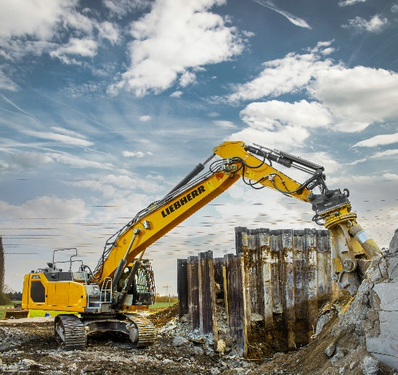

liebherr-R938.jpg  
Liebherr is one of the major players in the manufacture of equipment for special applications including demolition.

Contact

Ana Cabiedes   
Head of Marketing

Liebherr USA, Co  
E-Mail: ana.cabiedes@liebherr.com

Published by

Liebherr USA, Co.   
Newport News / USA  
www.liebherr.com