Press release

Strong performers: Liebherr presents new mid-sized wheel loader series

⸺

The new wheel loader series (8th generation) consists of three models: L 526, L 538, and L 546

The L 546 will be featured at World of Concrete 2024

New lift arms with optimized z-bar kinematics significantly increases performance

Increase in engine power and optimization of the hydrostatic travel drive

Modern equipment such as active personnel detection increases safety and comfort

Liebherr has redeveloped and fundamentally revised its range of mid-sized wheel loaders. The newly-designed lift arm ensures maximum breakout, holding and lowering forces. It has optimized z-bar kinematics and improved working hydraulics. Increases in engine power and tipping loads prepare the wheel loaders for demanding operations in various sectors, such as excavation, recycling or log handling. The new development of the mid-sized wheel loader series from Liebherr is also characterized by a powerful design and intelligent assistance systems. These includeactive personnel detection with brake assistant or the fully automatic quick-coupler system, Solidlink.

Newport News, VA (USA), January 23, 2024 – Liebherr will feature the [L 546 wheel loader](https://www.liebherr.com/en/usa/products/material-handling-equipment/wheel-loaders/details/650367.html) at World of Concrete 2024 for attendees to interact with at the tradeshow. The L 546 is one of three generation 8 mid-size wheel loader models. The three models, L 526, L 538, and L 546, in the latest Generation 8 have bucket sizes between 2.2 and 3.0 m³ in the standard version and are characterized by a significant increase in performance compared to the previous generation. The new L 526 offers around 20 percent more engine power and over 20 percent higher breakout forces than its predecessor. The L 538 and L 546 models also exhibit performance increases in all areas: for example, with the optimized travel drive, providing increased traction to ensure that the new wheel loaders accelerate dynamically in everyday work, and can penetrate powerfully into all materials. The three models are now available to order.

Powerful and versatile: Newly developed lift arms with optimized z-bar kinematics

Liebherr has reinforced the steel construction of the front section of the new wheel loaders to prepare the machines for handling heavy loads. Structural reinforcements on the new lift arms, for example on the lift arms or the cross tube, increase strength. The optimized z-bar kinematics with electro-hydraulic pilot controls has larger hydraulic cylinders and more powerful working pumps. The combination of these innovations enables faster cycle times and dynamic and powerful work movements – even with heavy attachments such as high dump buckets or log grapples.

With the increased performance providing a strong basis, Liebherr offers numerous equipment options for the lift arms for industry-specific challenges. High lift arms, for example, are an extended variant of the z-bar kinematics and ensure greater range and efficient loading processes at all heights. For wheel loader applications that regularly require different attachments, there is a view-optimized quick coupler and the fully automatic quick-coupler system, Solidlink. This allows the machine operator to change between mechanical and hydraulic working tools from the cab quickly and safely at the touch of a button. This saves time and reduces the risk of accidents.

Well thought-out details make day-to-day work with the wheel loaders easier. For example, you can activate the parallel guidance of the lift arms at the push of a button and thus work efficiently and safely with forks. The new, optional bucket-tilt assist helps when working with sticky materials, such as damp soil or compost, and ensures accurate loading by shaking out the bucket. While redesigning the lift arms, Liebherr has also revised the bucket design of the new mid-sized wheel loaders. Consequently, customers can now more accurately tailor the individual elements and wear parts of the buckets to their needs at the time of ordering.

Powerful and modern: Optimized travel drive and intelligent equipment

In addition to the new lift arms, the optimization of the hydrostatic travel drive contributes to the increased productivity of the wheel loaders. The new, more powerful engines are characterized by a higher maximum torque at a lower nominal speed. In this way, performance and efficiency can be increased with the same low fuel consumption. More powerful hydraulic components, such as larger travel motors and travel pumps, ensure greater traction in all three models and thus rapid loading cycles. For a high degree of robustness, Liebherr has reinforced the axles, as well as travel drive components; depending on the model, all three-wheel loaders have larger front or rear axles than their predecessors.

A modern design, which is reflected in the engine hood were designed for optimized visibility as well as the comfortable operator’s cab, and intelligent equipment are also part of the overall package of the new mid-sized Liebherr wheel loaders. An example of this is the active personnel detection with brake assistant. This optional assistance system, which is installed at the rear of the wheel loader, warns the machine operator visually on the display and with acoustic signals of dangers in the rear area of the wheel loader. To provide a specific warning of imminent injury to persons, the assistance system independently distinguishes between humans and objects using smart sensors. As soon as the active personnel detection emits a warning signal, the brake assistant automatically reduces the speed of the wheel loader to a standstill, to avoid a potential accident.

Performance data of the new mid-sized Liebherr wheel loaders

|  |  |  |  |
| --- | --- | --- | --- |
| Model: | L 526 | L 538 | L 546 |
| Tipping load: | 19,245 lbs. | 21,275 lbs. | 24,275 lbs. |
| Bucket capacity: | 2.9 y3 | 3.4 y3 | 3.9 y3 |
| Operating weight: | 29,035 lbs. | 32,010 lbs. | 33,975 lbs. |
| Engine power: | 116 kW / 156 | 129 kW / 173 | 138 kW / 185 |

All specifications refer to the standard version. All three-wheel loaders meet the currently applicable emission standards of emission stage V or Tier 4 final.

About Liebherr USA, Co.

[Liebherr USA, Co](https://www.liebherr.com/en/usa/start/start-page.html). based in Newport News, VA provides sales and service on behalf of ten different Liebherr product segments: earthmoving, material handling, mining, mobile and crawler cranes, tower cranes, concrete technology, deep foundation machines, maritime cranes; components, and refrigeration and freezing.

About Liebherr-Werk Bischofshofen GmbH

Liebherr-Werk Bischofshofen GmbH develops, produces, and sells wheel loaders from the Liebherr Group. The plant in the state of Salzburger Land (Austria) has grown steadily over the decades thanks to sustainable innovations, creative solutions and high-quality standards. The wheel loader range is constantly being expanded and includes different models in four different product groups: compact, stereo, mid-sized, and large wheel loaders, which have impressive, innovative drive designs.

About the Liebherr Group

The Liebherr Group is a family-run technology company with a highly diversified product portfolio. The company is one of the largest construction equipment manufacturers in the world. It also provides high-quality and user-oriented products and services in a wide range of other areas. The Liebherr Group includes over 140 companies across all continents. In 2021, it employed more than 49,000 staff and achieved combined revenues of over 11.6 billion euros. Liebherr was founded in Kirchdorf an der Iller in Southern Germany in 1949. Since then, the employees have been pursuing the goal of achieving continuous technological innovation and bringing industry-leading solutions to its customers.

Images

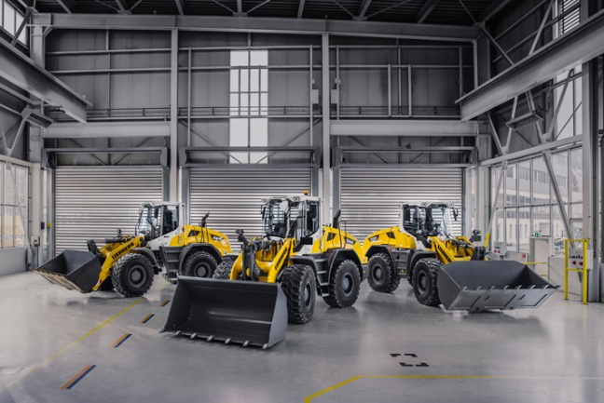

liebherr-new-mid-sized-wheel-loaders-all-three-models.jpg  
Powerful and versatile: The new mid-sized wheel loader series from Liebherr feature the L 526, L 538 and L 546 models.

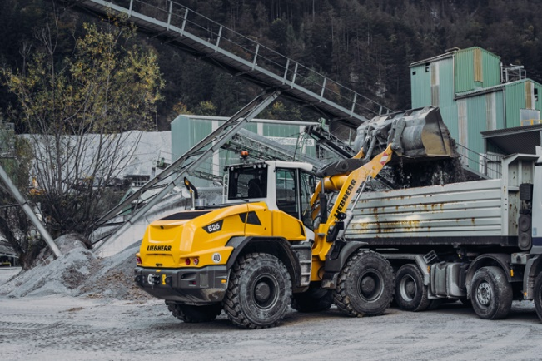

liebherr-new-mid-sized-wheel-loader-l526-quarry.jpg  
More engine power, higher breakout forces: the new Liebherr L 526 wheel loader loading a truck.

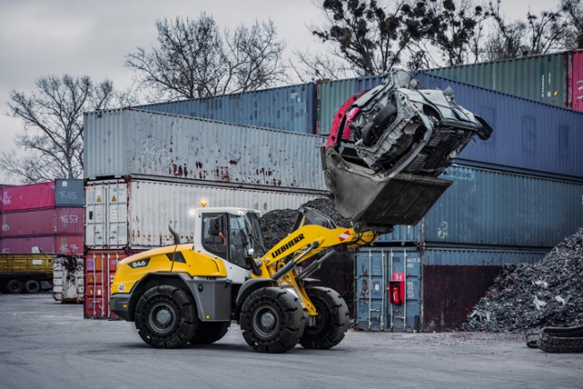

liebherr-new-mid-sized-wheel-loader-l546-recycling.jpg  
High performance in use: A new Liebherr L 546 wheel loader loads bulky and heavy materials in recycling.

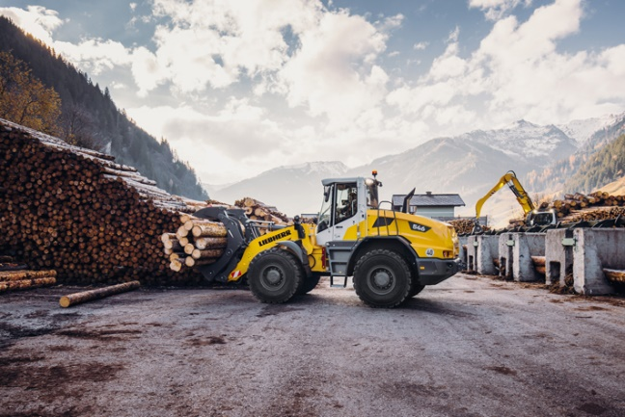

liebherr-new-mid-sized-wheel-loader-l546-timber.jpg  
New lift arms with high performance: The new Liebherr L 546 wheel loader transports logs with a log grapple.

Contact

Ana Cabiedes   
Head of Marketing

Liebherr USA, Co  
E-Mail: ana.cabiedes@liebherr.com

Martin Koller  
Marketing and Public Relations  
Phone: +43 50809 11475  
E-mail: martin.koller.lbh@liebherr.com

Published by

Liebherr-Werk Bischofshofen GmbH  
Bischofshofen/Austria  
www.liebherr.com