Press release

New ring-pan mixer for highest quality concrete

⸺

Raises the standards for productions of high-quality concrete even higher

Liebherr exhibitis the RIM 2.25 M ring pan mixers at the 2024 World of Concrete tradeshow.

Newport News, VA (USA), Liebherr USA, Co, January 23, 2024 – Ring-pan mixers by Liebherr have been successfully in operation in concrete plants for many years worldwide. The Rim 2.25 M ring-pan mixer raises the standards for production of high-quality concrete mix even higher.

An advantage of all Liebherr ring-pan mixer systems is the ring-trough system. The special form of the ring canal guarantees that the complete mix is forced to flow in the mixing chamber through the paddles or mixing tools and is completely homogenized very rapidly. The mix cannot avoid the tools.

The RIM models are considered the most versatile mixer, due its design that ensures full movement of the material inside the mixing chamber, plus the high speed agitator that ensures high shearing forces that ensures good mixing quality in a shorter time.

Open construction has tremendous advantages

The wide-open trough allows optimal material feed and free access to the mixing tools for all ring-pan mixers. Moreover, this type of construction allows quick and thorough cleaning. The generously designed mixer cover, free from overhead attachments, makes it possible to open the mixer, depending on the application, between 30% and 60%. This ensures easy access from above and, accordingly, easy maintenance. The gear and the drive motors are arranged below the mixer and are easily accessible. This leaves sufficient room for the components required for material feed and dedusting on the upper side. Liebherr, drawing on its great experience potential, can offer both innovative mixer systems and complete mixing plants for concrete production.

About Liebherr USA, Co.

[Liebherr USA, Co](https://www.liebherr.com/en/usa/start/start-page.html). based in Newport News, VA provides sales and service on behalf of ten different Liebherr product segments: earthmoving, material handling, mining, mobile and crawler cranes, tower cranes, concrete technology, deep foundation machines, maritime cranes; components, and refrigeration and freezing.

About the Liebherr Group

The [Liebherr Group](https://www.liebherr.com/en/usa/about-liebherr/about-liebherr.html) is a family-run technology company with a highly diversified product portfolio. The company is one of the largest construction equipment manufacturers in the world. It also provides high-quality and user-oriented products and services in a wide range of other areas. The Liebherr Group includes over 140 companies across all continents. In 2021, it employed more than 49,000 staff and achieved combined revenues of over 11.6 billion euros. Liebherr was founded in Kirchdorf an der Iller in Southern Germany in 1949. Since then, the employees have been pursuing the goal of achieving continuous technological innovation, and bringing industry-leading solutions to its customers.

Images

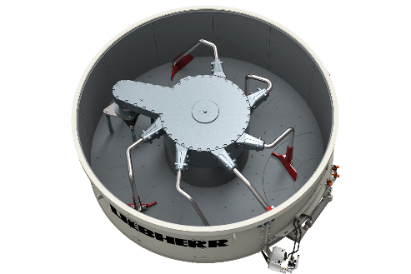

liebherr-RIM-1-5-M.jpg  
The RIM 2.25 M ring pan mixer offers continuance movement inside the mixing chamber for better performance.

Contact

Ana Cabiedes   
Head of Marketing

Liebherr USA, Co  
E-Mail: ana.cabiedes@liebherr.com

Published by

Liebherr USA, Co.   
Newport News / USA  
www.liebherr.com