Press release

One soul on two stages

⸺

**In Chavdar, over 70 km east of Sophia in Bulgaria, Geoservice Engineering (GSE) is building a cut-off wall around a settling basin at a local copper mine. The Bulgarian soil technology experts are using the LRB 355.1 piling and drilling rig from Liebherr for the job. As a passionate rock musician and CTO of the company, Anton Sariev knows what connects the two worlds: "You need soul and the right equipment for a successful performance."**

Nenzing (Austria), 3 June 2024 − The 12-kilometre long cut-off wall around the settling basin at a local copper mine is designed to prevent water from escaping. Geoservice Engineering (GSE) is using the Liebherr LRB 355.1 piling and drilling rig with 3-fold mixing rods for the job. "In this particular case, the soil mixing process is superior to any other technique. From an economic and ecological point of view, the use of local material as construction material definitely has positive effects," explains Anton Sariev. With this application, no material for the cut-off wall has to be delivered or removed because existing soil material is mixed with the binder suspension. In addition to the time and cost savings, soil mixing has the advantage of being very quiet and low in vibration. The Bulgarian company mixes with the piling and drilling rig to a depth of 20 metres and with a diameter of one metre.

Anton Sariev, Chief Technical Officer (CTO) at GSE sees many similarities in his two passions for large construction machines and music. "I can compare operating the LRB 355.1 to playing the guitar or drums − you have to work with your whole body. Everything is perfectly harmonised and you have to be 100 per cent committed to the cause. The ‘vibes’ are definitely similar."

"Then that's it"

The piling and drilling rig LRB 355.1 from Liebherr can be modularly equipped with one, two or three mixing rods as a longitudinal or transverse attachment. While the single or double versions are used for large mixing diameters and large areas, the triple version has the advantage of being very fast when – as in Chavdar – long cut-off walls have to be installed.

Using the right equipment for the respective requirements is essential for Anton Sariev – on the construction site and in music. But he emphasises, "I think it's even more important with the piling and drilling rig because you can hide mistakes in music, or at least try to disguise them. But if you get to the construction site and the machine doesn’t perform properly, then that's it." GSE decided in favour of the LRB 355.1 because of its good performance data and because Liebherr is well represented in Bulgaria. "It's a complex device with a lot of electronics that need to be serviced regularly. This requires someone who is reliable. We are very happy with our choice."

After a year of construction, GSE has completed the project in Chavdar. Anton Sariev knows what is important for the successful realisation of projects: "A good relationship with your band mates or with your team on site – that's the key to success. The equipment and the staff on site are everything. I think both worlds, live music and working on the construction site, have one thing in common: it always requires a lot of soul."

Film: <https://www.youtube.com/watch?v=JV3Q98yeLmE>

About the Liebherr Group – 75 years of moving forward

The Liebherr Group is a family-run technology company with a highly diversified product portfolio. The company is one of the largest construction equipment manufacturers in the world. It also provides high-quality and user-oriented products and services in a wide range of other areas. The Liebherr Group includes over 150 companies across all continents. In 2023, it employed more than 50,000 staff and achieved combined revenues of over 14 billion euros. Liebherr was founded by Hans Liebherr in 1949 in the southern German town of Kirchdorf an der Iller. Since then, the employees have been pursuing the goal of achieving continuous technological innovation and bringing industry-leading solutions to its customers. Under the slogan ‘75 years of moving forward’, the Group celebrates its 75th anniversary in 2024.

Images

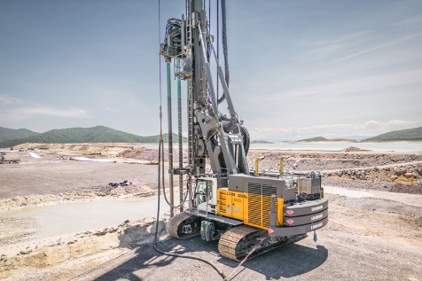

liebherr-lrb 355.1_1.jpg  
Whether drilling, vibrating or pile driving, the LRB 355.1 from Liebherr can be used universally.

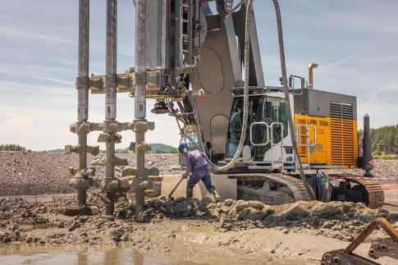

liebherr-lrb 355.1_2.jpg  
GSE creates the cut-off wall with the LRB 355.1 and 3-fold mixing rods.

Contact

Gregor Griesser  
Strategic Marketing and Communications  
Email: [gregor.griesser@liebherr.com](mailto:gregor.griesser@liebherr.com)

Wolfgang Pfister  
Head of Strategic Marketing and Communications  
Tel.: +43 50809 41-444  
Email: [wolfgang.pfister@liebherr.com](mailto:wolfgang.pfister@liebherr.com)

**Published by**

Liebherr-Werk Nenzing GmbH  
Nenzing/Austria  
[www.liebherr.com](http://www.liebherr.com)