Press release

Liebherr cranes are working on the final phase of the Sagrada Família construction project

⸺

The 710 HC-L 32-64 Litronic and 125 HC-L luffing jib cranes are ideal for this challenging project

The main crane is the Liebherr 710 HC-L model, which will be working on the Tower of Jesus Christ, currently standing at 135 metres high

Major project challenges include the unique assembly of the Liebherr 710 HC-L and 125 HC-L luffing jib cranes, the site’s central location in Barcelona and the basilica’s visitor traffic during crane erection

An efficient collaboration: the engineering department of Liebherr Tower Crane Solutions, Liebherr Ibérica and Grúas Cerezo, together with the construction department of the Sagrada Família

Contributing to a project as iconic as the Basilica of the Sagrada Família, which has been under construction for over 140 years, is a rare experience. The Liebherr 710 HC-L and 125 HC-L luffing jib cranes have been selected to bring this project to completion, with the primary task being the completion of the Tower of Jesus Christ, the temple’s main tower set to reach 172 metres in height. Their collapsibility and adaptability to site requirements were decisive factors in the Sagrada Família's decision to select this equipment.

Azuqueca de Henares, Guadalajara (Spain), 12 June 2024 – “The Temple of the Sagrada Família will represent the future of modern Catalonia,” this is how the architect Antonio Gaudí described his masterpiece, which began construction in 1882 in Barcelona. 2024 will be a significant year for this architectural feat, as the Liebherr 710 HC-L 32-64 Litronic and 125 HC-L luffing jib cranes will begin their work on completing the basilica. “The construction department of the Sagrada Família chose these cranes for two main reasons: firstly, their folding design minimises the impact on surrounding buildings, and secondly, their adaptability to the area’s specific requirements,” explains Fernando Villa, director of construction and technology at the Sagrada Família. “Liebherr is a global leader in the tower crane sector, and we are experts in special projects. Our engineering department, known as Tower Crane Solutions, comprises qualified professionals with many years of experience who plan the manoeuvres according to the specific needs of each project,” adds Roberto Insausti, commercial director of the tower crane and mobile construction crane division at Liebherr Ibérica. Thus, the Liebherr 710 HC-L 32-64 Litronic luffing jib crane of the Sagrada Família will be responsible for completing the Tower of Jesus Christ, the temple’s main tower, which is set to reach 135 metres in height. The Sagrada Família required a crane with a high lifting capacity; this equipment has a maximum lifting capacity of 64 tonnes and sufficient radius, in this case 55 metres, to cover the highest parts of the construction. The Liebherr 125 HC-L crane, meanwhile, will be working on the Chapel of the Assumption and the adjacent cloisters.

Main project challenges

A major challenge for this project was “to develop a solution for our largest luffing jib crane, the Liebherr 710 HC-L 32-64 Litronic, which could be erected at a height of approximately 54 metres and comply with the highest safety requirements. The crane then had to be brought to its final height and anchored to the Tower of Jesus Christ at a height of approximately 130 metres,” says Jochen Wille, Project Manager at Liebherr Tower Crane Solutions (TCS). A special bracing structure, measuring 20 metres long, 10 metres wide and weighing 27 tonnes, had to be designed and manufactured specifically for this phase. "Thanks to the close cooperation between the customer, our local supplier Grúas Cerezo and the Tower Crane Solutions department at the Liebherr factory in Germany, we managed to develop a tailor-made project for the customer," adds Tobias Böhler, General Manager of Liebherr Ibérica.

The assembly of the Liebherr 710 HC-L and 125 HC-L luffing jib cranes required extensive planning due to the stringent safety requirements and weather conditions. The erection, especially the telescoping, could only proceed under specific wind speeds. Moreover, the Sagrada Família’s location in the heart of Barcelona limits the availability of spacious work areas for manoeuvres, necessitating meticulous planning and detailed operations. Furthermore, the installation process faced a constant influx of tourists to this globally renowned site. As a result, the assembly of the Liebherr luffing jib cranes had to be completed swiftly, with minimal disruption to the cathedral’s construction work and the daily flow of visitors.

The use of luffing jib cranes will be another major challenge and “something unprecedented in Spain, which represents a significant commitment for us, as we début in this project where there is no room for error or doubt,” emphasises Miguel Cerezo, manager of Grúas Cerezo, the official distributor of Liebherr tower cranes. “The use of luffing jib cranes has many advantages because they are equipped with large load curves and can work in very tight spaces, thanks to the jib’s folding movement,” explains Gerardo Urendez, Head of Technical Service for Tower Cranes and Mobile Construction Cranes at Liebherr Ibérica.

Trusted partners

Liebherr’s tower crane division includes the Liebherr Tower Crane Solutions department, which has actively supported the Sagrada Família project from the beginning. “We specialise in planning large and demanding projects worldwide. We're the go-to experts for complex solutions and challenging applications, just like in this case,” concludes Jochen Wille.

In this project, Grúas Cerezo played a key role and will continue to do so as the third link in the chain: Liebherr 125 HC-L and 710 HC-L luffing jib cranes are the key pieces of the project, Liebherr as the equipment manufacturer responsible for crane after-sales service and Grúas Cerezo providing support as a local distributor, offering technical-legal advice, equipment assembly, as well as predictive and corrective maintenance.

About the Liebherr Tower Cranes Division

More than seven decades of experience have made Liebherr a recognised specialist for lifting technology on all types of construction sites. The range of Liebherr Tower Cranes encompasses an extensive selection of high-quality tower cranes that are used worldwide. This includes fast-erecting, top-slewing, luffing jib and special-purpose cranes as well as mobile construction cranes. In addition to these products, Liebherr also offers a wide range of services that complete the company’s portfolio: Tower Crane Solutions, the Tower Crane Center and Tower Crane Customer Service.

About Liebherr Ibérica, S.L.

Liebherr Ibérica, founded in 1988, is the Spanish sales and service company of the Liebherr Group. Currently, Liebherr Ibérica is responsible for sales and after-sales service for the mobile and crawler crane division, tower cranes, earthmoving, mining, construction machinery and maritime cranes.

About the Liebherr Group – 75 years of moving forward

The Liebherr Group is a family-run technology company with a highly diversified product programme. The company is one of the largest construction equipment manufacturers in the world. It also provides high-quality, user-oriented products and services in a wide range of other areas. The Liebherr Group includes over 150 companies across all continents. In 2023, it employed more than 50,000 staff and achieved combined revenues of over 14 billion euros. Liebherr was founded by Hans Liebherr in 1949 in the southern German town of Kirchdorf an der Iller. Since then, the employees have been pursuing the goal of achieving continuous technological innovation and bringing industry-leading solutions to its customers. Under the slogan ‘75 years of moving forward’, the Group celebrates its 75th anniversary in 2024.

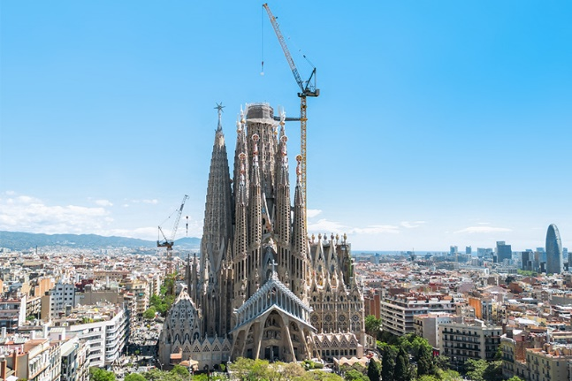Images

liebherr-710-hc-l-125-hc-l-sagrada-familia-01.jpg  
Liebherr 710 HC-L and 125 HC-L luffing jib cranes are in action in the final phase of the Sagrada Família construction project.

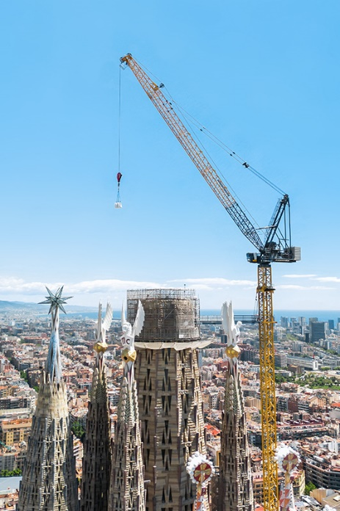

liebherr-710-hc-l-125-hc-l-sagrada-familia-02.jpg  
The main crane is the Liebherr 710 HC-L model and will be working on the Tower of Jesus Christ, which will stand at 172 metres in height.

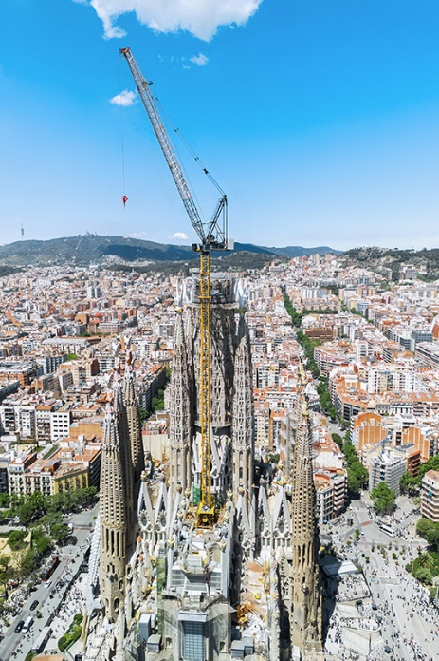

liebherr-710-hc-l-125-hc-l-sagrada-familia-03.jpg   
Major challenge: to develop a solution so that the Liebherr 710 HC-L 32-64 Litronic luffing jib crane could be erected at a height of approximately 54 metres and comply with the highest safety requirements.

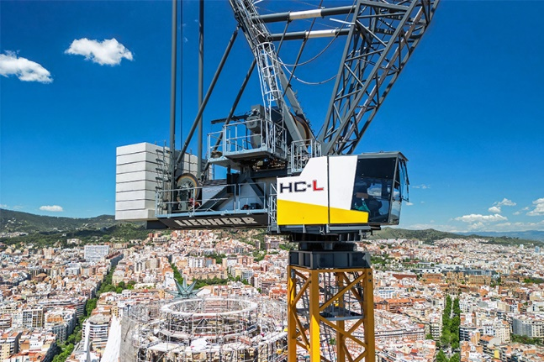

liebherr-710-hc-l-125-hc-l-sagrada-familia-04.jpg  
The use of luffing jib cranes has many advantages because they are equipped with large load curves and can work in very tight spaces, thanks to the jib’s folding movement.

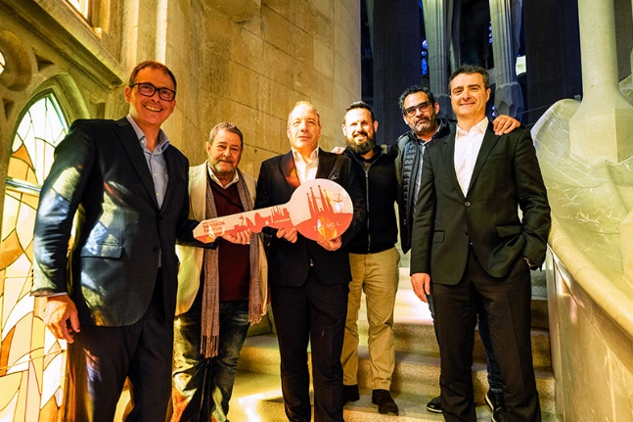

liebherr-710-hcl-sagrada-familia-official-delivery.jpg

liebherr-710-hc-l-125-hc-l-sagrada-familia-05.jpg  
Official delivery of the Liebherr 710 HC-L luffing jib crane. From left to right: Fernando Villa, Sagrada Familia; Antonio Cerezo, Grúas Cerezo; Tobias Böhler, Liebherr Ibérica; Daniel Morales, Sagrada Familia; Miguel Cerezo, Grúas Cerezo and Roberto Insausti, Liebherr Ibérica.

Contact

Astrid Kuzia  
Communication Specialist  
Phone: +49 7351 / 41– 4044  
Email: astrid.kuzia@liebherr.com

María Villanueva  
Marketing Manager  
Telephone: +34 690 329 365  
Email: maria.villanueva@liebherr.com

Published by

Liebherr-Werk Biberach GmbH  
Biberach / Germany  
[www.liebherr.com](http://www.liebherr.com)

Liebherr Ibérica  
Azuqueca de Henares, Guadalajara / Spain  
www.liebherr.com