Press release

Liebherr Zambia celebrates 10th anniversary

⸺

On 7 June, Liebherr Zambia celebrated its 10th anniversary as part of the Liebherr Group.

Liebherr Zambia was founded in June 2014 to support mining operations in the Zambian Copperbelt.

The company now has a workforce of more than 100 employees and operates out of three locations.

The anniversary festivities included a tour of the Kitwe branch, speeches from Liebherr Zambia’s managing directors, team-building activities, and a celebratory lunch.

Last week, Liebherr Zambia celebrated its 10th anniversary. This Liebherr sales and service company was founded in June 2014 to provide support for mining activities in the Zambian Copperbelt.

Colmar (France), 12 June 2024. Liebherr Zambia’s 10th anniversary was the perfect opportunity for employees from branches around the country to come together and celebrate all that had been achieved in the past decade. Employees travelled to the Kitwe branch to begin the celebrations with a tour of Kitwe’s office, warehouse, and remanufacturing facilities before attending a company-wide address from Liebherr Zambia’s managing directors, who said a few words about the company’s journey and achievements over the past decade. Employees also celebrated with team building activities and a lunch.

“We appreciate everyone who has supported Liebherr Zambia during our journey,” says Henri Wassink, Managing Director of Administration, Liebherr Zambia. “We thank our employees for their dedication, creativity, and loyalty over the past 10 years and look forward to what we will achieve together in the years to come.”

**How it started**

Liebherr Zambia was originally founded to support mining operations in the Zambian Copperbelt, so named for the rich deposits of copper within the region. During its first five years, Liebherr Zambia was solely a Liebherr Mining sales and service company, providing machinery, technical support, and spare parts to the open-cast copper mines in the country. However, in 2019, the company began offering equipment from Liebherr’s earthmoving product segment to expand its support capabilities and work alongside the gemstone industry as well as contractors providing mining and construction services.

“When we first opened, we had a handful of employees: one accountant, one parts representative, and a single technician,” says Wassink. “Today, Liebherr Zambia is more than 100 employees strong, and we are present on different customer sites.”

**Remaining competitive**

Despite being home to 20% of the world’s emeralds and being the seventh largest copper producer in the world, the Zambian mining industry is a small one and therefore extremely competitive. To meet customers’ high expectations, Liebherr Zambia has developed a variety of tailored support solutions that range from ad hoc and on-call support to full service contracts with more than 70 people involved.

“Customers’ needs are rarely static. As such, it’s important that we regularly engage with our customers to be sure that the supports and resources we provide, such as spare parts, are always exactly what they need,” says Jeffery Johnson, Service Manager, Liebherr Zambia.

**An important part to play**

In recent years, Liebherr Zambia has played a significant role in the development of product innovations such as Liebherr’s Trolley Assist System for haul trucks and the D98 series of combustion engines, designed specifically for the mining industry. In 2016, Liebherr Zambia welcomed the first two T 284 haul trucks in Africa. These were the first trucks to operate using Liebherr’s trolley and pantograph technology – a crucial step forward in the design and development of the Liebherr Trolley Assist System available today.

“The success of the trolley trial in Zambia paved the way for a substantial international sale of a T 284 fleet using trolley technology,” enthuses Sebastien Tomasina, Managing Director of Operations, Liebherr Zambia.

During the validation of the D98 series of combustion engines, Liebherr Zambia commissioned the first D9812 12-cylinder engine in 2018. Three years later, Liebherr Zambia repowered a T 284 haul truck so that it was the first to run on a D9816 16-cylinder engine. These were crucial steps in the creation of Liebherr’s D98 range of engines, which has now been adopted by customers in major mining markets all over the world.

**Growing and expanding**

“A key driver in our ability to cope with the rapid expansion and evolution in the industry in which we operate has been the core values of the Liebherr Group that have shaped our organisational culture,” says Kaluba Chaikatisha, General Manager, Finance and Administration, Liebherr Zambia. “These have driven, and continue to drive, the quality in our output, the innovation required to optimise solutions, and the trust we build with our stakeholders.”

When Liebherr Zambia first opened its doors 10 years ago, the company had just the one location and employees you could count on one hand. Today, Liebherr Zambia operates locations in Kitwe, Lusaka, and Kalumbila; represents multiple Liebherr product segments; and supports customers from a range of different industries.

“I am so proud to be part of the Liebherr Zambia team. Our diverse and talented workforce thrives on teamwork and supporting the business in reaching its business objectives,” says Muonga Kaunda, Head of Human Resources, Liebherr Zambia. “I’m excited to see what the next 10 years brings for us!”

2024 also marks the 75th anniversary of the Liebherr Group, with celebrations taking place in locations all over the world throughout the year.

**About Liebherr Mining**

Liebherr Mining is one of 13 product segments within the wider Liebherr Group and has been designing, manufacturing, and supporting mining equipment for over 50 years. The company provides a full range of solutions, including high-quality trucks, excavators, and dozers along with technology and service products that help customers get the very best out of their Liebherr machines. Liebherr Mining is also working hard to offer low and zero emission options for all of its equipment to support customers as they embark on their decarbonisation journeys. The company has a global presence with over 4,400 employees in 70 countries around the world.

**About the Liebherr Group – 75 years of moving forward**

The Liebherr Group is a family-run technology company with a highly diversified product programme. The company is one of the largest construction equipment manufacturers in the world. It also provides high-quality, user-oriented products and services in a wide range of other areas. The Liebherr Group includes over 150 companies across all continents. In 2023, it employed more than 50,000 staff and achieved combined revenues of over 14 billion euros. Liebherr was founded by Hans Liebherr in 1949 in the southern German town of Kirchdorf an der Iller. Since then, the employees have been pursuing the goal of achieving continuous technological innovation and bringing industry-leading solutions to its customers. Under the slogan ‘75 years of moving forward’, the Group celebrates its 75th anniversary in 2024.

Images

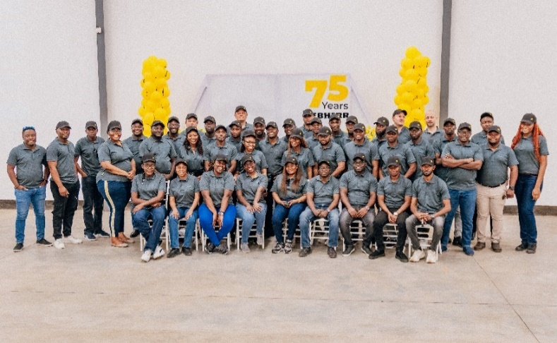

liebherr-LZM-group-photo-240dpi.jpg  
The Liebherr Zambia team commemorating its 10th anniversary.

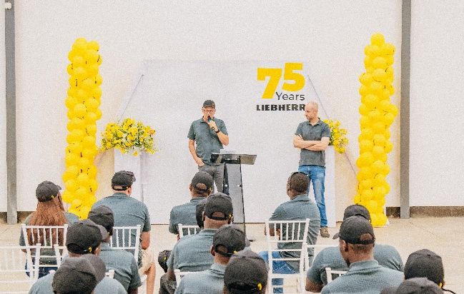

liebherr-LZM-speeches-240dpi.jpg  
Liebherr Zambia’s managing directors made speeches, highlighting the achievements of the company over the past decade.

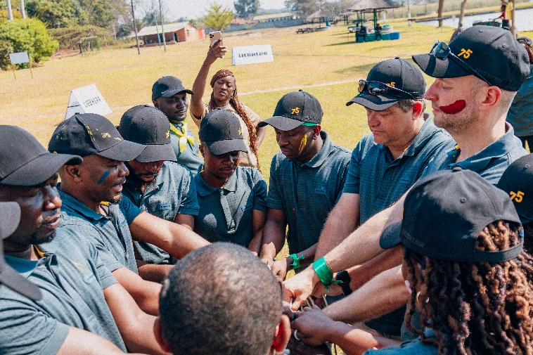

liebherr-LZM-team-building-activities-240dpi.jpg  
What better way to celebrate than with some team-building activities!

liebherr-T284-trolley-Zambia-72dpi.jpg  
One of the first T 284 haul trucks in Africa, operating under Liebherr’s Trolley Assist System.

Contact

Swann Blaise  
Divisional General Manager: Marketing & Business Intelligence  
Phone: +1 757 928 2239  
E-mail: swann.blaise@liebherr.com

Published by

Liebherr-Mining Equipment SAS   
Colmar / France  
www.liebherr.com