Press release

Sand kings: XPower wheel loaders and their smart machine concept are ideal for handling sand and gravel

⸺

Innovative bucket and lift assist systems make work cycles more effective

Power-split Liebherr XPower travel drive for fuel efficiency

Impressive service expertise, spare parts availability and machine quality

**For more than 20 years, Hülskens GmbH & Co. KG has been using powerful Liebherr machines for extracting and processing mineral raw materials. Eleven XPower wheel loaders perform part of the material handling on the site. Smart assistance systems ensure more effective work cycles and easier operation of the wheel loaders. In addition to the excellent machine quality, Hülskens appreciates Liebherr's outstanding service expertise and availability of spare parts.**

Wesel am Rhein (Germany), June 2024 – Hülskens GmbH & Co. KG processes several hundred thousand tonnes of mineral raw materials each year. Around 60% of this is used for concrete production and subsequently for tunnel and housing construction, infrastructure projects or the repair of bridges in the region. In addition to floating bucket chain excavators and suction dredgers, the group uses robust and powerful Liebherr construction machinery for extracting and processing raw materials. At the GMG site near Weeze, an L 580 XPower transfers the sorted and cleaned material to heaps and loads trucks with gravel and sand. The average loading cycle on the site, which covers several dozen hectares, is between 10 and 25 metres. This is where the advantages of the power-split XPower travel drive come into play. It combines both hydrostatic and mechanical propulsion, ensuring maximum performance and efficiency for every task. "The XPower wheel loaders are impressive across the board and are enormously powerful. When reloading, an L 580 XPower only consumes about 17 litres of diesel per operating hour on average," explains Ingo Thielen, press officer of Hülskens Holding GmbH & Co. KG.

**Smart assistance systems help the operator handle raw materials**

Innovative assistance systems and clever installation of components increase productivity and reduce wear while carrying out the challenging work. A bucket tilt assistant helps when dumping the material to ensure that it is evenly distributed. In addition, programmable bucket return-to-dig and auto lifting and lowering functions allow the bucket and lift arms to be automatically returned to a set position. Stepless traction control combined with automatic self-locking differentials prevent the wheels from spinning while loading.

24-hour spare parts service reduces downtime

"We appreciate Liebherr's outstanding service expertise and availability of spare parts. We have our own workshop with 40 employees, eight of them are responsible for construction machinery. They are able to carry out repairs, maintenance and service work themselves. Excellent cooperation with Liebherr and the high quality of the machines enable us to keep downtimes to a minimum," says Thielen. In addition to maximum efficiency in maintenance, the Liebherr machine concept provides a secure and well-designed service access. The rear-opening electric engine bonnet allows unhindered access to the whole engine compartment. Non-slip treads and sturdy handrails ensure maximum safety. For unique recognition value, all the machines, including the entire fleet of Liebherr wheel loaders, are painted in the blue Hülskens company livery.

About Hülskens Holding GmbH & Co. KG

Hülskens Holding GmbH & Co. KG is a group of companies active in the extraction of mineral raw materials, hydraulic engineering, concrete production, port and handling logistics, recycling and special insurance. The company operates worldwide. The headquarters of the owner-managed family business are in Wesel. Today, more than 900 employees work under the umbrella of Hülskens Holding. The group of companies currently uses nearly 70 Liebherr machines.

About the Liebherr Group – 75 years of moving forward

The Liebherr Group is a family-run technology company with a highly diversified product programme. The company is one of the largest construction equipment manufacturers in the world. It also provides high-quality, user-oriented products and services in a wide range of other areas. The Liebherr Group includes over 150 companies across all continents. In 2023, it employed more than 50,000 staff and achieved combined revenues of over 14 billion euros. Liebherr was founded by Hans Liebherr in 1949 in the southern German town of Kirchdorf an der Iller. Since then, the employees have been pursuing the goal of achieving continuous technological innovation, and bringing industry-leading solutions to its customers. Under the slogan ‘75 years of moving forward’, the Group celebrates its 75th anniversary in 2024.

Images

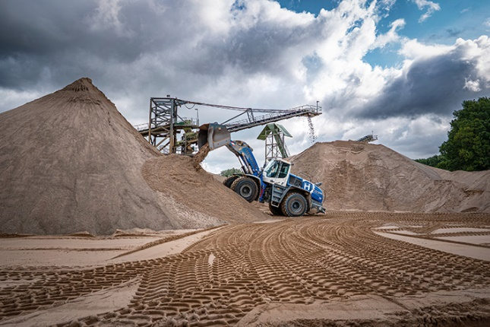

liebherr-xpower-wheel-loader-operation-report.jpg  
The extracted material is transferred using the efficient Liebherr wheel loaders.

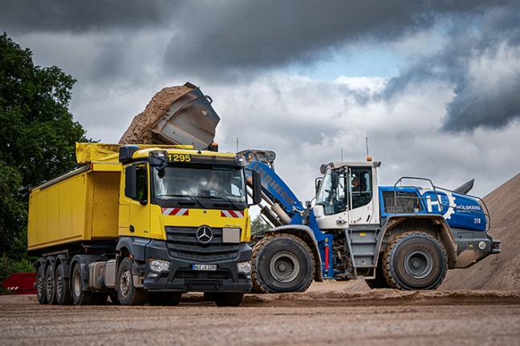

liebherr-xpower-wheel-loader-operation-report-germany.jpg  
A Liebherr wheel loader while loading a truck to take away the extracted material.

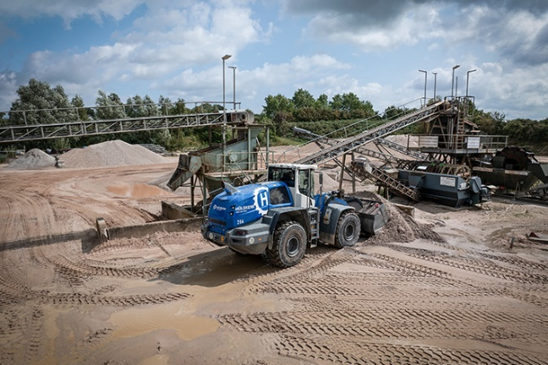

liebherr-xpower-wheel-loader-operation-report-huelskens.jpg  
25 Liebherr wheel loaders in company livery operate at Hülskens GmbH Co. KG.

Contact

Anna Zögernitz  
Marketing and Public Relations  
Phone: +43 50809 12195  
E-mail: anna.zoegernitz@liebherr.com

Published by

Liebherr-Werk Bischofshofen GmbH  
Bischofshofen/Austria  
[www.liebherr.com](http://www.liebherr.com)