Press release

Seven at one blow

⸺

The company Kurt Motz expands its fleet with seven new Liebherr machines. Six drilling rigs – one LB 25, two LB 30s, two LB 35s and one LB 45 – as well as one piling and drilling rig type LRB 23 will be delivered by the end of the year. Quality, customer service and digital solutions were decisive factors for the building professionals from Bavaria in choosing Liebherr - and have been for 65 years.

Nenzing (Austria), 25 June 2024 − “With Liebherr, we experience first-class construction machines, quick and expert service as well as parts that are always available. This combination enables us to drive our projects forward efficiently and without delays," says Markus Thomas, Workshop Manager at Kurt Motz. The Bavarians have been focusing on these values since the company was founded in 1959. Today, the company has around 65 Liebherr machines in use. With the new models, the deep foundation fleet has been strengthened sevenfold. Senior Site Manager Eike Spieler is delighted with the new additions: “We not only set standards in quality and performance with piling and drilling rigs from Liebherr, but also form partnerships that are based on trust, reliability and mutual success.”

A complete package from a single source

The keys for the seven new machines were recently handed over at the Liebherr plant in Nenzing. These will be delivered successively by the end of the year. The drilling rig LB 30 started off and is already in operation. The combination of quality, efficient customer service and digital solutions for the rapid handling of individual jobsite processes is the reason why Kurt Motz has relied on Liebherr for more than half a century. The positioning system LIPOS creates the ideal conditions for the company’s drilling and pile driving activities. It supports the machine operator with the precise alignment of the attachment tools using the latest satellite technology. Using MyJobsite, the data recorded here can be used to analyse the jobsite or as proof of quality. The company is further convinced since all machines can be operated with HVO, all have the same operating concept, and all are very quiet and fuel-efficient in use.

Kurt Motz was involved in the deep foundation work for major projects including "Stuttgart 21" and the extension of the main line in Munich. Anestis Papanikolaou, the operator of the drilling rig, describes his experience with Liebherr: "For me, the LB 45 means high performance right from the start, rapid assembly and unbeatable comfort. And the new design is just great.”

About the Liebherr Group of Companies – 75 years of moving forward

The Liebherr Group is a family-run technology company with a highly diversified product portfolio. The company is one of the largest construction equipment manufacturers in the world. It also provides high-quality and user-oriented products and services in a wide range of other areas. The Liebherr Group includes over 150 companies across all continents. In 2023, it employed more than 50,000 staff and achieved combined revenues of over 14 billion euros. Liebherr was founded by Hans Liebherr in 1949 in the southern German town of Kirchdorf an der Iller. Since then, the employees have been pursuing the goal of achieving continuous technological innovation and bringing industry-leading solutions to its customers. Under the slogan ‘75 years of moving forward’, the Group celebrates its 75th anniversary in 2024.

Image

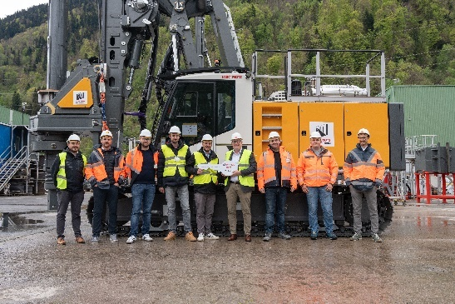

liebherr-handover_1.jpg  
Kurt Motz and Liebherr continue their long-standing partnership with the handover of the keys for seven new machines.

Contact

Gregor Griesser  
Strategic Marketing and Communications  
E-Mail: [gregor.griesser@liebherr.com](mailto:gregor.griesser@liebherr.com)

Wolfgang Pfister  
Head of Strategic Marketing and Communications  
Tel.: +43 50809 41-444  
E-Mail: [wolfgang.pfister@liebherr.com](mailto:wolfgang.pfister@liebherr.com)

**Published by**

Liebherr-Werk Nenzing GmbH  
Nenzing/Austria  
[www.liebherr.com](http://www.liebherr.com)