Press release

Liebherr premiere: first large wheel loader with hydrogen engine and first hydrogen filling station in Salzburg

⸺

World's first prototype large wheel loader with hydrogen engine presented at the Liebherr plant in Bischofshofen

Opening of the first hydrogen filling station in the state of Salzburg

Hydrogen-powered combustion engines are ideal for large machines which are difficult to electrify

In the future, hydrogen engine will enable zero emissions of greenhouse gases and almost no nitrogen oxides

Liebherr pressing ahead with phasing out fossil fuels and preparing solutions to decarbonise construction sites, gravel plants etc. The Liebherr plant in Bischofshofen celebrated two groundbreaking events: the presentation of the first large wheel loader with a hydrogen engine and the opening of the first hydrogen filling station in the state of Salzburg.

Bischofshofen (Austria), June 2024 - At a trade event at the Liebherr plant in Bischofshofen, the world's first large wheel loader with a hydrogen engine was recently presented to high-ranking representatives from politics and business. The event included a series of talks on the topic of alternative drives. However, the focus was on Liebherr's impressive machine show, where the hydrogen wheel loader was demonstrated for the first time in practical use.

At the same time as this world première, the first hydrogen filling station in the state of Salzburg was inaugurated, representing an important milestone in the use of hydrogen as a sustainable energy source. "To make progress in hydrogen research, we need to have access to hydrogen. We built this filling station to further advance our goals for decarbonising construction machinery," says Dr.-Ing. Herbert Pfab, Chief Technical Officer of Liebherr Bischofshofen.

**Prototype L 566 H is the world's first wheel loader with a hydrogen engine**

The L 566 H from Liebherr is the world's first prototype large wheel loader with a hydrogen engine. Following extensive studies, this groundbreaking technology was identified as the optimal solution for operating large vehicles that are difficult to electrify without CO2 emissions.

For smaller vehicles up to about 15 tons, battery-electric solutions are often suitable. However, the situation is different with larger machines with an operating weight of up to 40 tons and high energy requirements. Hydrogen reciprocating piston engines prove to be ideal in this case.

These hydrogen engines are manufactured at the engine plant of Liebherr's Components product segment in Bulle (Switzerland). They are highly efficient and will enable near zero emissions of greenhouse gases and almost no nitrogen oxides in the future. Another advantage is that the interfaces are comparable to those of a diesel engine - thermally and mechanically. This represents a significant step forward in the development of sustainable large-scale machinery.

Another highlight of the show was a MAN truck, also with a hydrogen engine. This shows that hydrogen technology is not only feasible in wheel loaders, but is already used in construction site trucks.

First hydrogen filling station in the state of Salzburg

As part of the development of the hydrogen wheel loader, Liebherr Bischofshofen opened its own hydrogen filling station – the first of its kind in the entire state of Salzburg. An important strategic partner in this project is Maximator Hydrogen, which is not only the manufacturer of the newly opened filling station, but also a research partner of Liebherr. Together, they are working on mobile filling facilities so that machinery can be refuelled directly at the construction sites. This is particularly important for remote construction sites and machines that are not very mobile.

Another reliable partner is MPREIS, which ensures the supply of green hydrogen. This is important because only through emission-free production – using wind, hydroelectric or solar energy – can hydrogen play a key role as a sustainable and climate-friendly energy source.

About Liebherr-Werk Bischofshofen GmbH

Liebherr-Werk Bischofshofen GmbH develops, produces and sells wheel loaders from the Liebherr Group. The plant in Salzburger Land (Austria) has grown steadily over the decades thanks to sustainable innovations, creative solutions and high quality standards. The wheel loader range is constantly being expanded and includes models in different product groups: compact loaders, stereo loaders, and mid-sized and large wheel loaders with impressive, innovative drive designs.

About the Liebherr Group – 75 years of moving forward

The Liebherr Group is a family-run technology company with a highly diversified product programme. The company is one of the largest construction equipment manufacturers in the world. It also provides high-quality, user-oriented products and services in a wide range of other areas. The Liebherr Group includes over 150 companies across all continents. In 2023, it employed more than 50,000 staff and achieved combined revenues of over 14 billion euros. Liebherr was founded by Hans Liebherr in 1949 in the southern German town of Kirchdorf an der Iller. Since then, the employees have been pursuing the goal of achieving continuous technological innovation, and bringing industry-leading solutions to its customers. Under the slogan ‘75 years of moving forward’, the Group celebrates its 75th anniversary in 2024.

Images

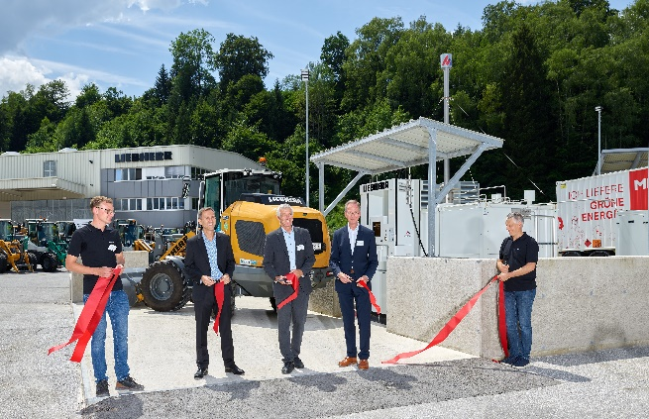

liebherr-L566-H2-Event-Bischofshofen-inauguration-06-2024.jpg  
The hydrogen refuelling station was officially opened at the plant site in Bischofshofen.

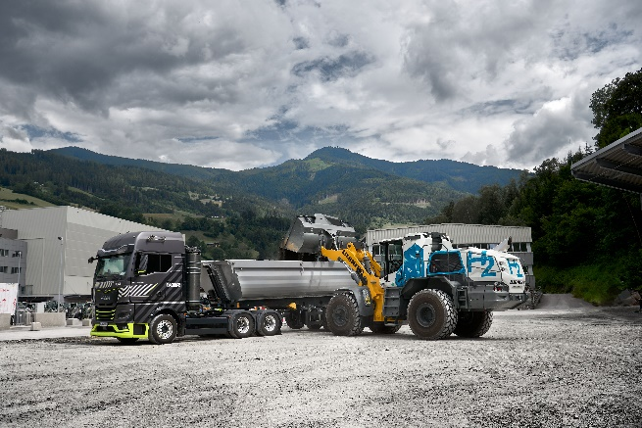  
liebherr-L566-H2-wheel-loader-Bischofshofen.jpg  
The Liebherr plant in Bischofshofen presented the first large wheel loader with a hydrogen engine.

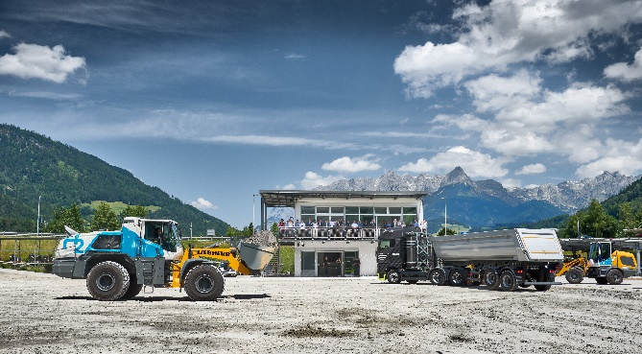

liebherr-L566-H2_Event-Bischofshofen-06-2024.jpg  
The large wheel loader with hydrogen engine was demonstrated in practical use during a machine show.

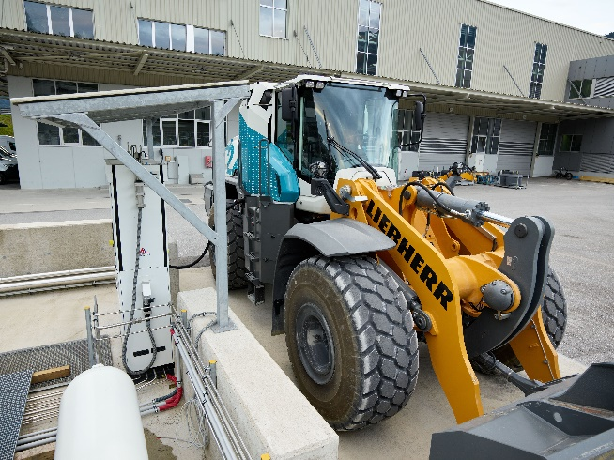

liebherr-L566-H2-wheel-loader-refuelling-Bischofshofen.jpg  
Refuelling takes place at the company's own hydrogen filling station on the Liebherr factory premises.

Contact

Anna Zögernitz  
Marketing and Public Relations  
Phone: +43 50809 12195  
E-mail: anna.zoegernitz@liebherr.com

Published by

Liebherr-Werk Bischofshofen GmbH  
Bischofshofen/Austria  
[www.liebherr.com](http://www.liebherr.com)