Press release

Efficient machines for harsh conditions: XPower wheel loaders in the far north

⸺

Liebherr earthmoving machinery in operation in northern Sweden

Liebherr XPower wheel loaders help to maintain the roads and are on hand at loading and receiving points

XPower wheel loaders prove themselves with their reliability, performance and comfort

GE Maskintjänst is a Swedish family-run company that carries out earthworks and construction work. The company has several Liebherr machines, which are used as service machines in loading and unloading areas, for material transport, for the removal of excavated material and for maintenance work. GE Maskintjänst appreciates the reliability and robustness of Liebherr machines in tough operating conditions – whether faced with extremely cold temperatures or heavy snow.

Gällivare (Sweden), June 2024 – Around 100 kilometres north of the Arctic Circle, the Swedish family business GE Maskintjänst is active in the construction industry. The company specialises in earthmoving and construction work and their expertise ranges from mechanical and engineering workshops – where design, production, repair and maintenance are carried out – to mechanical engineering and drilling, the operation of wind turbines and the sale of electrical energy. Various earthmoving machines from Liebherr are used for embankment work including wheel loaders, crawler excavators and bulldozers. GE Maskintjänst needs robust and powerful machines for the demanding work.

Three L 550 XPower wheel loaders and two L 586 XPower are responsible for maintaining the roads and loading and unloading areas. They eliminate safety risks by keeping the transport routes and loading and receiving points free of stones that could disrupt the transport chain. Several Liebherr excavators with various attachment tools handle material, sort it, and load it into dump trucks. When the material is received, three Liebherr dozers distribute it as required for the reinforcement.

**Cleverly designed: XPower wheel loaders are versatile all-rounders**

The Liebherr XPower travel drive combines the hydrostatic drive for short loading manoeuvres with the mechanical drive for long distances and inclines. The combination of these two drive types offers the highest efficiency in all applications and results in a lower load on the respective drive path. This means the wheel loader always operates at maximum performance and efficiency, whatever it is being used for. The result is fuel savings of up to 30 percent compared to conventionally driven wheel loaders.

Assistance systems provide additional safety and enhance productivity

For safe and efficient working, the L 586 XPower from GE Maskintjänst is also equipped with two assistance systems. Active personnel detection helps the operator avoid collisions with obstacles or people. It monitors the rear area of the wheel loader and automatically warns of hazards by means of a warning sound and a symbol that is shown on the display. In addition, the integrated tyre pressure monitoring system uses sensors on the tyre valves to provide an important overview of the current pressure. As soon as the tyre pressure changes, a warning appears on the display. This increases safety, optimises handling and reduces maintenance costs in the long term.

Reliability is the key element

“In order to be a reliable partner for our customers, the performance of our machines is of utmost importance. We are very satisfied with our XPower wheel loaders, as they deliver full performance even under the toughest operating conditions,” reports Janne Pellikka, Managing Director of GE Maskintjänst. This is made possible by the powerful and durable components of the Liebherr wheel loaders, which guarantee high quality standards. “Our machine operators also find the machines very comfortable and appreciate the high amount of glazing in the operator’s cab, which allows good all-round visibility of the working attachment and the operating area” says Pellikka.

About GE Maskintjänst

GE Maskintjänst is a family-run construction company based in Gällivare. The company, which initially supplied services to the mining industry, was founded in 1955 by Göran Eriksson and has grown continuously since then. It is involved in almost every aspect of the construction industry – from excavation work and mechanical engineering to the operation of wind turbines. Furthermore, GE Maskintjänst strives to be a leading player in sustainability for present and future generations. The company utilises wind energy from its own wind turbines and heats all its premises with geothermal energy. The company currently employs around 270 people.

About Liebherr-Werk Bischofshofen GmbH

Liebherr-Werk Bischofshofen GmbH develops, produces and sells wheel loaders from the Liebherr Group. The plant in Salzburger Land (Austria) has grown steadily over the decades thanks to sustainable innovations, creative solutions and high quality standards. The wheel loader range is constantly being expanded and includes models in different product groups: compact loaders, stereoloaders, and mid-sized and large wheel loaders with impressive and innovative drive designs.

About the Liebherr Group – 75 years of moving forward

The Liebherr Group is a family-run technology company with a highly diverse product portfolio. Not only is the company one of the largest construction equipment manufacturers in the world, it also provides high-quality and user-oriented products and services in many other areas. The Liebherr Group now includes over 150 companies across all continents. In 2023, the group employed more than 50,000 staff and achieved combined revenues of over €14 billion. Liebherr was founded by Hans Liebherr in 1949 in Kirchdorf an der Iller, in Southern Germany. Since then, its staff have worked tirelessly to impress their customers with sophisticated solutions and actively advance technology. The group will celebrate its 75th anniversary in 2024 with the motto, “75 years of moving forward”.

Images

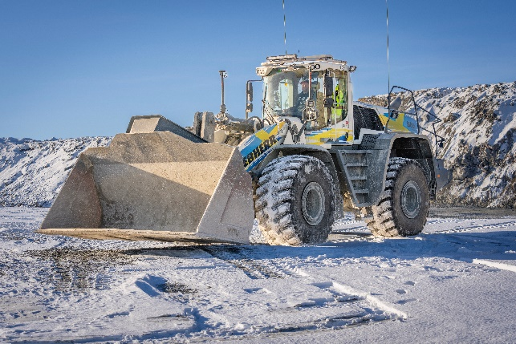

liebherr-xpower-l586-wheel-loader-operation-report-ge-maskintjaenst.jpg  
The XPower L 586 wheel loader defies icy temperatures and snow in the far north.

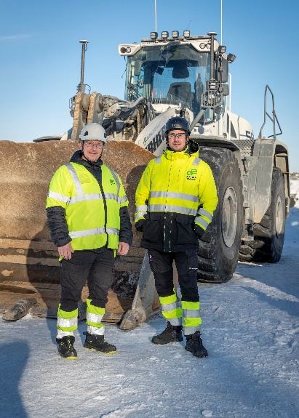

liebherr-xpower-wheel-loader-operation-report-ge-maskintjaenst.jpg  
Håkan Martinsson, Business Developer, and Simon Antman, Site Manager, in front of their latest L586 XPower®.

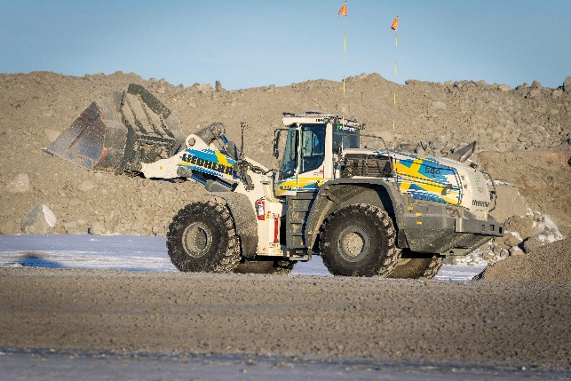

liebherr-xpower-wheel-loader-operation-report-ge-maskintjaenst-sweden.jpg  
An XPower L 586 wheel loader in the design of the Swedish national flag is in use in northern Sweden.

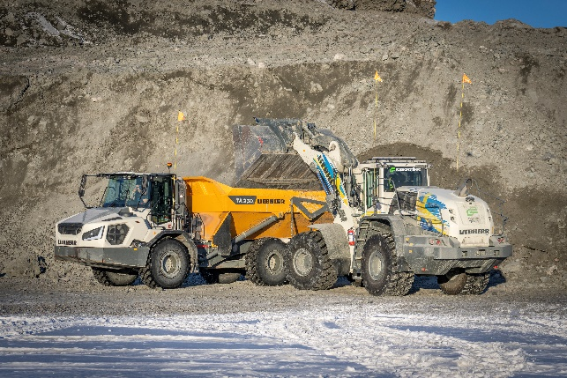

liebherr-earth-moving-machinery-operation-report-ge-maskintjaenst.jpg  
At the Aitik mine several Liebherr earthmoving machines support a wide range of earthmoving and construction work.

Contact

Anna Zögernitz  
Marketing and Public Relations  
Phone: +43 50809 12195  
E-mail: [anna.zoegernitz@liebherr.com](mailto:anna.zoegernitz@liebherr.com)

Published by

Liebherr-Werk Bischofshofen GmbH  
Bischofshofen/Austria  
[www.liebherr.com](http://www.liebherr.com)