Press release

The Liebherr R 992 crawler excavator: high performance and low emissions at CMSE

⸺

The R 992 is part of our range of 70–100 tonne crawler excavators belonging to Generation 6.2

An ideal crawler excavator for rock extraction

Centred on technological innovation with the Liebherr Bucket Fill Assist (BFA) and Liebherr Power Efficiency (LPE) systems

CMSE produces materials for use in construction, public works and civil engineering

CMSE (Carrières & Matériaux Sud-Est) uses the R 992 crawler excavator to extract rocks at its quarry at Saint-Pons-de-Thomières (France). The company is the first customer in France to acquire a new-generation crawler excavator. This 94 tonne machine is specially equipped for extraction work. The improvements and technological innovations in the range guarantee performance and versatility on the ground.

Colmar (France), 3rd of July 2024 − Liebherr’s Generation 5.2 and 6.2 crawler excavators, in the 70–100 tonne range, were inveiled to the public at the last Bauma. The R 972, R 978 SME, R 992 and R 998 SME models replace the R 966, R 970 SME, R 976 and R 980 SME models respectively. These new excavators, developed with a particular focus on reducing fuel consumption, also feature other improvements, such as enhanced performance data, optimal operator comfort and new operator assistance functions.

**Challenging working conditions in the extraction of** **blue quartzite**

Extracting rock in quarries is the R 992’s main task at the site of CMSE (Carrières & Matériaux Sud-Est). The machine’s high tooth force, reliability and precision are guarantees of quality in this challenging application. It is specially equipped with piston rod guards, an HD undercarriage and a 5.20 m3 HDV bucket with guide rails for a drop ball. The bucket is specially reinforced, as the high abrasiveness of digging blue quartzite, the primary product from this quarry, demands a specifically adapted cutting tool. After **blasting, the excavator loads lumps of rock into the three dump trucks that take the material to the crushing station.**

**Liebherr Bucket Fill Assist (BFA) and Liebherr Power Efficiency (LPE) improve performance**

The R 992, like all models of the new generation, comes with the Bucket Fill Assist (BFA) assistance system and the Liebherr Power Efficiency – Engine Control (LPE) system. CSME uses BFA for a higher bucket filling level and optimal penetration into the rock. This system improves operator comfort by reducing vibration and reduces fuel consumption by 10%. At less than 60 litres per hour, the excavator’s current fuel consumption is lower than that of their previous excavator. CMSE also appreciates the Liebherr Power Efficiency – Engine Control (LPE) system, which provides optimal control of machine power. It actively regulates engine speed and the hydraulic pumps’ angle of inclination.

**A major player in the first link of the construction chain**

CMSE, a subsidiary of Colas France, has 40 quarries across 18 French locations. The Saint-Pons-de-Thomières quarry, where the R 992 is in operation, produces, distributes and sells aggregates for public works construction sites and has previously supplied materials for race car tracks in France and other countries. The choice of a Liebherr Generation 6.2 excavator was based on the customer’s wish to acquire a robust, high-performance machine with low fuel consumption. As a holder of the UNICEM Cap Environment label, the CMSE is particularly keen to reduce CO2 emissions across its entire fleet.

About Liebherr-France SAS

Liebherr-France SAS, based in Colmar, has been responsible for development and production of Liebherr Group crawler excavators since 1961. Its current product range includes around 30 crawler excavator models, from the R 914 Compact to the R 998 SME, designed for earthmoving and stone quarrying. The product range also includes a whole series of special working attachments designed for specific tasks such as demolition works, materials transport and maritime or tunnel applications, as well as large-capacity electric excavators. With their operating weight of 14 to 100 tonnes, the crawler excavators are equipped with Liebherr engines with power ratings from 90 to 420 kW. Liebherr-France SAS employs over 1,260 staff and generates annual sales of 605 million euros.

About the Liebherr Group – 75 years of moving forward

The Liebherr Group is a family-run technology company with a highly diversified product programme. The company is one of the largest construction equipment manufacturers in the world. It also provides high-quality, user-oriented products and services in a wide range of other areas. The Liebherr Group includes over 150 companies across all continents. In 2023, it employed more than 50,000 staff and achieved combined revenues of over 14 billion euros. Liebherr was founded by Hans Liebherr in 1949 in the southern German town of Kirchdorf an der Iller. Since then, the employees have been pursuing the goal of achieving continuous technological innovation, and bringing industry-leading solutions to its customers. Under the slogan ‘75 years of moving forward’, the Group celebrates its 75th anniversary in 2024.

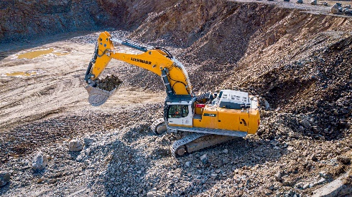Photos

R992-Colas-1.jpg  
The Colas R 992 crawler excavator is specially equipped for the client’s application.

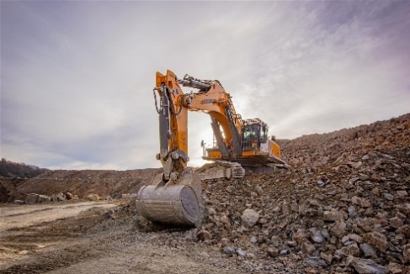

R992-Colas-2.jpg  
The enlarged, reinforced bucket is ideal for extracting solid rock.

Contact

Alban Villaumé  
Marketing and Communication  
Telephone: +33 3 89 21 36 09  
Email: alban.villaume@liebherr.com

Published by

Liebherr-France SAS   
Colmar, France  
www.liebherr.com