Press release

Power trio at HEIS: Liebherr earthmoving machines at work

⸺

Liebherr XPower wheel loaders, material handling excavators and articulated trucks handle slag from blast furnaces

Liebherr earthmoving machines impress with their high handling performance and clever machine design

Fuel economy, reliability and serviceability

**HEIS** **– Hargreaves-EWT Industrieservices GmbH – uses powerful earthmoving machinery from Liebherr for handling slag, soil stones and minerals. Alongside mining trucks and material handling excavators, XPower wheel loaders load material for crushers, screening plants and trucks. HEIS appreciates the fuel efficiency, reliability and clever maintenance concept of the robust machines.**

Duisburg (Germany), July 2024 – As a direct neighbour of DK Recycling und Roheisen GmbH, HEIS processes the blast furnace slag that arises as a by-product of pig iron production. On a site covering 15,000 m², Liebherr dump trucks, material handling excavators and wheel loaders perform handling and loading operations. Two TA 230 articulated dump trucks take cooled slag from DK and drop it in heaps. An LH 40 M material handling excavator then sieves out ferrous material using a magnetic separation system. An L 576 XPower wheel loader then loads the roughly sorted slag into a screening plant, where it is crushed and refined to different sizes. Finally, trucks are loaded with the various grades of product before they sold as building materials and for the production of blasting abrasives. “Liebherr earthmoving machines boast excellent handling performance and low fuel consumption”, says Lars Haltermann, head of operations at HEIS.

Fuel efficient Liebherr wheel loaders ensure high customer satisfaction

What makes the XPower wheel loaders so fuel-efficient is their power-split XPower travel drive. At low speeds and short loading cycles, the hydrostatic drive does most of the work, while at higher speeds and uphill, the mechanical drive takes over. Together, the components always transmit 100 percent of the diesel engine power, with only the ratio between them changing. This means the wheel loader operates with maximum performance and efficiency, regardless of the task. The result is fuel savings of up to 30 percent compared to conventionally driven wheel loaders. “Our XPower wheel loaders currently consume an average of 14 litres of fuel per operating hour when loading, and when feeding the screening and crushing plants”, says Haltermann.

**Reliability and low maintenance**

The XPower wheel loaders deliver maximum performance even on the toughest and most demanding jobs. The robust and durable components ensure a long service life for the machine. “In addition to the high quality and performance of Liebherr machines, we also appreciate the quick and easy maintenance of the XPower wheel loaders. This completes the overall package perfectly”, says Haltermann. The rear-opening electric bonnet allows safe and unhindered access to the whole engine compartment, resulting in less downtime and reduced costs.

About HEIS – Hargreaves-EWT Industrieservices GmbH

Since 2020, HEIS – Hargreaves-EWT Industrieservices GmbH – has been offering various industrial services including the processing of slag, soil stones and minerals at the port of Duisburg. The products of the processed blast furnace slag are then sold for further refinement. HEIS unites the two parent companies Hargreaves raw material services GmbH and EWT Schifffahrtgesellschaft mbH.

About the Liebherr Group – 75 years of moving forward

The Liebherr Group is a family-run technology company with a highly diversified product programme. The company is one of the largest construction equipment manufacturers in the world. It also provides high-quality, user-oriented products and services in a wide range of other areas. The Liebherr Group includes over 150 companies across all continents. In 2023, it employed more than 50,000 staff and achieved combined revenues of over 14 billion euros. Liebherr was founded by Hans Liebherr in 1949 in the southern German town of Kirchdorf an der Iller. Since then, the employees have been pursuing the goal of achieving continuous technological innovation, and bringing industry-leading solutions to its customers. Under the slogan ‘75 years of moving forward’, the Group celebrates its 75th anniversary in 2024.

Images

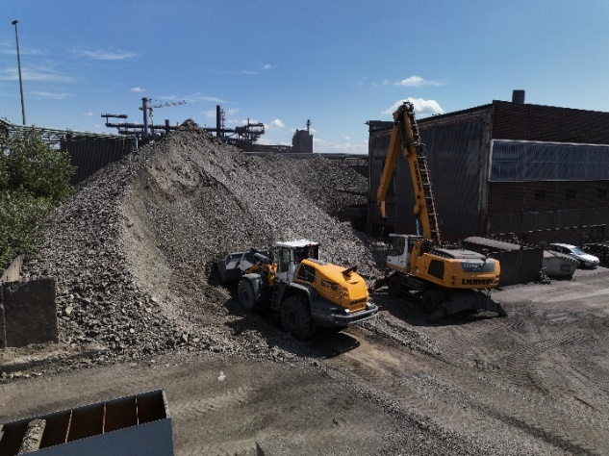

liebherr-earth-moving-machinery-heis-germany.jpg  
Several Liebherr earthmoving machines are in use at HEIS.

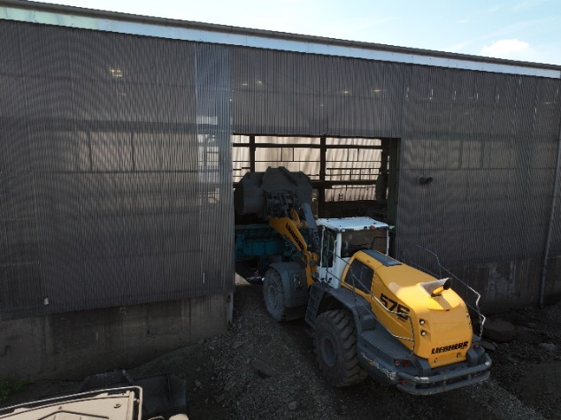

liebherr-xpower-wheel-loader-report-heis-germany.jpg  
An XPower L 576 loads material for screening plants and crushers.

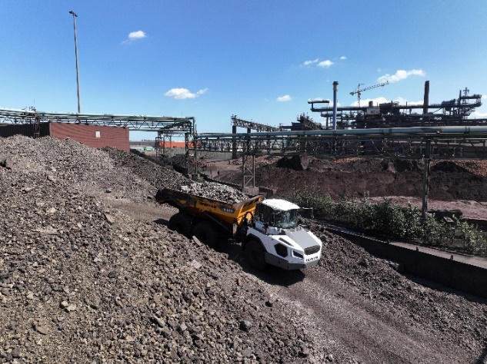

liebherr-earth-moving-machinery-report-heis-germany.jpg  
A TA 230 dump truck transports cooled slag from DK and piles it up.

Contact

Anna Zögernitz  
Marketing and Public Relations  
Phone: +43 50809 12195  
Email: anna.zoegernitz@liebherr.com

Published by

Liebherr-Werk Bischofshofen GmbH  
Bischofshofen/Austria  
www.liebherr.com