Press release

Your mining partner: Liebherr to present its new mining solutions at MINExpo

⸺

For the seventh time, the Liebherr Group will be exhibiting at MINExpo, the largest mining exhibition in the world, at the Las Vegas Convention Center in Nevada, USA.

At the Liebherr booth, #7832 in Central Hall, visitors will experience the latest innovations and products from Liebherr’s mining, earthmoving, mobile and crawler crane, components, and aerospace and transportation product segments.

Visitors attending the exhibition in person and via online channels will learn about Liebherr’s high-quality equipment, decarbonisation solutions, technology products, and services that make the OEM a fantastic partner for mining solutions.

From 24 to 26 September 2024, Liebherr will present advancements from its mining, earthmoving, mobile and crawler cranes, components, and aerospace and transportation product segments at MINExpo in Las Vegas, USA. In line with Liebherr’s motto for the event, ‘Your mining partner’, Liebherr will showcase its reliability as a partner for best-in-class equipment, decarbonisation solutions, cutting-edge technology, and service excellence for the mining industry.

Nussbaumen (Switzerland), 10 July 2024 – Liebherr will be sharing its latest news, products, services, and innovations for the mining sector at the world’s largest mining exhibition, MINExpo INTERNATIONAL®, this September. Visitors will experience over 2,777 m2 (over 29,000 sq. ft) of Liebherr exhibits at booth #7832. Daily masterclasses and live demonstrations will take place at the Liebherr booth each day, showcasing the company’s latest product updates and providing insights into these technologies and services with the latest information from the field. Fans and customers who cannot attend in person will not miss out: all exhibits, announcements, and showcases from the exhibition will be shared on Liebherr’s website and social media channels.

T 264: the perfect platform for technology advancements

Liebherr’s T 264 haul truck will be showcased on the Liebherr booth. The 240-tonne machine will be equipped with Liebherr’s latest technology, including the Trolley Assist System. Liebherr will reveal the latest technology for the T 264 at an exciting event during the exhibition.

R 9400 E: more than 40 years of E-xperience

To highlight Liebherr as a reliable partner for decarbonisation solutions, the booth will include the R 9400 E 350-tonne electric excavator. This machine is not only a testament to Liebherr’s more than 40 years’ experience in the development and manufacture of electric excavators, but also features some of the mining product segment’s latest innovations. This machine will be equipped with the company’s brand-new cable reel solution for increased manoeuvrability.

PR 776: the next generation of dozing

Liebherr’s PR 776 dozer will be a highlight on the booth so visitors can experience Liebherr’s best-in-class equipment. The 70-tonne dozer boasts the lowest hourly fuel burn – and therefore the lowest greenhouse gas emissions – in its class. Additionally, Liebherr’s Assistance Systems, designed to support operators and increase onsite productivity, will be installed on the PR 776.

LRT 1100-2.1: the safe choice

Liebherr’s mobile and crawler crane product segment will present the LRT 1100-2.1 rough-terrain crane at this year’s MINExpo. This rough-terrain crane has outrigger monitors as standard that automatically detect the support status of the crane and save it to the crane’s controller. The standard VarioBase® variable support base of the crane further optimises safety by enhancing flexibility on site and increasing the crane’s lifting capacity. The LRT 1100-2.1 has a telescopic boom with Liebherr’s tried-and-tested telematic telescoping system for rough-terrain cranes, on which the various telescoping sections can be extended independently with a single cylinder and then pinned to the telescopic section above.

Cutting-edge technology: integrated operations for your mine

At Liebherr’s technology showcase, the OEM will share its range of latest innovations. In the decarbonisation space, the company has developed a variety of alternative drives and will showcase some of its brand-new solutions for its range of haul trucks for the first time at MINExpo 2024. Liebherr will also share its new approach and solutions for autonomous haulage and fleet management as well as its new Machine Guidance System.

During the exhibition, Liebherr will present its latest solutions for automating, operating, and maintaining Liebherr equipment. One such solution is LiReCon (Liebherr Remote Control), the teleoperations system for Liebherr dozers. Visitors can see how this remote system helps keep operators safe while increasing equipment uptime and productivity. While on the booth, visitors can also learn about Liebherr’s latest offerings in the digital service space for connecting site technicians to Liebherr experts and minimising equipment downtime in the process.

Service excellence: support when you need it, where you need it

At this year’s MINExpo, Liebherr will highlight its capabilities as a partner for service excellence with its range of service products for mining. Visitors will see how the OEM supports customers from initial equipment consultation – with Liebherr’s highly skilled Application Engineering team – right through to machine maintenance, customer support, and equipment upgrades.

Liebherr’s modular design approach to its machines ensures that today’s equipment is future-proofed for the technology of tomorrow. Liebherr’s existing machines can be repowered to run on Liebherr’s D98 series of engines, designed specifically for mining conditions, and can be converted from a diesel to an electric powertrain. This modularity is what enables Liebherr’s modular maintenance program, a service concept that minimises the downtime and risk associated with major component changeouts.

Innovation Lab: tomorrow’s solutions, today

At the Innovation Lab, visitors will see Liebherr’s latest pioneering concepts and technologies for the future of mining. Liebherr’s components product segment will feature innovative technologies as the core of every powerful mining machine. Liebherr’s commitment to excellence and sustainability is demonstrated in every component on display – be it a hydrogen engine, a travel or a wheel drive, a CFRP hybrid hydraulic cylinder, an advanced slewing bearing with bearing clearance monitoring, or the remanufacturing program.

Another highlight in the Innovation Lab is a 55 kW compressor. Backed up by experience gathered during the last two decades and jointly developed by the Liebherr components and aerospace and transportation systems product segments, the high-speed compressor is driven by an electrical motor and features an air bearing. Such technology is an enabler for the deployment of fuel cell propulsion systems with only emissions of water and heat, which aids in the movement for more environmentally friendly transportation.

For more information, visit [liebherr.com/minexpo](http://www.liebherr.com/minexpo)

About the Liebherr Group – 75 years of moving forward

The Liebherr Group is a family-run technology company with a highly diversified product programme. The company is one of the largest construction equipment manufacturers in the world. It also provides high-quality, user-oriented products and services in a wide range of other areas. The Liebherr Group includes over 150 companies across all continents. In 2023, it employed more than 50,000 staff and achieved combined revenues of over 14 billion euros. Liebherr was founded by Hans Liebherr in 1949 in the southern German town of Kirchdorf an der Iller. Since then, the employees have been pursuing the goal of achieving continuous technological innovation and bringing industry-leading solutions to its customers. Under the slogan ‘75 years of moving forward’, the Group celebrates its 75th anniversary in 2024.

Images

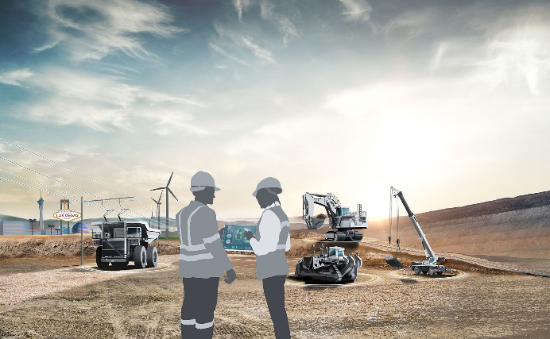

liebherr-MINExpo-key-visual-300dpi.jpg  
Your mining partner: Liebherr to present its latest product developments for the mining industry at MINExpo 2024.

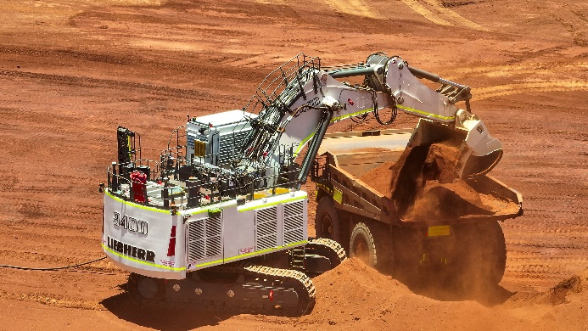

liebherr-R9400E-onsite-96dpi.jpg  
Liebherr’s R 9400 E will be a feature on the Liebherr booth, highlighting the company’s more than 40 years’ experience in manufacturing electric excavators.

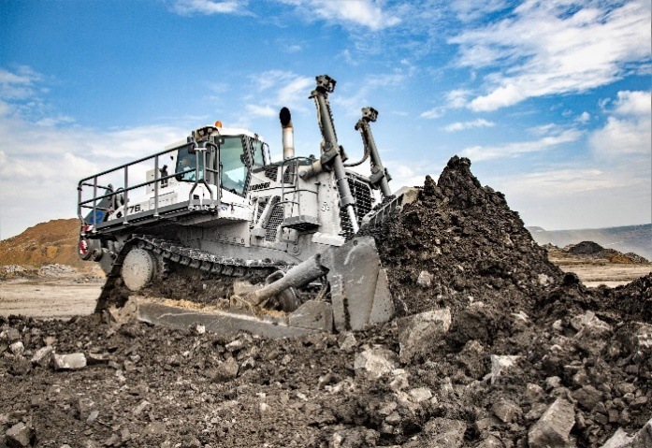

liebherr-PR776-in operation-96dpi.jpg  
Focus on efficiency: the PR 776 proves itself as a strong partner for the mining industry.

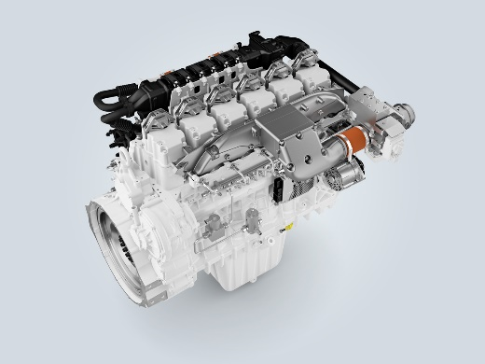

liebherr-H966-off-road.jpg  
Liebherr Components presents its 6-cylinder engine prototype, the H966, for off-road applications.

Contact

Larissa Lunitz  
Head of Public Relations  
Tel: +41 79 645 70 67  
Email: larissa.lunitz@liebherr.com

Published by

Liebherr-International AG

General-Guisan-Strasse 6  
5415 Nussbaumen, Switzerland  
www.liebherr.com