Press release

Liebherr presents solutions for aviation at Farnborough International Airshow 2024

⸺
At Farnborough International Airshow 2024, Liebherr-Aerospace will present from July 22 to 26 its wide range of capabilities in hall 4 at booth no. 4918. Innovative solutions for local, decentralized hydraulic supply, modular electromechanical drives and a compressor for fuel cell technology for on-board energy supply will be for example on display.
Toulouse (France), July 2024 – Under the motto "transform.develop.sustain." Liebherr-Aerospace shows at Farnborough International Airshow 2024 how the company is dealing with the challenges of the aviation industry. The company invests far above the industry average in research and technology including electrification, 3D printing, as well as hydrogen technologies and thus makes a significant contribution to making air transport more environmentally friendly and efficient.
Long wingspan for improved aerodynamics with folding mechanism
Innovative designs of thinner and longer wings support more CO2-efficient flying by improved aerodynamics. Liebherr is supporting this trend by offering reliable folding mechanisms for future more efficient aircraft platforms. An example is the Boeing 777X's folding wingtip, which "beckons" visitors to the Liebherr booth. The moving mock-up (scale 1:1.15) shows how the wingtip of the extra-long wing can be folded upward to better fit the airport infrastructure. Components of the mechanism, such as the angle gearbox, the power drive unit, and numerous actuators are designed by Liebherr and will be on display.
3D printing and digitization
3D-printed components made by Liebherr are flying every day. The company is constantly developing its capabilities and extending them towards multiple applications. On display at Farnborough International Airshow is an additively manufactured housing of a secondary locking actuator. According to in-depth tests, the aviation-certified housing is of lower weight, and its performance is 100% equivalent to that of a conventionally manufactured component.
In addition, digital means are revolutionizing the way Liebherr designs, builds and maintains aircraft systems. On its way to becoming a model-based enterprise, Liebherr is exchanging models with customers as early as possible to contribute to more efficient aircraft design and development.

Electrification and decarbonization
In aircraft that will be more electric in the future, the engine will be decoupled from onboard power consumers for increased efficiency. Electric power will replace bleed air or hydraulic systems and enable the introduction of electric air management and actuation systems. Liebherr's exhibits show that the company can already master these requirements today: Electromechanical actuators (EMA) and a hologram of the high-efficiency power pack (HEPP), are on display.
Furthermore, future more sustainable aircraft will require autonomous electrical power generation. Liebherr is working to ensure that hydrogen technology can be used to power non-propulsive systems on board future aircraft using electricity provided by fuel cells. At the same time, thermal management of the whole, i.e. fuel cells and electrified systems, is being ensured.
Leader in the development of electromechanical actuators
As electrification moves on in aviation, Liebherr has further added small electromechanical actuators to its product portfolio. The new concept specifically addresses the quickly emerging AAM (Advanced Air Mobility) sector. It is also essential for smaller aircraft, business jets and helicopters. Liebherr’s product approach offers scalability for small installation envelopes, a favorable power-to-weight ratio and high reliability.

About Liebherr-Aerospace & Transportation
Liebherr-Aerospace & Transportation SAS, headquartered in Toulouse (France), is one of 13 product segments of the Liebherr Group and a first-tier provider of on-board solutions in the aerospace and transportation industry, contributing to a more sustainable transport through innovative products, best in class services and performance excellence.
The aerospace product portfolio offered to civil and defense customers includes environmental control and thermal management systems, flight control and actuation systems, landing gears as well as on-board electronics. For rail vehicles of all kinds Liebherr offers heating, ventilation and air conditioning systems, passive and active hydraulic systems for braking, damping, axle steering and levelling. Furthermore, Liebherr serves the commercial vehicle market with trailer cooling systems.
About the Liebherr Group – 75 years of moving forward
The Liebherr Group is a family-run technology company with a highly diversified product programme. The company is one of the largest construction equipment manufacturers in the world. It also provides high-quality, user-oriented products and services in a wide range of other areas. The Liebherr Group includes over 150 companies across all continents. In 2023, it employed more than 50,000 staff and achieved combined revenues of over 14 billion euros. Liebherr was founded by Hans Liebherr in 1949 in the southern German town of Kirchdorf an der Iller. Since then, the employees have been pursuing the goal of achieving continuous technological innovation and bringing industry-leading solutions to its customers. Under the slogan ‘75 years of moving forward’, the Group celebrates its 75th anniversary in 2024.

Images
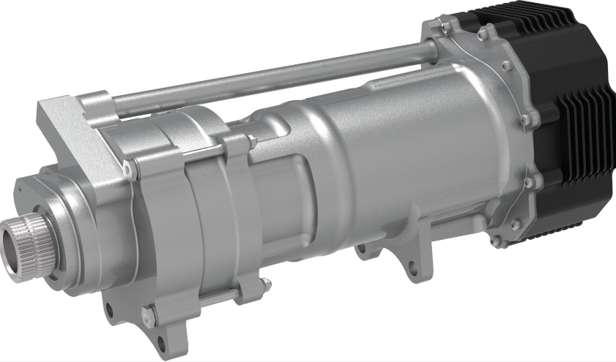
liebherr-modular-electro-mechanical-actuator-copyright-liebherr.jpg
Liebherr counts among the leaders in research and development of electromechanical actuators. – © Liebherr

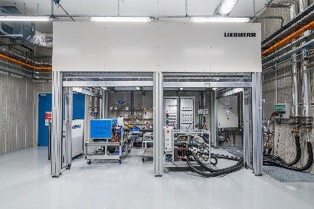
liebherr-aerospace-toulouse-hydrogen-bench-copyright-liebherr
A hydrogen test bench in its test center at its Toulouse site enables Liebherr-Aerospace to demonstrate the ability to generate electrical power, using fuel cells, to supply the major non-propulsive electrical systems of a new generation single-aisle aircraft. – © Liebherr

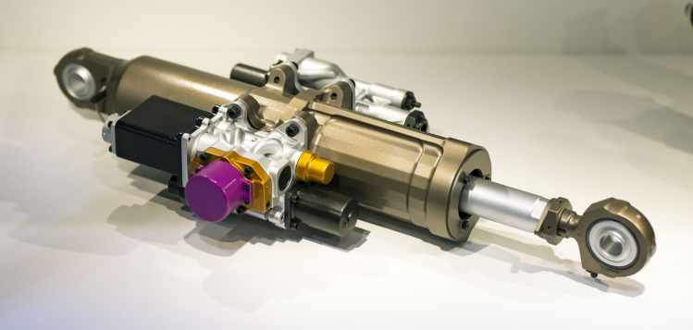
liebherr-thin-wing-servo-control-actuator-copyright-liebherr
Thin wing servo control rudder actuator by Liebherr with 3D printed component. – © Liebherr

Contact
Ute Braam
Head of Corporate Communication
Phone: +49 8381 / 46 - 4403
E-mail: ute.braam@liebherr.com
Published by
Liebherr-Aerospace & Transportation SAS
Toulouse / France
www.liebherr.com

