Press release

A dozen MK cranes: Wittrock and Ulferts network orders impressive set of Liebherr mobile construction cranes

⸺

The consortium of companies consisting of Herrmann & Wittrock, Titschkus & Wittrock, Ulferts, and Ulferts & Wittrock is expanding and modernising its MK crane fleet

The corporate network has placed the largest single order for mobile construction cranes in Germany with Liebherr

Efficient use in inner-city areas: MK cranes can be transported, assembled and operated by just one person

The largest single order for Liebherr’s mobile construction cranes in Germany has been placed by the groups Wittrock and Ulferts. The companies are investing in twelve new MK 88-4.1 and MK 140-5.1 cranes to upgrade and expand their existing fleet.

Biberach (Germany), 23 July 2024 – The groups Wittrock and Ulferts regularly order cranes from Liebherr for their crane fleet, which is active throughout Europe. The latest order with Liebherr-Werk Biberach GmbH consists of twelve mobile construction cranes; nine MK 88-4.1s and three MK 140-5.1s. The machines will be delivered to various locations in Germany between October 2024 and July 2025.

Fleet expansion for two groups of companies

The network is made up of two groups of companies with more than 25 branches throughout Germany. Marcus Wittrock, one of the Managing Directors at the Wittrock Group, says, “We have been focussing on mobile construction cranes since 2003, meaning we can offer our customers the full range of mobile cranes.” Oliver Hermann, also Managing Director at the Wittrock Group, adds, “The market for MK cranes has developed quite favourably for us in recent years. These cranes are now in high demand, which is why we're not only replacing them, but also expanding the fleet.” “The independent, family-run groups work closely together,’ says Temmo Niekamp. He manages the Ulferts Group together with Hermann Ulferts and is also Managing Director at Ulferts & Wittrock.

A popular choice for inner-city use

The four-axle MK 88-4.1 mobile construction crane offers a maximum reach of 45 metres, while the five-axle MK 140-5.1 can achieve a maximum reach of 65 metres with the help of VarioJib and hook heights of up to 92 metres. All the mobile construction cranes are ready for use within a short space of time and can be transported, assembled and operated by just one person. As they need very little space, they can be positioned close to buildings and are therefore ideal for construction sites in inner-city areas. All ordered machines are equipped with an access cage. Passengers can therefore be transported using these specially designated carriers without delay. The cranes also come with an optional modular switchgear cabinet that provides redundant protection for the control system.

About the company network

Herrmann & Wittrock, Titschkus & Wittrock, Ulferts, and Ulferts & Wittrock offer a comprehensive range of crane work and rental services as well as heavy haulage and assembly solutions. The rental of working platforms, telescopic forklifts and forklift trucks is a further area of expertise. The first crane hire company started out in Bremen in 1970. Today, the fleet belonging to the different companies includes 14 mobile construction cranes and over 200 mobile cranes (up to 700 tonnes lifting capacity), as well as crawler cranes up to 650 tonnes. The majority of the cranes are manufactured by Liebherr.

About the Liebherr Tower Cranes Division

More than seven decades of experience have made Liebherr a recognised specialist for lifting technology on all types of construction sites. The range of Liebherr Tower Cranes encompasses an extensive selection of high-quality tower cranes that are used worldwide. This includes fast-erecting, top-slewing, luffing jib and special-purpose cranes as well as mobile construction cranes. In addition to these products, Liebherr also offers a wide range of services that complete the company’s portfolio: Tower Crane Solutions, the Tower Crane Center and Tower Crane Customer Service.

About the Liebherr Group – 75 years of moving forward

The Liebherr Group is a family-run technology company with a widely diversified product programme. The company is one of the largest construction equipment manufacturers in the world. It also provides high-quality, user-oriented products and services in a wide range of other areas. The Liebherr Group includes over 150 companies across all continents. In 2023, it employed more than 50,000 staff and achieved combined revenues of over 14 billion euros. Liebherr was founded by Hans Liebherr in 1949 in the southern German town of Kirchdorf an der Iller. Since then, employees have been pursuing the goal of achieving continuous technological innovation, and bringing industry-leading solutions to its customers. Under the slogan ‘75 years of moving forward’, the Group celebrates its 75th anniversary in 2024.

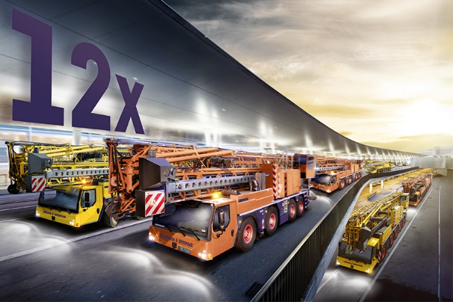Image

liebherr-mk-88-4-1-mk-140-5-1-wittrock.jpg  
Nine MK 88-4.1s and three MK 140-5.1s in one go: the groups Wittrock and Ulferts have placed the largest single order for Liebherr mobile construction cranes in Germany.

Contact

Astrid Kuzia  
Communication Specialist  
Phone: +49 7351 / 41 – 4044  
Email: astrid.kuzia@liebherr.com

Published by

Liebherr-Werk Biberach GmbH  
Biberach / Germany  
[www.liebherr.com](http://www.liebherr.com)