Press release

High Efficiency and Power Output: Liebherr - Crawler Dozer PR 776

⸺

Spanish construction company AMM invests in Liebherr Crawler Dozers

Two Liebherr PR 776 Crawler Dozers power up AMM's machine fleet

With fuel consumption of 55 l/h, the highly efficient Liebherr PR 776 comes in well below the average industry standard

**Which is why AMM, one of Spain’s leading construction companies, relies on Liebherr's advanced machines. The recent addition of two Liebherr PR 776 Crawler Dozers to the vehicle fleet are part of a conscious expansion of the company’s equipment portfolio, for cost-effective delivery of more demanding projects.**

Telfs (Austria), July 23 2024 − The AMM construction company (Murcia, Spain) specialises in civil engineering and major construction projects, covering a range of services, spanning railway construction, hydraulic engineering and industrial projects. With a significant commitment to industrial and agricultural transformation, AMM contributes to the development of sustainable infrastructure in Spain. The two new Liebherr PR 776 Crawler Dozers compliment the existing fleet, which includes a PR 744, PR 746, PR 764 and PR 766, ensuring the company is well equipped for major construction projects.

**The impressive efficiency of Liebherr Crawler Dozers**

Rising energy prices and stricter environmental standards are a constant feature of modern times, where fuel efficiency plays a critical role. And the decisive advantages of the PR 776 where recently reported by one of AMM’s experienced machine operators. For more than two decades, he has exclusively operated dozers from other leading manufacturers - that is till now: He has been so impressed with the high efficiency and power output of the Liebherr Crawler Dozers, he has become a full convert and outspoken Liebherr fan. The PR 776 is noted for optimum efficiency and power transfer, making construction operations not just more efficient, but also more sustainable. With an impressive average fuel consumption of 55 litres per operating hour, the Liebherr model sets new class leading standards. AMM’s experienced operator was quick to emphasise how the Liebherr machine shows significantly different performance in terms of fuel consumption compared to alternative dozers, such as the models from one of the well-known manufacturers in this class. From the operator’s own experience, the average fuel consumption on these machines was up to 90 litres per hour.

PR 776: Power pack for material quarry extraction and renaturalisation

The first of the new Liebherr PR 776 Crawler Dozers has already completed 1,200 operating hours in a quarry near Murcia, Spain. Here, it has been used primarily for material extraction for railway construction, with the machine being used equally for pushing and ripping operations. In the quarry, the efficiency and power output of the PR 776 really stand out. With maximum power output for pushing and pulling, it is ideal for transporting large quantities of rock. The hydrostatic drive ensures stepless speed adjustment and continuous power transmission, even in difficult terrain. This enables precise and effective movement of material - ideal for use in quarries - while the Eco mode makes operation even more efficient.

The second PR 776 is being used for restoration of an expired quarry near Ciudad Real, Spain. The renaturalisation of quarries is critical for minimising environmental impact of mining work and returning the terrain to a near-natural state. The PR 776 offers significant advantages in this application: The precision and mobility of the hydrostatic drive provide the driver with optimum support when modelling the terrain and filling in excavated pits.

**Liebherr-Werk Telfs GmbH**

Liebherr-Werk Telfs GmbH has been producing and developing an ever-growing range of construction machines with hydrostatic drives since 1976. The company is able to draw on the many years of experience of the Liebherr Group with this type of drive. Whether it’s Crawler Dozers or Loaders, Telescopic Handlers or Pipe Layers – construction machinery from Telfs is consistently designed to keep you on the move with the highest efficiency and cost effectiveness. Then, increasing efficiency as well as reducing fuel consumption and CO2 emissions are a central focus. The latest computer-aided technologies are used both in development and production: from design engineering to welding robot processes, right through to computerised quality management.

**Liebherr Spain**

Liebherr Ibérica, S.L., founded in 1988, is the Spanish sales and service company of the Liebherr Group. Liebherr Ibérica is currently responsible for sales and customer service of mobile and crawler cranes, tower cranes, earthmoving machinery, mining, construction machinery and maritime cranes.

**The Liebherr Group – 75 years of moving forward**

The Liebherr Group is a high technology company, in family ownership, with a diversified portfolio of products. The company is one of the largest construction machinery manufacturers in the world. But it also offers a range of high quality, high customer benefit products and services in many other areas. The Group currently consists of more than 150 companies across all continents. In 2023, it employed more than 50,000 people and generated a consolidated sales turnover of over €14 bn. Liebherr was founded by Hans Liebherr in 1949, in Kirchdorf an der Iller in southern Germany. From inception, the goal of the employees has been to delight their customers through novel contribution to technological progress and advanced technology solutions. In 2024 the Liebherr Group celebrates “75 years of moving forward”, to mark its 75th anniversary.

Pictures

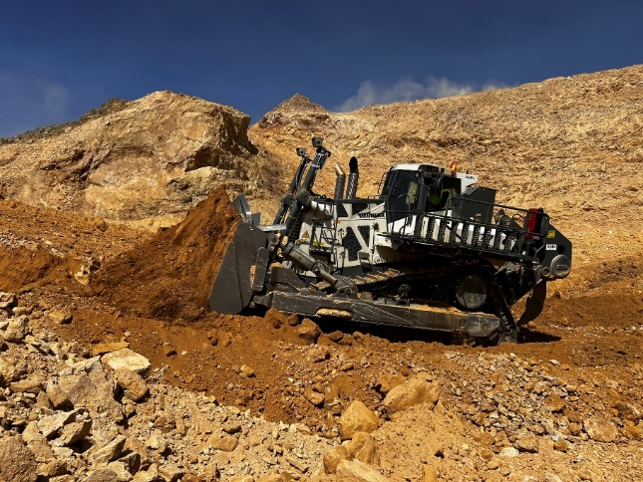

liebherr-img-5454.jpg  
Liebherr PR 776 Crawler Dozer: maximum power transfer.

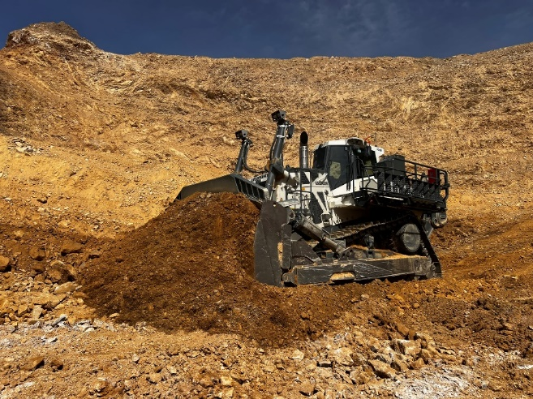

liebherr-img-5413.jpg  
Liebherr Crawler Dozers setting new standards in quarry operations.

**Contact**

Mag. Lisa Kahlig  
Marketing Manager PR and Press  
Phone: +43 690 500 644 96  
E-Mail: lisa.kahlig@liebherr.com

**Published by**

Liebherr- Werk Telfs GmbH  
Telfs / Austria  
www.liebherr.com