Press release

100,000th machine: Liebherr sets milestone on its 75th anniversary

⸺

100,000 machine at the founding location Kirchdorf an der Iller

Employees personally sign the anniversary machine

It is another milestone in the history of Liebherr-Hydraulikbagger GmbH: the production of the 100,000th machine at the Liebherr Group's founding site. The anniversary machine is absolutely unique, as all employees were able to place their names on the machine. The white LH 22 M Industry therefore bears a very special signature.

Kirchdorf an der Iller (Germany), July 25, 2024 – On the anniversary machine of Liebherr-Hydraulikbagger GmbH, the founding plant of the Liebherr Group, the 100,000 is emblazoned in large black numbers on white ground. The machine was presented to employees for the first time as part of the celebrations to mark the Liebherr Group's 75th anniversary. As a special highlight, all employees were able to sign the LH 22 M Industry personally.

Like all Liebherr mobile material handling machines, the anniversary machine is characterized by high flexibility and exceptional mobility. The LH 22 M Industry impresses with its sturdy and compact design, which makes it particularly suitable for deployment in the area of recycling. With the latest engine and hydraulics technology, developed in-house by Liebherr, the main focus is on fuel efficiency while at the same time enhancing material handling performance. The attachment of the machine is available in a variety of versions and is thus always optimally matched to your respective application. The 100,000 machine is equipped with a sorting grapple, making it ideal for demolition or recycling applications.

**Liebherr was founded 75 years ago in Kirchdorf an der Iller**

In 1949, the pioneer Hans Liebherr invented the world’s first mobile tower crane, laying the foundations for the future group of companies. Back in 1954 Hans Liebherr laid the foundation for a new type of machine with his first L 300 wheeled excavator which to this day is still among the best in the world. In the following years, the product range was constantly expanded to meet the growing demands of the construction industry. The A 650 wheeled excavator was the first fully hydraulic wheeled excavator from Liebherr in 1960. Based on this success, Liebherr expanded its product portfolio in the 1980s to include material handling machines in order to meet the growing requirements in the field of material handling. The specialized machines are designed to move large quantities of bulk materials, scrap, timber and other materials efficiently and safely.

In 1989 the Litronic followed as another innovation highlight from Liebherr. The Litronic is a complete system of intelligent electronics and functional hydraulics for monitoring, controlling and coordinating all key systems of the excavator. The perfect interaction of machine and tool attachment plays a decisive role for successful deployment on site. This is why Liebherr also invested in this area and in 2001 was able to present its fully automatic quick coupler system LIKUFIX. With LIKUFIX the machine operator can change all mechanical and hydraulic tool attachments at the touch of a button from the cab as well as adjust the hydraulic pressures and volumes. With the introduction of the new generation of articulated trucks in 2020, Liebherr developed into a full-liner in the earthmoving sector. Further developments are continually being added in all areas in line with the motto "Standing still is a step backwards".

**About the Liebherr Group – 75 years of moving forward**

The Liebherr Group is a family-run technology company with a widely diversified product programme. The company is one of the largest construction equipment manufacturers in the world. It also provides high-quality, user-oriented products and services in a wide range of other areas. The Liebherr Group includes over 150 companies across all continents. In 2023, it employed more than 50,000 staff and achieved combined revenues of over 14 billion euros. Liebherr was founded by Hans Liebherr in 1949 in the southern German town of Kirchdorf an der Iller. Since then, employees have been pursuing the goal of achieving continuous technological innovation, and bringing industry-leading solutions to its customers. Under the slogan ‘75 years of moving forward’, the Group celebrates its 75th anniversary in 2024.

**Image**

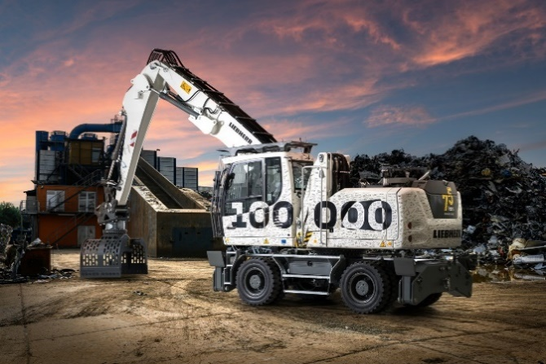

liebherr-100.000-maschine.jpg  
The 100,000 machine at the founding site in Kirchdorf an der Iller bears a special signature: All employees have signed it.

Contact

Marc Wiedenmann  
Marketing  
Phone: +49 7354 / 80 - 8494  
E-Mail: marc.wiedenmann@liebherr.com

Published by

Liebherr-Hydraulikbagger GmbH   
Kirchdorf an der Iller / Germany  
[www.liebherr.com](http://www.liebherr.com)